FOR IMMEDIATE RELEASE
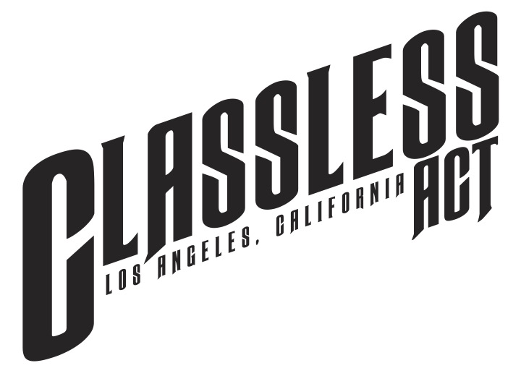

CLASSLESS ACT PAYS HOMAGE TO DAVID BOWIE
WITH DOUBLE-A-SIDE SINGLE
“All The Young Dudes” and “Starman” Due Out Today, February 3

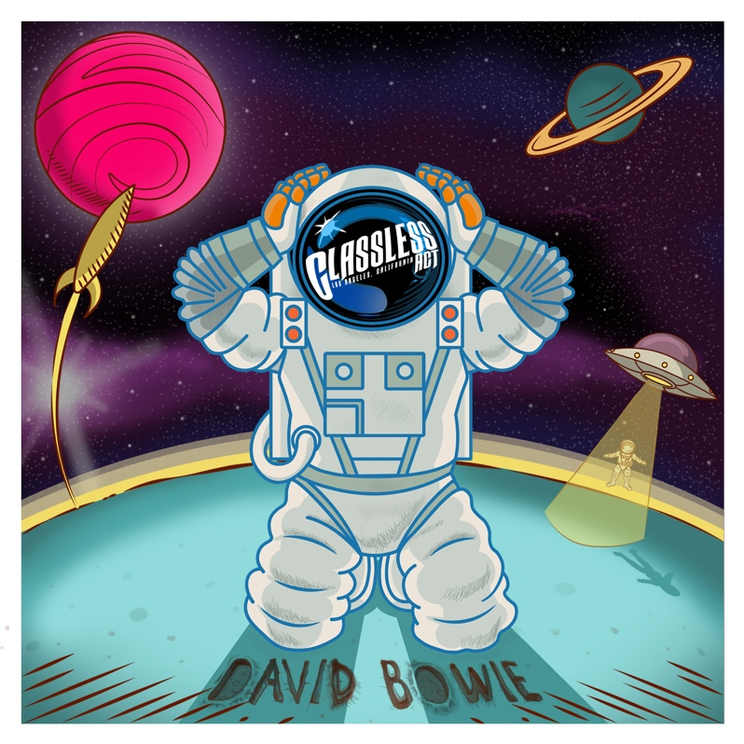

There’s a starman waiting in the sky
He’d like to come and meet us
But he thinks he’d blow our minds
There’s a starman waiting in the sky
He’s told us not to blow it
‘Cause he knows it’s all worthwhile...﻿
--- David Bowie, "Starman"

LOS ANGELES, CA — Friday, February 3, 2023 — With the David Bowie documentary “Moonage Daydream” shortlisted as Best Documentary for the 2023 Academy Awards, Classless Act, one of the hottest new rock bands to emerge in 2022, pays tribute to Bowie with its upcoming double-A-side digital single, “All The Young Dudes,” and “Starman.” The tracks will be available via all DSPs today, February 3 (Better Noise Music).

Click HERE to stream both “All The Young Dudes” and “Starman.”

“When we learned there was a documentary about the creative, spiritual and musical journey of the great David Bowie, we wanted to pay our tribute, acknowledge his genius, his artistry, his influence and our gratitude to him,” said band vocalist Derek Day. “We’ve always had a few cover songs in our set; in the beginning, it was out of necessity as we didn’t have enough of our own songs. Now it’s our choice. Whether it was Led Zeppelin, The Beatles, Guns N’ Roses, Queen, or many others, they represent a road map of our influences, our roots…and how we’ve gotten ‘here’ musically. David Bowie played a major role."

Twenty-twenty-two was a true break-out year for Classless Act. The band - Day, guitarists Dane Pieper and Griffin Tucker, bassist Franco Gravante, and Chuck McKissock on drums - toured the U.S. with Dorothy on her Spring "Gifts From The Holy Ghost" trek, released its debut album, Welcome To The Show, in June, receiving rave press reviews from North America to the U.K. and Europe, South America and Australia, hit the North American road in July on the summer’s biggest tour, The Stadium Tour, opening for Motley Crüe and Def Leppard, split the month of December between supporting Giovannie and The Hired Guns, and their own headline dates on its “The Most Wonderful Tour of the Year,” and wrapped up the year with the release of Welcome To The Acoustic Show EP, that featured stripped-down versions of five songs from their album.

As BraveWords’ Jonathan Smith wrote about Classless Act in his Stadium Tour review, “Led by highly charismatic and off-the-wall frontman Derek Day, who could be best described as a composite of Robert Plant’s high-end brilliance, Roger Daltry’s power, Axl Rose’s grittiness, and David Lee Roth’s stage presence, their comparatively short set, set the air ablaze.”

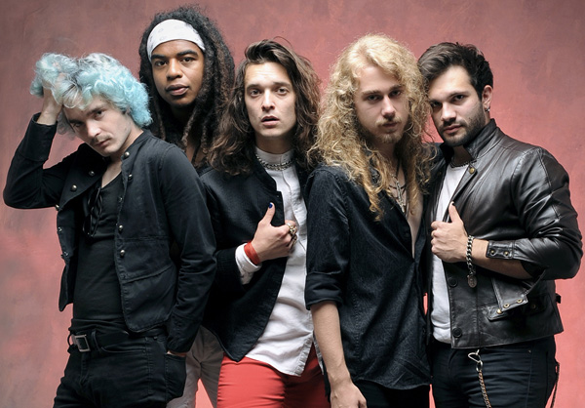
Classless Act L-R: Chuck McKissock, Dane Pieper, Derek Day, Griffin Tucker, Franco Gravante
Photo Credit: Glen LaFerman

ABOUT CLASSLESS ACT:
It’s not often that a band comes around like Classless Act, who have tempted a new generation of fans and given rock’s faithful a reason to keep believing. Influenced by Queen, Led Zeppelin, The Beatles, and Bowie, the L.A.-based five-piece brings a fresh, young take on a golden age of music. They’ve been applauded by bands like Jane’s Addiction, given nods from execs with Live Nation and MTV, and are already finding their footing in major international markets barely a year after releasing their first single, “Give It To Me,” in 2021.

With 2022’s release of their anticipated debut Welcome To The Show via Better Noise Music, the band immediately racked up two-million streams and got the attention of rock bibles like Loudwire, SPIN, Metal Hammer, and Blabbermouth, the latter who said Classless Act “stands ready to carve out a legacy of its own.”

While the music tells its own story, so do the members of the band themselves, hailing from all over the globe, including Hawaii, Los Angeles, Argentina, and Dallas. The band, featuring Derek Day (vocals), Dane Pieper (guitar), Griffin Tucker (guitar), Franco Gravante (bass), and Chuck McKissock (drums), first formed in 2018 when the five former strangers met through friends via social media. Their chemistry quickly came to light, the members fusing together anthemic rhythms, shreddy guitars, soaring vocals, and clever arrangements that, as one writer astutely said, have "...enough energy to power a city."

02.03.23

Classless Act Press Assets (bio, photos/art, news, more):
https://www.herfitzpr.net/classless-act-home-2023

North American Media Contacts:
National Media:
Heidi Ellen Robinson-Fitzgerald
heidirobinsonfitz@icloud.com
818-705-1267

Tour Media:
Selena Fragassi
selena@fr-pr.net
(847) 942-3093

