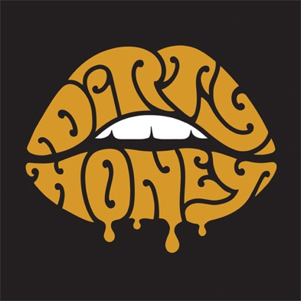

FOR IMMEDIATE RELEASE

DIRTY HONEY 'S DEBUT SINGLE "WHEN I'M GONE"
EARNS THE #1 SPOT ON THE ROCK RADIO CHARTS
Band Announces New Single, Music Video for "Rolling 7s"

LOS ANGELES, CA - Monday, September 23, 2019 - White-hot rock band Dirty Honey proved today that you don't need a record deal to fly to #1 on the Rock Radio Charts. In less than six months, they are 2019's only new, independent artist to climb the charts all the way to #1 with their debut single "When I'm Gone," all while racking up five-million+ streams for their self-titled EP and touring alongside rock royalty like The Who, Slash and Guns N' Roses.

The band - Marc Labelle/vocals, John Notto/guitars, Justin Smolian/bass and Corey Coverstone/drums - has been winning fans over with their high-energy, attitude heavy rock'n'roll show, making stops at major music festivals like Welcome to Rockville, Heavy MTL, Rocklahoma, and Sonic Temple. They are currently traveling cross-country with Alter Bridge and Skillet and will join Guns N' Roses for two dates in Las Vegas before embarking on their first headline tour. All dates are below.

With "When I'm Gone" now at #1, Dirty Honey celebrates with the launch of their latest single + music video "Rolling 7s," produced and directed by Scott Fleishman for APLUSFILMZ. Said Fleishman, "The concept for 'Rolling 7s' was to capture the raw energy of a Dirty Honey show while following a series of characters in the crowd, all in a cinematic one-take inside a dive bar somewhere in the California desert. The single-take places the emphasis on the band's performance, while interactions play out around them, building up to chaos on the dance floor as the song reaches its climax."

Check out the "Rolling 7s" video HERE.

SEPTEMBER
24 Terminal 5, New York, NY **
25 The Met, Philadelphia, PA **
27 Express Live!, Columbus, OH **
28 Louder Than Life, Louisville, KY (GN'R, Ice Cube)
30 Rebel, Toronto **

OCTOBER
1 MTelus, Montreal **
3 The Palladium, Worcester, MA **
5 Agora Theatre, Cleveland, OH **
6 The Fillmore, Detroit, MI **
8 Myth Live, St. Paul, MN **
10 Chicago Theatre, Chicago, IL **
11 Arvest Bank Theatre at the Midland, Kansas City, MO **
13 Exit 111, Manchester, TN (Guns N'Roses)
14 The Pageant, St. Louis, MO **
16 Saenger Theatre, Mobile, AL **
17 Avondale Brewing Co., Birmingham, AL **
19 Vibes Event Center, San Antonio, TX **
20 The Bomb Factory, Dallas, TX **
22 Jannus Live, St. Petersburg, FL **
24 House of Blues, Orlando, FL **
25 House of Blues, Orlando, FL **

NOVEMBER
1 The Colosseum at Caesars Palace, Las Vegas, NV (Guns N' Roses)
2 The Colosseum at Caesars Palace, Las Vegas, NV (Guns N' Roses)
4 Rebel Lounge, Phoenix, AZ ^
5 Sister Bar, Albuquerque, NM ^
7 Jake's Backroom, Lubbock, TX ^
9 Lost Lake, Denver, CO ^
12 The Saint, Reno, NV ^
13 Holy Diver, Sacramento, CA ^
14 Strummers, Fresno, CA ^
16 Voodoo Room @ House of Blues, San Diego, CA ^
22 The Troubadour, Los Angeles, CA ^
* Alter Bridge/10 Years
** Alter Bridge/Skillet
^ Headline

# # #

