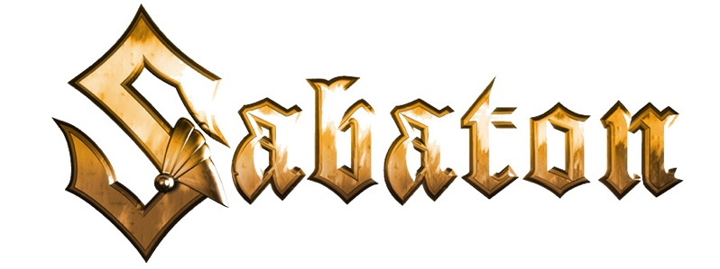

The War To End All Wars
The Songs' Inspirations

Sarajevo
The album opens with a song about the shots in Sarajevo and the assassination of Archduke Franz Ferdinand which escalated the situation and is counted as a major cause for the outbreak of World War 1.

Stormtroopers
Smaller, well-trained and well-equipped units of soldiers who would break the stalemate of the frontlines.

Dreadnought
A song dedicated to the massive battleship class Dreadnought and the naval confict at Jutland

The Unkillable Soldier
Sir Adrian Carton De Wiart was of Belgian heritage but fought for the British Empire during WW1. Being injured multiple times, he became known as the “Man who could not be killed.”

Soldier of Heaven
This is a song about the Alpine front and the White War. High in the Alps, in the most extreme circumstances, men fought and protected the borders between Austria-Hungary and Italy during WW1. The song tells the story of those brave soldiers who froze to death, and whose bodies still remain under the snow to this day.

Hellfighters
A song about the 369th regiment who mainly was formed out of African American and Puerto Rican soldiers and were not allowed to fight alongside the ordinary American soldiers.

Race To The Sea
This is a song about the decision from Albert of Belgium during WW1 to flood the last part of Belgium and with the help of water prevent all of Belgium to fall into German hands.

Lady of the Dark
Milunka Savic was a Serbian woman who took her brother's place in the army. Partly disguised as a man, she would eventually be among the most decorated soldiers of WW1.

The Valley of Death
This is the Macedonian front and the Battle of Doiran where Bulgarian troops stood against a larger invading British force and due to strong command and strong fortifications were able to hold the line.

Christmas Truce
Christmas Eve 1914, six months on the battlefield, and World War 1 still hadn't come to an end. British Expeditionary Forces heard German troops in the trenches opposite them singing Christmas carols, and saw lanterns and small fir trees along their trenches. Messages began to be shouted between the trenches. Missing home even more than on any other day, the British soldiers started quietly singing along. Early Christmas morning, the British and German soldiers slowly crawled out of their trenches and met in no-man's land to wish each other a Merry Christmas, take photographs, play football, and even exchange a few gifts. It was a rare but magic moment of peace and harmony in the midst of one of the most atrocious events of the 20th century.
(See the story video of "Christmas Truce" HERE ).

Versailles
Eventually, World War 1 came to an end and the French city of Versailles was chosen as the city where the treaty would be signed. This final song on the album talks about the end of the war...but will it only lead to another war?

