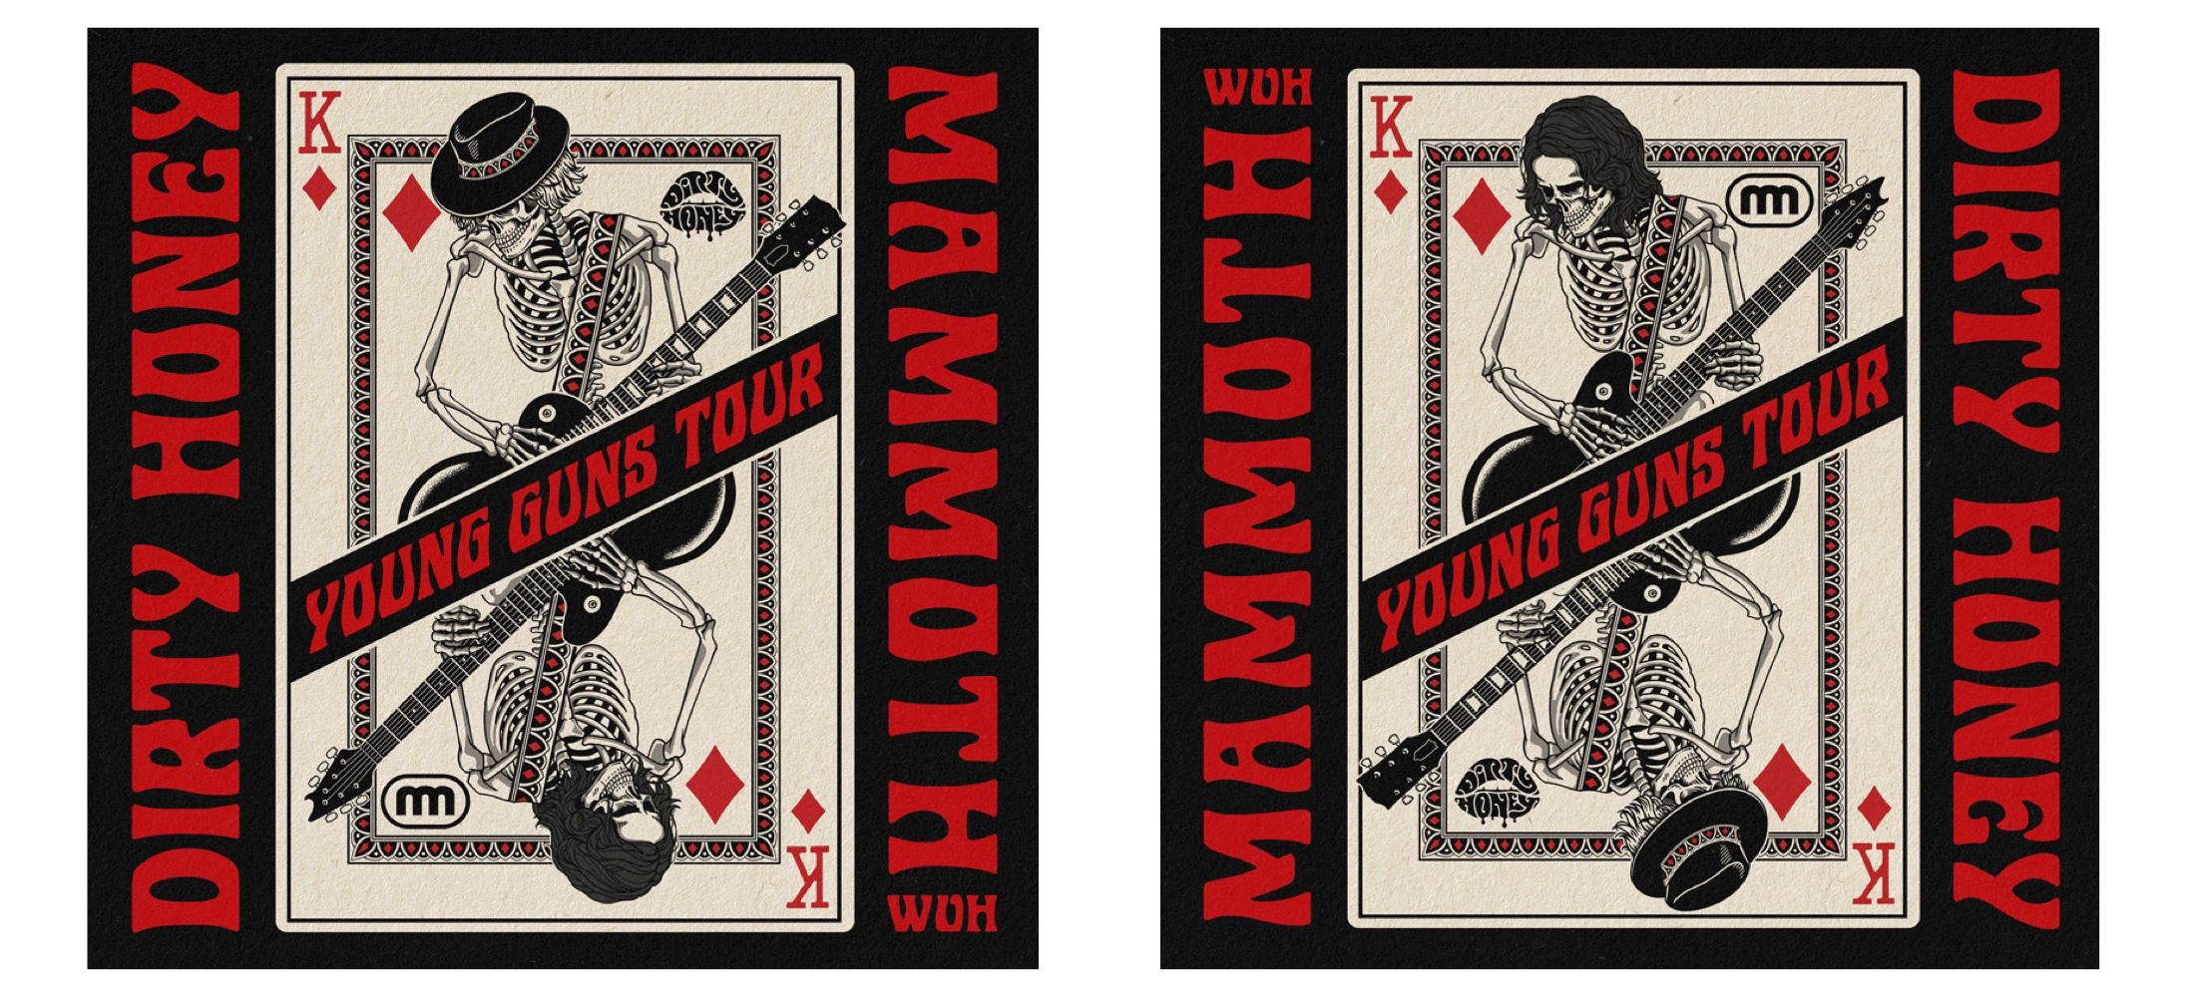

FOR IMMEDIATE RELEASE

DIRTY HONEY AND MAMMOTH WVH ANNOUNCE
“YOUNG GUNS” CO-HEADLINE, NORTH AMERICAN TOUR

“Dirty Honey and Mammoth WVH are two of the best new, real, emerging rock bands we have today.
Touring together will prove that rock is far from dead, and will no doubt showcase its very bright future.”
— Eddie Trunk • TrunkNation Sirius XM Radio

LOS ANGELES, CA — (February 7, 2022) — Two of today’s most dynamic live bands, Mammoth WVH and Dirty Honey, are joining forces to bring their kick-ass rock’n’roll out on a 33-date, co-headline North American tour. The “Young Guns” tour begins on February 20 in Denver, CO and will see the bands alternating the closing slot throughout the tour. Dirty Honey will also headline its own concert on April 3 at Iron City, Birmingham, AL. Tickets for all dates are on sale now and can be purchased HERE.

“We played one co-headline show with Dirty Honey back in September. As soon as the night was over, we knew this would be a great package to take across the US. We couldn’t be more excited to share the stage with them and give all of the fans an unforgettable night of rock music,” explains Wolfgang Van Halen.

Both of these “young guns” spent their summer on high-profile U.S. tours - Dirty Honey with The Black Crowes and Mammoth WVH with Guns N’ Roses. With only two live gigs under their collective belt, Mammoth WVH’s tour initiation was a baptism-by-fire, opening for the iconic Guns N’ Roses in stadiums. At the end of the tour, in Hollywood, Florida, Guns N’ Roses brought Wolfgang Van Halen back onstage to join them performing “Paradise City.”

After selling out their U.S. headline tour last June, Dirty Honey brought their sexy, bluesy rock’n’roll to amphitheaters with The Black Crowes. Vocalist Marc LaBelle grew up listening to the Crowes, so this tour was truly a dream come true. Winning over those who had primarily come to see The Black Crowes, Dirty Honey received standing ovations at the majority of the tour’s 35 shows. Not bad for a still-breaking, opening act.

The "Young Guns” tour is in support of both artist’s self-titled debut albums; Mammoth WVH and Dirty Honey, both released earlier this year. Both bands saw their debut singles - Dirty Honey’s “When I’m Gone” and Mammoth WVH’s “Distance” - occupy the #1 position on Billboard’s Mainstream Rock Airplay chart. In addition, both bands’ debut albums made quite impressive bows; Mammoth WVH debuted at #1 on Billboard’s Top Rock Albums chart, and Dirty Honey - the band, totally independent with no label affiliation - claimed the #2 position on that chart.

“People who come to our shows are going to see two bands who are looking to prove that rock’n’roll is definitely very much alive and well,” said Dirty Honey’s Marc LaBelle. “We both carry the weight of that on our shoulders, and there’s a lot to prove.”

Dates for the "Young Guns” tour are as follows:

FEBRUARY
20 Ogden Theatre, Denver, CO
21 The Complex, Salt Lake City, UT
22 Revolution, Boise, ID
24 House of Blues, Las Vegas, NV
25 Ace of Spades, Sacramento, CA
27 Grand Sierra Resort, Reno, NV

MARCH
1 House of Blues, San Diego, CA
2 The Wiltern, Los Angeles, CA
4 The Marquee, Tempe, AZ
5 Fantasy Casino, Indio, CA
9 House of Blues, Dallas, TX
10 Aztec Theatre, San Antonio, TX
12 Diamond Ballroom, Oklahoma City, OK
13 Uptown Theatre, Kansas City, MO
15 The Rave, Milwaukee, WI
16 House of Blues, Chicago, IL
18 The Bluestone, Columbus, OH
20 Roxian Theatre, Pittsburgh, PA
21 Piere's Entertainment Complex, Ft. Wayne, IN
23 Royal Oak Music Theatre, Royal Oak, MI
24 Danforth Music Hall, Toronto, ONT
26 Big Night Live, Boston, MA
27 Toad's Place, New Haven, CT
28 Webster Hall, New York, NY
30 Starland Ballroom, Sayreville, NJ
31 The Fillmore, Philadelphia, PA

APRIL
1 Rams Head Live, Baltimore, MD
3 Iron City, Birmingham, AL (Dirty Honey solo headline date)
5 The Ritz, Raleigh, NC
6 The Fillmore, Charlotte, NC
8 Marathon Music Works, Nashville,TN
9 The Plant, Dothan, AL
10 Hard Rock Orlando, Orlando, FL
12 Tabernacle, Atlanta, GA

• • • • •

Media Contacts:
Dirty Honey
National Media: Heidi Ellen Robinson-Fitzgerald • herfitz@mac.com • 818-705-1267
Tour/Local Media: Selena Fragassi • selena@fr-pr.net • (847) 942-3093

Mammoth WVH
Kevin Chiaramonte: Kevinc@pfamedia.net • (917) 723-9653

