FOR IMMEDIATE RELEASE

PIXIES MUSIC VIDEO FOR “CATFISH KATE”
VENTURES INTO SOME SERIOUSLY STRANGE TERRITORY
“Catfish Kate” is the First Radio Single from the Band’s Upcoming Album, Beneath The Eyrie

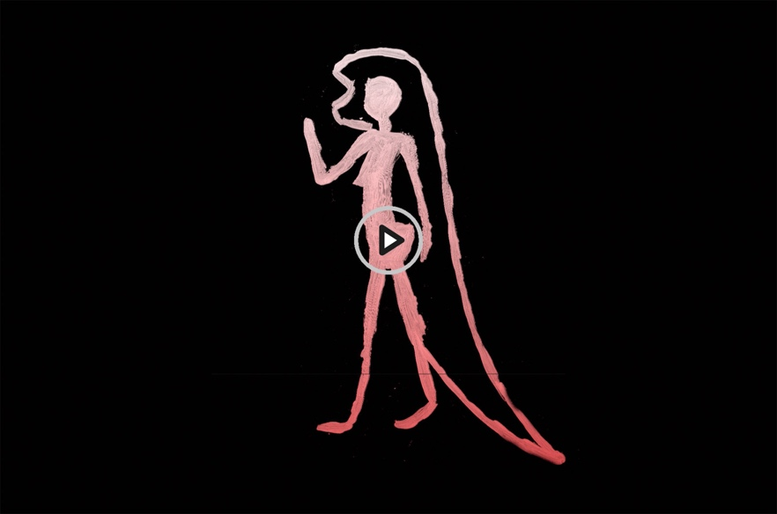

LOS ANGELES, CA — Tuesday, August 6, 2019 — The animated new music video for “Catfish Kate,” the first radio single from Pixies’ studio album Beneath The Eyrie due out September 13 (BMG), ventures deep into the imagination of the band’s main lyricist Black Francis. The clip weaves the bizarre lyrical and visual tale of mountain woman Kate’s simple task to catch a fish for that night’s dinner, and what occurs that has her known forever after as “Catfish Kate." You can view the video here.

The clip was created by the UK/European-based Krank! Collective who also produced the animated video for Pixies’ “Tenement Song” from 2016’s Head Carrier. Krank!’s Neirin Best and Lianne Pierce created the “Catfish Kate" video using a variety of handmade and digital animation techniques, including old school light box, painted animation, rotoscoping and digital compositing.

“Catfish Kate” follows “On Graveyard Hill,” the first track released from the album that debuted at #1 on FMQB’s SubModern Chart. Beneath The Eyrie was produced by GRAMMY-nominated Tom Dalgety and recorded last December at Dreamland Studios near Woodstock, NY. The band’s “It’s a Pixies Podcast” is the 12-episode podcast that gives fans a real “fly-on-the-wall" look at the album’s recording process. Each episode has fans witnessing the interaction between vocalist/rhythm guitarist Black Francis, guitarist Joey Santiago, drummer David Lovering, bassist Paz Lenchantin and Dalgety, shining a light on how the songs evolved from a simple riff to what you’ll hear on the finished album. "It’s a Pixies Podcast" is about half-way through with Episode Seven released this Thursday (8/8), and is available globally on Apple, Spotify, Deezer, and Stitcher; check out all of the episodes here.

Pixies 2019-2020 global trek to support Beneath The Eyre begins Saturday August 31 at the Daydream Festival in Pasadena, CA. The band then heads to the UK for its first European tour in two years, kicking off September 13. More worldwide dates will be announced shortly.

AUGUST
31 Daydream Festival, Pasadena, CA

SEPTEMBER
12 De La Warr Pavilion, Bexhill, UK
13 Motorpoint Arena, Cardiff, UK
14 Pavilions, Plymouth, UK
16 O2 Academy, Birmingham, UK
17 O2 Academy, Leeds, UK
18 O2 Apollo, Manchester, UK
20 Alexandra Palace, London, UK
21 O2 Academy, Newcastle, UK
22 O2 Academy, Glasgow, UK
23 Usher Hall, Edinburgh, UK
25 Ulster Hall, Belfast, UK
26 Olympia Theatre, Dublin, Ireland
29 Sentrum Scene, Oslo, Norway
30 Cirkus, Stockholm, Sweden

OCTOBER
1 KB Hallen, Copenhagen, Denmark
3 TivoliVredenburg, Utrecht, The Netherlands
4 O13 Poppodium, Tilburg, The Netherlands
5 Columbiahalle, Berlin, Germany
7 Palladium, Cologne, Germany
8 Lucerna Music Hall, Prague, Czech Republic
9 Gasometer, Vienna, Austria
11 Estragon, Bologna, Italy
12 Todays at OGR, Turin, Italy
13 X-Tra, Zurich, Switzerland
15 Tonhalle, Munich, Germany
16 Forest National, Brussels, Belgium
17 Luxexpo, Luxembourg City, Luxembourg
19 L'Olympia, Paris, France
20 Le Radiant, Lyon, France
21 Le Liberte, Rennes, France
23 Sant Jordi Club, Barcelona, Spain
24 Riviera, Madrid, Spain
25 Campo Pequeno, Lisbon, Portugal
26 Coliseum, Galicia, Spain

# # #

