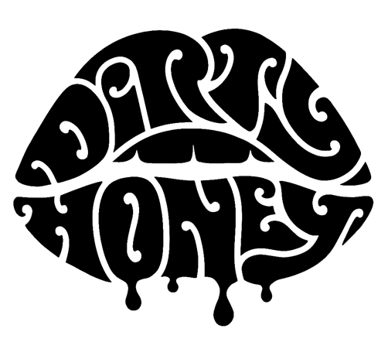
FOR IMMEDIATE RELEASE

DIRTY HONEY’S DEBUT ALBUM ENTERS
THE CURRENT HARD ROCK ALBUMS CHART AT #2
Band Kicks Off the Shackles of COVID and Announces
“The California Dreamin’ Tour"

LOS ANGELES, CA - Wednesday, May 5, 2021 - Today is a good day for Dirty Honey. For the second time in their brief history, the band is nailing some impressive accomplishments. In October, 2019, they became the first unsigned band to go all the way to #1 on Billboard's Mainstream Rock Songs chart with their very first single, "When I'm Gone." Today, the band sees its debut full-length album score the #2 spot on the Current Hard Rock Albums chart, #4 on the Current Independent Albums chart, and #5 on the Current Rock Albums chart. And all without the support of a major label.

"It exceeded all of our expectations," said Dirty Honey's vocalist/lyricist Mark LaBelle about the release of the band's debut album, the Dirty Honey album. "We're all really excited to release new music, especially after such a long wait, and it's great to feel the momentum again, with the 'California Dreamin'' single, the response to all of the new music, our social media...it's just a very exciting time."

But wait, there's more: Recent Dirty Honey press features and socials posts - not to mention the viral video clip that actor and good-friend-of-the-band's Taylor Kitsch posted on his Instagram last week - have made it clear that all Dirty Honey wants to do is get back on the road and play live shows. So, today, the band - LaBelle, John Notto/guitars, Justin Smolian/bass, and Corey Coverstone/drums - announces "The California Dreamin' Tour," the first round of dates since the band's sold-out, headline trek back in January/February 2020. The tour will kick off June 3 in Tempe, AZ with fellow Californians Joyous Wolf supporting on all of Dirty Honey's headline shows. Ticket presales are available tomorrow from 10:00AM - 10:00PM local; password is DREAMIN. General tickets go on sale this Friday at 10:00AM local; go HERE for all ticketing information for Dirty Honey's upcoming tour dates.

JUNE
3 The Marquee, Tempe, AZ*
5 Jake’s Backroom, Lubbock, TX*
6 Hoot's Pub, Amarillo, TX*
8 The Rock Box, San Antonio, TX*
9 Brewster Street Ice House, Corpus Christi, TX*
11 Club LA, Destin, FL*
12 Soul Kitchen Music Hall, Mobile, FL*
14 Shagnasty’s, Huntsville, AL*
15 Capone’s, Johnson City, TN*
17 The Signal, Chattanooga, TN*
19 Diamond Ballroom, Oklahoma City, OK*
20 The Cotillion, Wichita, KS*
22 Bourbon Theatre, Lincoln, NE*
24 Piere’s, Fort Wayne, IN*
26 Ford Park Live, Oshkosh, WI
27 Now Arena, Hoffman Estates, IL

SEPTEMBER
25 MMR*B*Q, BB&T Pavilion, Camden, NJ
Tickets on-sale Friday, May 7 at 10:00AM ET

* Dirty Honey headline dates, Joyous Wolf will special guest

MEDIA CONTACTS:
National Media:
Heidi Ellen Robinson-Fitzterald
HERFitzgerald@outlook.com
818-705-1267

Local/Tour Media:
Selena Fragassi
selena@fr-pr.net
(847) 942-3093

Dirty Honey Press Assets Site (bio, photos/artwork, news, lyrics/credits, more):
https://www.herfitzpr.net/dirty-honey-home-2021

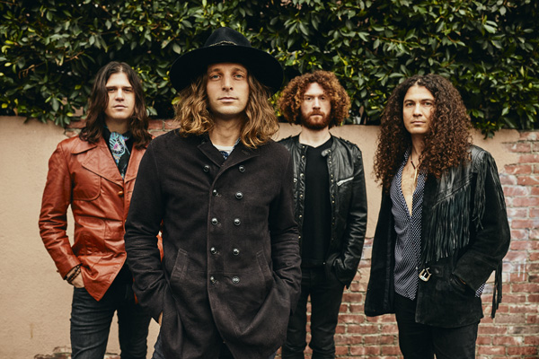
Dirty Honey L-R: John Notto, Marc LaBelle, Corey Coverstone, Justin Smolian
Photo Credit: Daniel Prakopcyk

