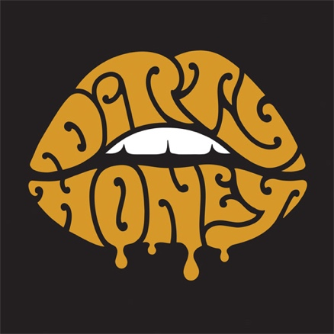

FOR IMMEDIATE RELEASE

GROUNDED DUE TO COVID-19, DIRTY HONEY,
WITH THEIR AUSTRALIAN-BASED PRODUCER,
ARE WRITING AND DEMOING NEW MUSIC VIA ZOOM

LOS ANGELES, CA - (Monday, June 15, 2020) - As a result of the COVID-19 pandemic, Dirty Honey was forced to cancel travel plans to Australia in mid-March to write and record new music with producer Nick DiDia (Pearl Jam, Rage Against The Machine), but that hasn't prevented the band from figuring out a way to get it done. Since late March, the band - Marc LaBelle/vocals, John Notto/guitar, Justin Smolian, and Corey Coverstone/drums - has been holed up in their home studio/rehearsal space, writing and demoing a slew of new tunes with DiDia staying in the mix via Zoom. Recently, while working on the new songs, the band connected with DiDia at his Byron Bay, Australia studio, where they performed and discussed the tracks' progress. You can check out that Zoom video exchange and hear what the band's been working on HERE.

In terms of recording plans for the album - when and where - the band is still working out those logistics as they will be determined by any travel restrictions as pertain to COVID-19. Dirty Honey and DiDia are aiming to get into a studio, with everyone together next month, either in Los Angeles or Australia, or, as a backup, via Zoom, with the band in L.A. and DiDia in Australia.

* * * * *

ABOUT DIRTY HONEY:
To say that 2019 was a breakout year for Dirty Honey would be an understatement. Recorded in Byron Bay, Australia with producer Nick DiDia (Pearl Jam, Rage Against The Machine), the band released its self-titled debut EP in March 2019. Over the course of the last year-plus, Dirty Honey opened for The Who, Guns N' Roses, and Slash ft. Myles Kennedy & The Conspirators, performed at more than a dozen major summer festivals including Welcome to Rockville, Louder Than Life, Heavy MTL, Rocklahoma, Sonic Temple and Epicenter, and played to SRO crowds at every show on its first-ever headline tour in December and January & February this year. Dirty Honey also made music history when it became the only unsigned artist ever to hit #1 on Billboard's Mainstream Rock Chart with its debut track "When I'm Gone." Additionally, the band was named Canadian Rock Radio's #1 International Breakout Artist of 2019,

Loudwire cited "When I'm Gone" as one of the "66 Best Songs of the Decade," the UK's
Louder/Classic Rock magazine hailed Dirty Honey as one of the "20 great bands to shake up the 2020s," and the band was nominated as Best New Rock/Alternative Artist for the 2020 iHeartRadio Music Awards. "Rolling 7s," Dirty Honey's second single, went all the way to #4 at Rock Radio, and the band has racked up more than 28.6-million total streams.

