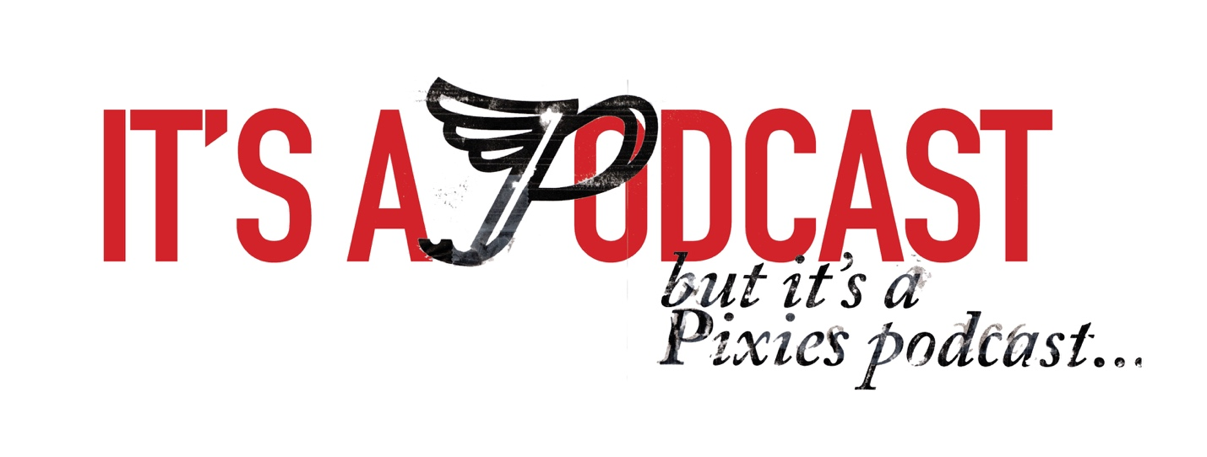

FOR IMMEDIATE RELEASE

PIXIES RELEASE NEW TRAILER FOR
“IT’S A PIXIES PODCAST”
THAT DOCUMENTS THE MAKING OF THE BAND’S UPCOMING NEW ALBUM, BENEATH THE EYRIE
View The Trailer HERE
First Album Track, “On Graveyard Hill,”
Debuts at #1 on FMQB’s SubModern Chart

LOS ANGELES, CA - Monday, June 17, 2019 — Earlier this month, Pixies announced Beneath The Eyrie, the band’s brand new studio album due out September 13 (Infectious/BMG). Today, Pixies release an audio/video trailer for “It’s a Pixies Podcast," the 12-episode podcast recorded during the making of the album last December at Dreamland Recordings near Woodstock, NY. “It’s a Pixies Podcast” was produced by Pixies and narrated by New York Times best-selling author Tony Fletcher. Over the course of the series, fans will be given an up-close and personal perspective to the interaction between the band members and with the album’s producer Tony Dalgety, in the studio’s control room, the main room and in a special “audio booth” where Black Francis, Joey Santiago, David Lovering and Paz Lenchantin offered their thoughts and observations. In addition, Fletcher spent many hours at the studio, soaking up the entire process and conducting interviews with all band members as well as with Dalgety. Check out the trailer HERE.

“It’s A Pixies Podcast” will be available on all podcast platforms globally including Apple, Pandora, Acast, Stitcher, Google and more. The series debuts on Thursday, June 27 with a new episode available every Thursday leading up to the September 13 release of Beneath The Eyrie. Pre-orders can be placed at https://pixies.lnk.to/eyriePR

# # #

