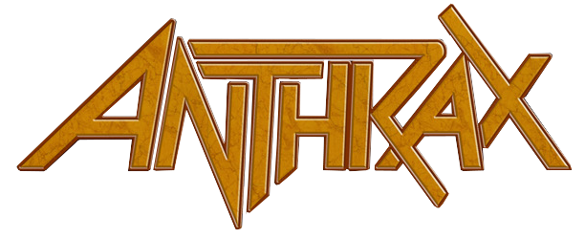

FOR IMMEDIATE RELEASE

ELECTRIFYING ANTHRAX “AMONG THE KINGS” UK CONCERT CAPTURED FOR UPCOMING DVD

LOS ANGELES, CA - Thursday, February 16, 2017 -- Thrash pioneers ANTHRAX, armed with an initial six dynamic SRO dates on “Among The Kings," their first UK/European headline tour in more than a decade, over-the-top rave press reviews, and hundreds of effusive social posts from fans who attended the shows, will chronicle the frenzy with a live DVD expected to be released later this year (Megaforce).

With the energy level through the roof, Anthrax's show was filmed last night at Glasgow’s historic venue Barrowland. Seventeen cameras, including five Go-Pros and a full-size camera crane, captured more than two hours of Anthrax favorites that were voted onto the evening's set list by fans and included “Madhouse,” “Be All, End All,” “Breathing Lightning,” and “A.I.R.,” followed by Anthrax’s classic 1987 album Among The Living performed start to finish (“Caught In A Mosh,” “I Am the Law,” “Indians,” “N.F.L.”). In addition to the live footage, the DVD will include “fly-on-the-wall” interviews and other B-roll shot on the band’s tour bus, backstage, in hotels and elsewhere.

The DVD is being produced and directed by Paul Green of the Manchester, UK-based Paul Green Productions who has filmed concerts for Opeth, The Damned, Gary Numan, The Levellers, and many others.

Last year’s celebration of Anthrax's 35th anniversary saw the band getting some of the best live reviews of its career, but the reception from British fans on this tour has been far more than anyone anticipated.

“I don’t know why it took us so long to come back to the UK and headline our own tour,” said Anthrax’s Joey Belladonna, “but I’m sure glad we did. These shows have been some of the best we’ve ever done, and that’s really due to the interaction with the fans, they’ve just been crazy. And that’s what we wanted to capture for this DVD.”

The first five days on the UK tour saw a 150% increase in traffic on the band’s website, and in less than a week, nearly 30,000 votes were cast by fans to help the band create the set lists for the UK and European shows.

Anthrax plays its last "Among The Kings” UK date tomorrow in Norwich and then heads to 22 European cities winding up in Paris on March 16 . Starting March 29, Anthrax will co-headline the “KillThrax” North Ameircan tour with Killswitch Engage. Dates are below and ticketing info can be accessed at www.anthrax.com

MARCH
29 The Wellmont Theatre, Montclair, NJ *
30 LC Pavilion, Columbus, OH **
31 Arcada Theatre, St. Charles, IL (Anthrax only)
31 The International, Knoxville, TN (KsE only)

APRIL
1 Little River Casino, Manistee, MI (Anthrax only)
1 Norva, Norfolk, VA (KsE only)
3 The Fillmore, Silver Springs, MD *
4 The Dome, Wallingford, CT *
5 Electric Factory, Philadelphia, PA **
7 20 Monroe Live, Grand Rapids, MI *
8 The Fillmore, Detroit, MI **
9 Stage AE, Pittsburgh, PA *
11 The Ritz, Raleigh, NC **
12 Tabernacle, Atlanta, GA **
13 House of Blues, Orlando, FL *
15 Texas Independence Festival, Austin, TX **
16 Boggus Ford Events Center, Pharr, TX **
17 House of Blues, Houston, TX *
18 House of Blues, Dallas, TX **
20 The Marquee, Phoenix, AZ *
21 Las Rageous, Las Vegas, NV *
22 The Wiltern, Los Angeles, CA **
23 The Fillmore, San Francisco, CA **
25 Showbox SoDo, Seattle, WA *
26 Roseland Theatre, Portland, OR **
28 Fillmore Auditorium, Denver, CO *
29 Sokol Auditorium, Omaha, NE **
30 Midland Theatre, Kansas City, MO *

MAY
1 The Pageant, St. Louis, MO **
3 Danforth Music Hall, Toronto, ON CANADA **
5 Paramount Theatre, Hunrtington, NY **
6 Upstate Concert Hall, Clifton Park, NY *
7 House of Blues, Boston, MA *

* - KsE closes
** Anthrax closes

