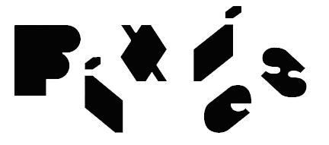

PIXIES CONFIRMED AS MUSICAL GUESTS
• TUESDAY, MAY 2, 2023 •

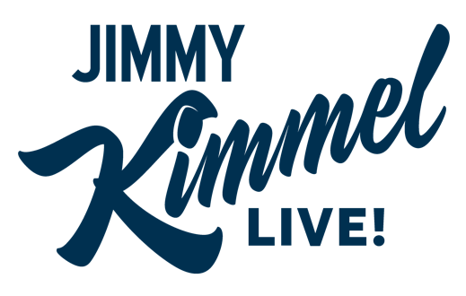

LOS ANGELES, CA — FRIDAY, April 28, 2023 — Next Tuesday, May 2, the iconic Pixies will be the featured musical guests on ABC-TV’s "Jimmy Kimmel Live!" airing at 11:35 PM ET on ABC. The band - Black Francis/vocals, rhythm guitar, Joey Santiago, guitar, Dave Lovering, drums, and bassist Paz Lenchantin - will perform the song “Get Simulated,” Paz and Joey’s favorite track from the band’s latest album, Doggerel, released September 30, 2022 (BMG).

The “Kimmel" performance immediately precedes the final legs of the band’s World Tour in support of Doggerel, which began last Summer. The 40-plus-date headline tour covers three legs across the USA, Canada, and Mexico, starting in California on May 4 and ending in mid-September in the same state. Dates are below, and tickets can be purchased HERE.

LEG ONE:
MAY 2023
4 Fox Theater, Oakland, CA* (sold out)
5 BeachLife Festival, Redondo Beach, CA (Festival)
6 Golden State Theatre, Monterey, CA* (sold out)
8 The Van Buren, Phoenix, AZ* (sold out)
9 Lensic Performing Arts Center, Santa Fe, NM* (sold out)
10 The Mission Ballroom, Denver, CO (sold out)
12 Encore Theatre at Wynn, Las Vegas, NV*
13 Encore Theatre at Wynn, Las Vegas, NV*
14 Kilby Block Party, Utah State Park, Salt Lake City, UT (Festival)
18 Teatro Metopólitan, Mexico City, Mexico (sold out)
21 Corona Capital Festival 2023, Guadalajara, Mexico (Festival)

* Slow Pulp supporting
@ Pond supporting

LEG TWO (all dates with Franz Ferdinand and Bully):
JUNE 2023
6 The Atlantis, Washington, D.C. (sold out)
8 MGM Music Hall at Fenway, Boston, MA (sold out)
9 The Met, Philadelphia, PA (sold out)
10 The Anthem, Washington, D.C. (sold out)
12 Kemba Live!, Columbus, OH
13 Stage AE, Pittsburgh, PA
14 Andrew J. Brady Music Center, Cincinnati, OH
16 Red Hat Amphitheater, Raleigh, NC (sold out)
17 Rabbit Rabbit, Asheville, NC (sold out)
18 Bonnaroo, Manchester, TN (Festival)
20 Coca-Coca Roxy, Atlanta, GA
21 The Fillmore, New Orleans, LA
23 Bayou Music Center, Houston, TX
24 Southside Ballroom, Dallas, TX
25 Moody Amphitheatre, Austin, TX (sold out)

LEG THREE: (all dates, co-headline with Modest Mouse, special guest Cat Power):
AUGUST 2023
20 Stone Pony Summerstage, Asbury Park, NJ (sold out)
21 The Rooftop at Pier 17 - New York, NY (sold out)
22 The Rooftop at Pier 17 - New York, NY (sold out)
24 Hartford HealthCare Amphitheatre, Bridgeport, CT
25 Brewery Ommegang, Cooperstown, NY
26 MASS MoCA, North Adams, MA (sold out)
28 Artpark Amphitheater, Lewiston, NY
29 TCU Amphitheatre at White River State Park, Indianapolis, IN
30 Salt Shed - Outdoors, Chicago, Il (sold out)
31 Salt Shed - Outdoors, Chicago, Il (sold out)

SEPTEMBER 2023
2 Gerald R. Ford Amphitheatre, Vail, CO
4 Outlaw Field at the Idaho Botanical Garden, Boise, ID (sold out)
6 Pavilion at Riverfront, Spokane, WA
7 Kettlehouse Amphitheatre, Bonner, MT (sold out)
8 Climate Pledge Arena, Seattle, WA
9 Doug Mitchell Thunderbird Sports Centre, Vancouver, BC
12 McMenamins Edgefield, Troutdale, OR
13 McMenamins Edgefield, Troutdale, OR
15 Oxbow RiverStage, Napa, CA
16 Gallagher Square, San Diego, CA

North American Media Contacts:
Nat’l Media: Heidi Ellen Robinson-Fitzgerald • heidirobinsonfitz@icloud.com • 818-705-1267
Tour/Local Media: Selena Fragassi • selena@fr-pr.net • (847) 942-3093

