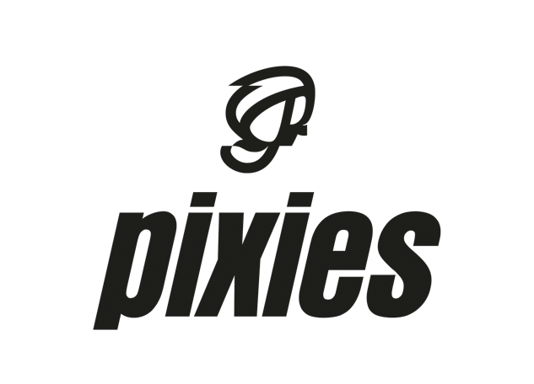

FOR IMMEDIATE RELEASE

PIXIES TO RELEASE BENEATH THE EYRIE DEMOS
ON ALL DIGITAL PLATFORMS

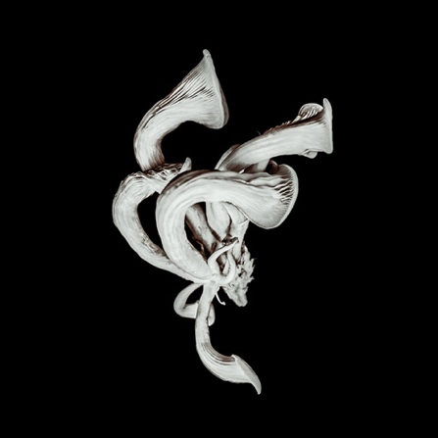

LOS ANGELES, CA — MONDAY, January 20, 2020 —Today, Pixies release Beneath The Eyrie Demos: Pt. 1, three tracks recorded over the course of 2018 leading up to the band’s December 2018 Beneath The Eyrie album sessions at Dreamland Recordings in Woodstock, NY. Written by Charles Thompson, the three songs, “The Good Works of Cyrus (Demo),” “Please Don’t Go (Demo),” and “Chapel Hill (Demo),” are now available for the first time on all streaming and download services, and can be accessed HERE.

Beneath The Eyrie, produced by GRAMMY-nominated Tom Dalgety (Ghost, Royal Blood, Pixies’ Head Carrier), was released on September 13, 2019 (BMG/Infectious) and has received some of the best reviews of the band’s post-reunion career. Under the Radar wrote that Beneath The Eyrie “can be legitimately a consideration of their best work, taking off from where Trompe le Monde left off,” while the UK’s Arts Desk said, ‘With Beneath The Eyrie, it’s time to consider Pixies on the same terms as some of their heroes and influences, like Lou Reed, Leonard Cohen, and Neil Young.”

Pixies - Black Francis/guitar, vocals, Joey Santiago/guitar, David Lovering/drums, and Paz Lenchancin/bass - launch the third leg of the band’s 2019-2020 global tour on February 24 with a 15-date tour of Japan, China, New Zealand and Australia. A massive tour of Europe and Eastern Europe will follow this summer. Go HERE for all dates and ticketing info.

*****

About the Pixies
Pixies have been acclaimed as the most influential, pioneering band of the late 80s alt/rock movement, having blazed the trail for artists from Nirvana to Radiohead to Pearl Jam. Today, a whole new generation of music fans is discovering the band's iconic “loudquietloud” signature sound. After five genre-defining studio albums -- including the now-Platinum-certified Doolittle — Pixies disbanded in 1993, and then launched their reunion tour in April 2004, playing to sell-out crowds across the globe for 15 years, a far longer period of time than they were a band originally. But writing, recording and releasing new music was something that the band had been wanting to do for a long time, so they secretly booked studio time in Wales for the fall of 2012. Six days into the recording, founding bassist Kim Deal decided to leave the band; Black Francis, Joey Santiago and David Lovering made the decision to carry on, finishing and releasing the band’s first studio album in more than two decades, 2014’s Indie Cindy. Also wanting to play live, the three began working with a number of touring bassists, including former A Perfect Circle bassist, Paz Lenchantin, who came out on the road with the band in 2014. The group welcomed her Pixies' permanent bassist in 2016.

With Lenchantin in the permanent line-up, Pixies recorded its second post-reunion studio album in 2016, Head Carrier, produced by Tom Dalgety (Ghost, Royal Blood), about which the UK’s DIY wrote, “They’re back. They’re still brilliant. God save the Pixies.” December 2018 saw the band holed up at Dreamland Studios near Woodstock, NY, again with producer Dalgety, where they recorded their second album as a unit. Beneath the Eyrie was released on September 13, 2019 to a slew of great reviews: “…a full-on band effort…sounds most like a classic Pixies album.” (Goldmine) “Beneath The Eyrie turns the Pixies’ legacy into stadium-ready tunes…” (Under the Radar) “…the most vibrant and alive of the three albums the Pixies have recorded since emerging in 2004.” (Paste Magazine)

# # #

