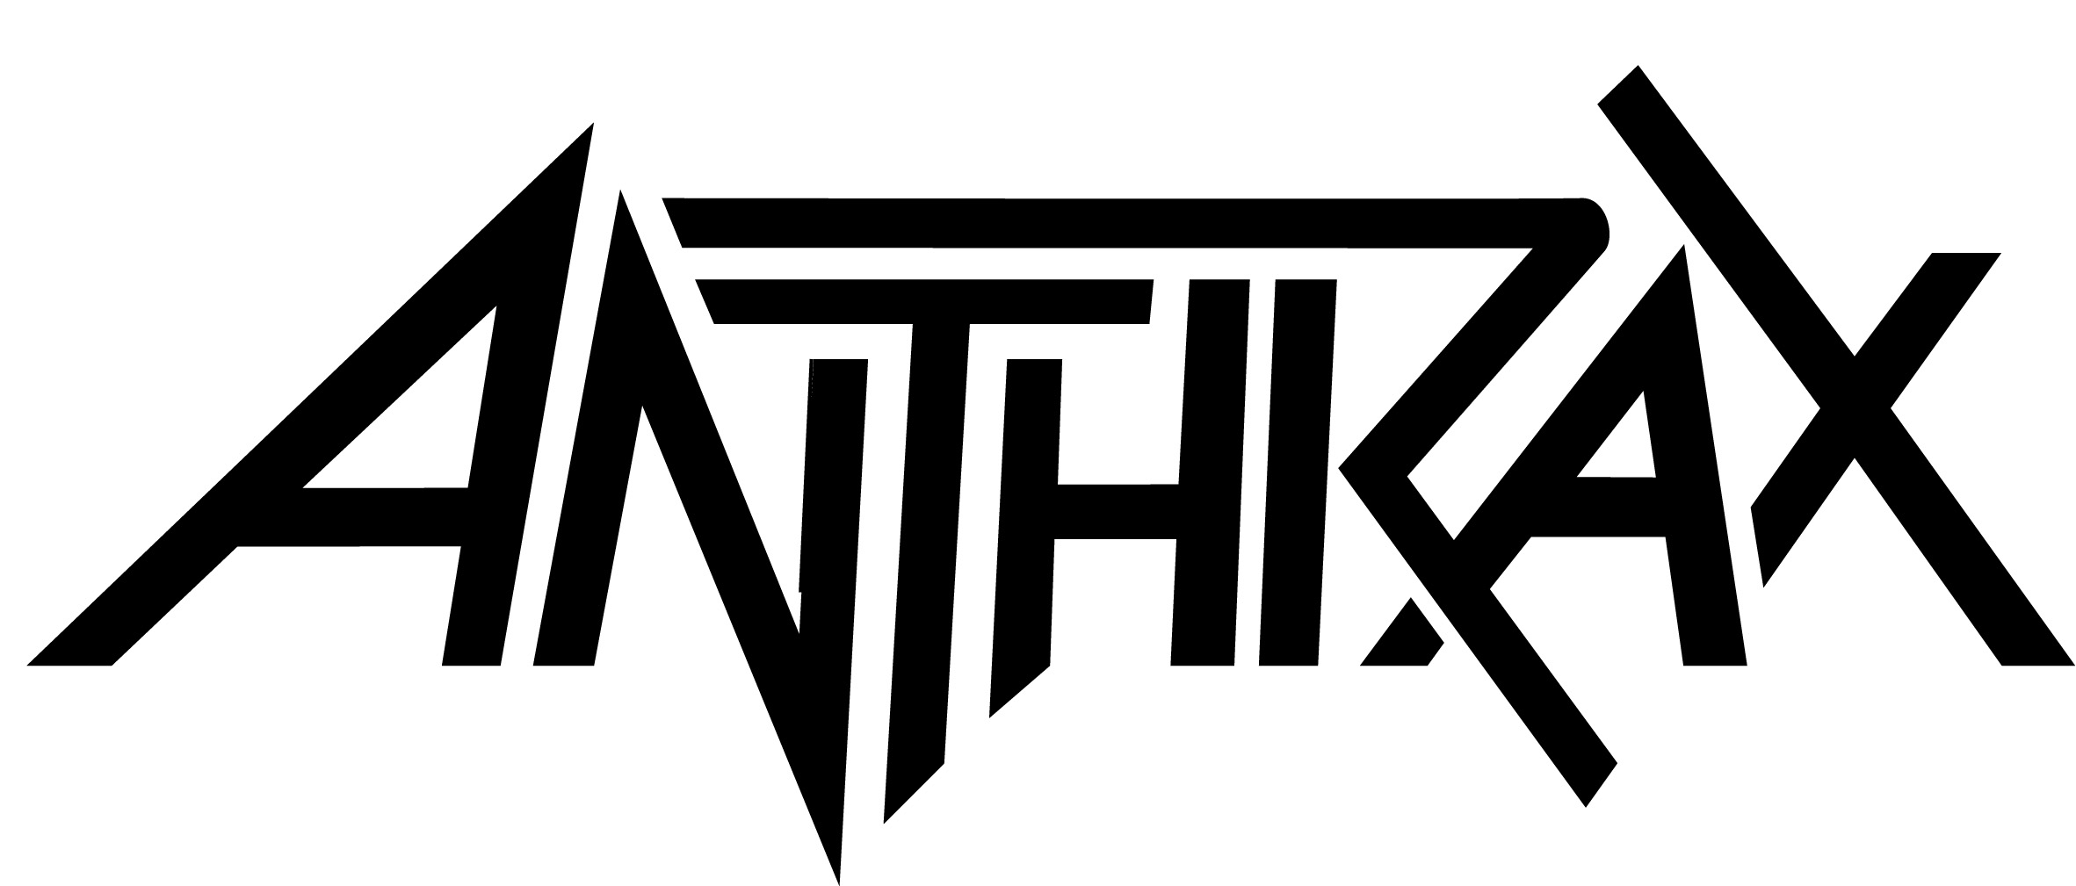

Credits for
For All Kings

Album title: For All Kings
Release date: February 26, 2015
Label: Megaforce Records

Anthrax is:
Joey Belladonna – vocals
Frank Bello - bass
Charlie Benante – drums
Jonathan Donais – lead guitar
Scott Ian – rhythm guitar

All songs written by Anthrax

Produced by Jay Ruston and Anthrax
Mixed by Jay Rustin at TRS West, Sherman Oaks, CA
Mastered by Paul Logus for PLX Mastering, NYC

Drums recorded at:
Serenity West Recording, Hollywood, CA
Engineers: James Ingram, Josh Newell, Michael Peterson

Guitars recorded at:
Steakhouse Studios, Burbank, CA
Assistant Engineer: Ken Eisennagel
Additional guitars recorded at Serenity West Recording

Bass guitar and lead guitars recorded at:
Downtown Music Studios, NYC
Assistant engineers: Molly Martin, Alex Elsammak

Additional bass guitar overdubs:
Swing House Studios, Los Angeles, CA
Assistant Engineer: Tony Perry

Album cover art: Alex Ross
Additional art: Stephen Thompson, Deviant Art
Album design: Charlie Benante
Band photos: Jimmy Hubbard

