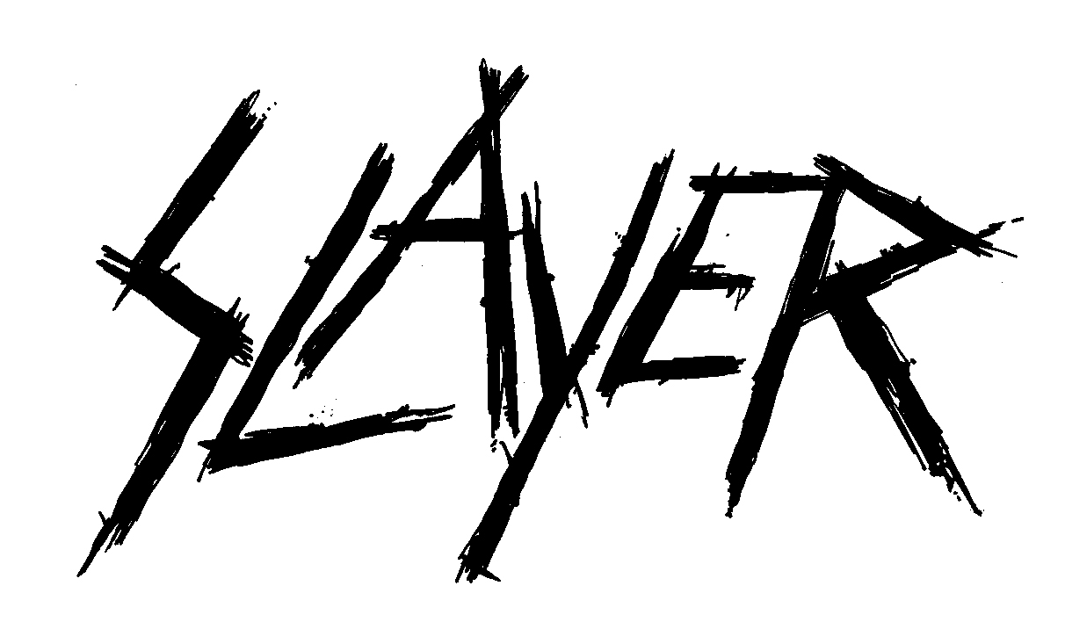

FOR IMMEDIATE RELEASE

WITH AN UNPRECEDENTED DEMAND FOR TICKETS,
SLAYER ANNOUNCES A SECOND NORTH AMERICAN LEG
FOR ITS FINAL WORLD TOUR

LOS ANGELES, CA - MONDAY, (March 5, 2018) -- Literally by popular demand - with more than half the tour’s Leg One dates already either completely sold out or a sell-out imminent - today Slayer announces Leg Two, North America, of its final world tour, set to kick off on Thursday, July 26 at the Bank of New Hampshire Pavilion in Gilford, NH. The tour will travel to 20 cities over about five weeks, culminating at San Jose’s SAP Center on August 26. Lamb of God, Anthrax, Testament and Napalm Death will accompany the band on all dates. The general ticket on sale for most dates begins this Friday, March 9 at 10AM (local). Very limited Slayer onstage + Meet & Greet + exclusive merchandise packages will be available. Log on to www.slayer.net for all ticket and package purchasing information.

A second North American leg for this tour had been considered to take place at some point down the line, but within 48-hours of the initial January 26 ticket on sale date, that all changed.

“We were blown away by the speed of sales for the final run,” said Rick Franks, President of Touring for Live Nation, one of the tour’s promoters. "Thirty-six years later and Slayer is bigger than ever before.”

On January 22, 2018, Slayer announced that it would do one last concert tour around the globe to thank their fans for all of their support over the years, for making the last three-and-a-half decades so packed with good times and unforgettable experiences, and then move on.
New and previously announced dates for Slayer’s final world tour, North America Legs One and Two, are as follows:

LEG ONE
MAY
10 Valley View Casino Center, San Diego, CA
11 FivePoint Amphitheatre, Irvine, CA SOLD OUT
13 Papa Murphy's Park at Cal Expo, Sacramento, CA
16 Pacific Coliseum Vancouver, BC
17 South Okanagan Events Centre, Penticton, BC
19 Big Four, Calgary, AL SOLD OUT
20 Shaw Conference Centre, Edmonton, AB SOLD OUT
22 Bell MTS Place, Winnipeg, MB
24 The Armory, Minneapolis, MN SOLD OUT
25 Hollywood Casino Amphitheatre, Tinley Park, IL
27 Michigan Lottery Amphitheatre at Freedom Hill, Detroit, MI SOLD OUT
29 Budweiser Stage, Toronto, ON SOLD OUT
30 Place Bell, Montreal, PQ SOLD OUT

JUNE
1 Mohegan Sun Arena, Uncasville, CT SOLD OUT
2 PNC Bank Arts Center, Holmdel, NJ
4 Santander Arena, Reading, PA SOLD OUT
6 Riverbend Music Center, Cincinnati, OH
7 Blossom Music Center, Cleveland, OH
9 KeyBank Pavilion, Pittsburgh, PA
10 Jiffy Lube Live, Bristow, VA
12 Veteran’s United Home Loans Amphitheater, Virginia Beach, VA
14 PNC Music Pavilion, Charlotte, NC
15 Orlando Amphitheater, Orlando, FL
17 Smart Financial Centre at Sugar Land, Houston, TX SOLD OUT
19 The Bomb Factory, Dallas, TX SOLD OUT
20 Austin360 Amphitheater, Austin, TX SOLD OUT

LEG TWO
JULY
26 Bank of New Hampshire Pavilion, Gilford, NH
27 Impact Music Festival, Darling’s Waterfront Pavilion, Bangor, ME
29 Northwell Health at Jones Beach, Wantagh, NY
31 The Pavilion at Montage Mountain, Scranton, PA

AUGUST
1 Times Union Center, Albany, NY
3 Darien Lake Performing Arts Center, Darien Lake, NY
4 Lakeview Amphitheater, Syracuse, NY
6 Budweiser Gardens, London, ON
7 Van Andel Arena, Grand Rapids, MI
9 Hollywood Casino Amphitheatre, St. Louis, MO
10 Cellairis Amphitheatre at Lakewood, Atlanta, GA
12 Municipal Auditorium, Nashville, TN
13 Walmart AMP, Rogers, AR
15 Freeman Coliseum, San Antonio, TX
16 The Zoo Amphitheatre, Oklahoma City, OK
18 Fiddler’s Green Amphitheatre, Denver, CO
19 USANA Amphitheatre, Salt Lake City, UT
21 Ford Idaho Center Amphitheater, Boise, ID
23 Sunlight Supply Amphitheater, Portland, OR
26 SAP Center, San Jose, CA

SLAYER Press Assets Site (bio, photos, more info);
https://www.herfitzpr.net/slayer-home-2018

SLAYER Media Contacts:
National Media • Heidi Ellen Robinson Fitzgerald • herfitz@mac.com • 818-705-1267
Tour Media • Julie Arkenstone • julieark@me.com • 747-900-6212

SLAYER’s Final World Tour Press Assets • North American Leg 2 (info on support bands, admat, more)
https://www.herfitzpr.net/slayer-2018-leg2-press-assets

