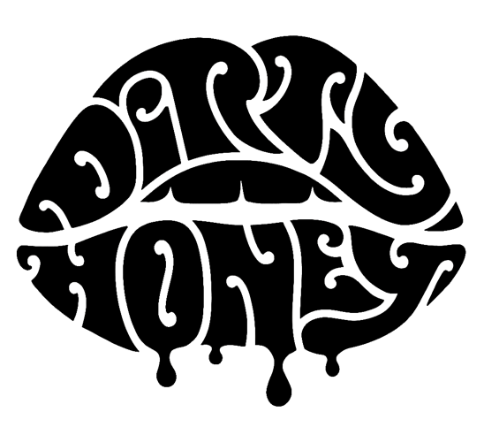

FOR IMMEDIATE RELEASE

From the Basement Tavern to The Fabulous Forum...
DIRTY HONEY SELECTED AS
MAIN SUPPORT ON THE BLACK CROWES'
"SHAKE YOUR MONEY MAKER 2021 SUMMER TOUR"

LOS ANGELES, CA - (Monday, May 17, 2021) — Dirty Honey, one of today's most exciting and fastest-rising rock bands, who has been generating the kind of buzz seldom experienced by other new rockers, will be main support on The Black Crowes’ “Shake Your Money Maker 2021 Tour” this summer. The band will bring its sexy, bluesy, new-fashioned rock’n’roll to The Crowes’ U.S. trek that kicks off July 20 in Nashville, TN, and will include a Dirty Honey hometown stop at The Forum in Los Angeles - a long way from the days when the band played the Basement Tavern in Santa Monica, CA. All dates are listed below; tickets are on sale now and can be purchased HERE.

Sharing the stage with The Black Crowes is something Dirty Honey front-man Marc LaBelle has dreamt about his entire life. "The Black Crowes are one of my all-time favorite bands, period," said LaBelle. "I grew up listening to them in my stepbrother's car, so to now be opening the show on their 'Shake Your Money Maker Tour,’ truly is a dream come true.”

Since “When I’m Gone,” Dirty Honey’s 2019 debut single that became the first song by an unsigned artist to land at #1 on Billboard’s Mainstream Rock chart, the band has injected a potent shot of adrenaline into the rock music scene. They’ve opened for The Who, Guns N’ Roses, and Slash, sold out their first-ever headline tour, was named an “Artist You Need To Know” by Rolling Stone, saw all three of their singles go Top 10 on the rock charts, and earlier this year, the band’s debut full-length, self-titled album entered the Current Hard Rock Chart at #2.

“We’re all so excited to play shows again, share some music with the world, see some fans, and find out how well we can play our new music,” added LaBelle. “And that we’re going on tour with The Black Crowes is just beyond amazing... we really can’t wait.”

Before joining The Black Crowes, Dirty Honey – LaBelle, John Notto/guitars, Justin Smolian/bass, and Corey Coverstone/drums – will headline a three-week club tour. All dates are below.

DIRTY HONEY HEADLINE CLUB DATES:
June
3 The Marquee, Tempe, AZ*
5 Jake's Backroom, Lubbock, TX*
6 Hoot's Pub, Amarillo, TX*
8 The Rock Box, San Antonio, TX*
9 Brewster Street Ice House, Corpus Christi, TX*
11 Club LA, Destin, FL*
12 Soul Kitchen Music Hall, Mobile, FL*
14 Shagnasty's, Huntsville, AL*
15 Capone's, Johnson City, TN*
17 The Signal, Chattanooga, TN*
19 Diamond Ballroom, Oklahoma City, OK*
20 The Cotillion, Wichita, KS*
22 Bourbon Theatre, Lincoln, NE*
24 Piere's, Fort Wayne, IN*
26 Ford Park Live, Oshkosh, WI
27 Now Arena, Hoffman Estates, IL
* Dirty Honey Headline dates, Joyous Wolf will special guest

THE BLACK CROWES’ “SHAKE YOUR MONEY MAKER 2021 TOUR”:
July
20 Ascend Amphitheatre, Nashville, TN
21 Ascend Amphitheatre, Nashville, TN
24 Bank of New Hampshire Pavilion, Gilford, NH
25 The XFINITY Theatre, Hartford, CT
28 S&T Bank Music Park, Pittsburgh, PA
29 DTE Energy Music Theatre, Detroit, MI
31 Hollywood Casino Amphitheatre., St. Louis, MO

August
1 Ruoff Home Mortgage Music Center, Indianapolis, IN
3 Riverbend Music Center, Cincinnati, OH
7 Hollywood Casino Amphitheatre, Chicago, IL
8 American Family Insurance Amphitheatre, Milwaukee, WI
10 Walmart Amp., Rogers, AR
11 Dos Equis Pavilion, Dallas, TX
14 Cynthia Mitchell Woods Pavilion, Houston, TX
15 Germania Amphitheatre, Austin, TX
18 North Island Credit Union Amphitheatre, San Diego, CA
19 The Forum, Los Angeles, CA
21 Concord Pavilion, Concord, CA
22 Shoreline Amphitheatre, Mountain View, CA
25 Sunlight Supply Amphitheatre, Portland, OR
26 White River Amphitheatre, Seattle, WA
29 Red Rocks Amphitheatre, Denver, CO
30 Red Rocks Amphitheatre, Denver, CO

September
4 Cellairis Amphitheatre at Lakewood, Atlanta, GA
5 Oak Mountain Amphitheatre, Birmingham, AL
7 Coral Sky Amphitheatre, West Palm Beach, FL
8 MIDFLORIDA Credit Union Amphitheatre., Tampa, FL
10 PNC Music Pavilion, Charlotte, NC
11 Coastal Credit Union Music Park @ Walnut Creek, Raleigh, NC
14 Saratoga Performing Arts Center, Saratoga Springs, NY
15 Xfinity Center, Boston, MA
17 Jones Beach Theatre, Wantagh, NY
18 PNC Bank Arts Center, Holmdel, NJ
22 Jiffy Lube Live, Washington, DC
23 BB&T Pavilion, Philadelphia, PA

DIRTY HONEY DATES:
September
25 WMMR MMR*B*Q, BB&T Pavilion, Camden, NJ

October
2 98Rockfest, Amalie Arena, Tampa, FL
7 Tulsa State Fair, Tulsa, OK
8 WPLA Radio Show, St. Augustine Amphitheatre., St. Augustine, FL
9 WJRR Earthday Birthday, Tinker Field, Orlando, FL

* * *

Dirty Honey Media Contacts:
National Media::
Heidi Ellen Robinson-Fitzgerald
HERFitzgerald@outlook.com
818-705-1267

Tour Media:
Selena Fragassi
selena@fr-pr.net
(847) 942-3093

