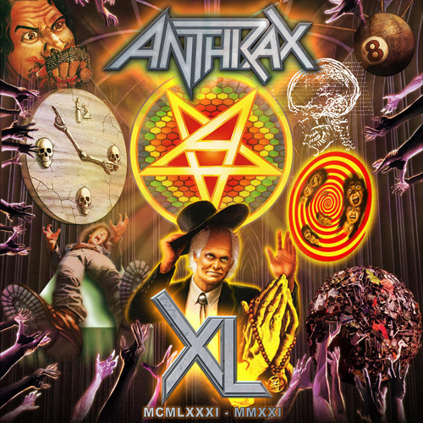

FOR IMMEDIATE RELEASE

ANTHRAX TO RELEASE 40TH ANNIVERSARY
LIVESTREAM CONCERT ON BLU-RAY / CD / DIGITAL
Watch The “Aftershock” Video Clip HERE

LOS ANGELES, CA - Wednesday, June 1, 2022 — July 18, 2021 marked the 40th anniversary of thrash metal pioneers ANTHRAX. The celebration began in May of last year and culminated on July 16/17 with a global Livestream event shot at the Los Angeles soundstage/studio The Den. For two-plus hours, Anthrax performed an extensive set of hits and deep cuts pulled from their vast catalog. Today, Anthrax announces that the entire performance, plus never-before-seen rehearsal footage and Scott Ian’s New York City “walking tour,” pointing out the spots that played a role in Anthrax’s formation and history, will be released in North America on July 15 on Blu-Ray / CD / Digital (Megaforce). Anthrax XL will also have a European digital release on July 15 (Nuclear Blast), followed by a Blu-Ray release later this year. Pre-orders for Anthrax XL can be placed HERE
Also today, Anthrax serves up a taste of the Anthrax XL celebration LiveStream with “Aftershock,” the Blu-Ray and CD's first single/video, that can be streamed HERE and viewed HERE.
“Forty years doesn’t feel like 40 years,” said drummer Charlie Benante. “Sometimes, I have to remind myself about how long this strange trip has been. I enjoy playing these songs, they’re such a huge part of my life, and I know for a lot of our fans, they play a big part in theirs as well.”

From the night of the Livestream, bassist Frank Bello recalled, “For me, each song was like reading through a scrapbook of my life and the band’s career. Specifically, ‘Madhouse,’ one of my first recordings with the band, and then to where we are now with 'Blood Eagle Wings.' What a great ride it’s been, I’m very grateful.”

"Even though we were performing in a studio with just the crew there, we played that set like we were in front of 50,000 screaming fans,” said vocalist Joey Belladonna. "I felt like we made a full-on connection with everyone watching from their homes or wherever, and that they connected with us. It was quite an intense experience.”

Currently, Anthrax is about six months into its 41st year, and the band - Belladonna, Ian, Bello, Benante, and guitarist Jon Donais - doesn’t quite have their 40th-anniversary in the rear-view mirror. Said Ian, “We had planned to do a big, 40th-anniversary world tour last year, but because of COVID, we couldn’t. So we’re doing our 40th-anniversary this year, our 41st. We’re starting in America in July, going out with Black Label Society and Hatebreed, and then we headline a UK and European tour this fall. We’re all really looking forward to being out on the road, playing shows and some deep cuts to celebrate our 40th with our fans.”

The track listing for Anthrax’s Anthrax XL Blu-Ray / CD / Digital is as follows:
Time/Fight Em ’Til You Can’t
Madhouse
Caught In A Mosh
Metal Thrashing Mad
Got The Time
I Am The Law
Keep It In The Family
Lone Justice
The Devil You Know
Be All End All
Now It’s Dark
Antisocial
In The End
Medusa
Evil Twin
Indians
Skeletons In The Closet
Blood Eagle Wings
Bring The Noise
A.I.R.
Among The Living

Credits:
Anthrax: Scott Ian/guitars, Charlie Benante/drums, Frank Bello/bass, Joey Belladonna/vocals, Jon Donais/guitars

Produced by Jack Bennett, Mike Monterulo, Anthrax
Directed by Jack Bennett
Mixed by Jay Ruston
Running time: 2h 5m 34s

••••••••••

ABOUT ANTHRAX:
July 18, 2021 marked Anthrax's 40th anniversary, during which time the band released 11 studio albums, was awarded multiple Gold and Platinum certifications, received six GRAMMY nominations, and a host of other accolades from the media, the music industry, and fans. In 1991, the band helped break down race and genre barriers when they collaborated with Public Enemy on the track "Bring The Noise" and was the first metal band to have its music heard on Mars when NASA played "Got The Time" to wake up the Mars Rover in 2012. Along with Metallica, Slayer, and Megadeth, Anthrax is a card-carrying member of The Big Four, the four bands that defined the speed/thrash/metal genre. Anthrax has also introduced a series of now sold-out signature whiskeys and bourbons and partnered with the Stockholm-based NEZUMI Studios for a high-end, limited-edition Baleine dive watch. Twenty-twenty-one also saw the release of Z2 Comics' "Among the Living" graphic novel with a track-by-track storyline inspired by Anthrax's iconic 1987 album, Among The Living. The book pulls together a "who's who" of names from the worlds of comics and music who created "bubble dialogue" and original artwork to express what the songs meant to them. Taking advantage of COVID-19's prohibition of concert touring, the band has been hard at work writing the next Anthrax album.

For Anthrax, 2022 is already off to a great start, but their 40th-anniversary isn't quite in the band's rear-view mirror. Unable to launch a planned 40th anniversary world tour due to COVID, the band will launch their 40th anniversary World Tour this year. The celebrations start July 26 in North America, co-headlining with Black Label Society, then a headline trek in the UK and Europe in the fall.

# # #

