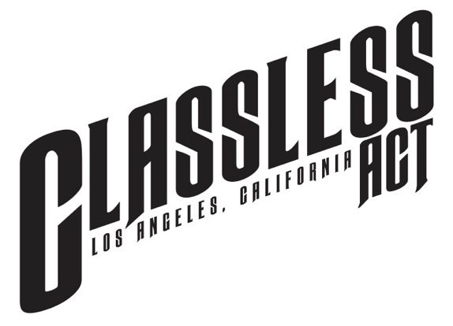

FOR IMMEDIATE RELEASE

CLASSLESS ACT
CLOSES OUT BREAKTHROUGH YEAR WITH
WELCOME TO THE ACOUSTIC SHOW EP, RELEASED TODAY
FEATURING ALL 5 STRIPPED-BACK TAKES
ON SONGS FROM BAND’S 2022 DEBUT ALBUM
PLUS IN-STUDIO MUSIC VIDEOS

FINAL SONG IN THE COLLECTION,
“STORM BEFORE THE CALM” ALSO RELEASED TODAY
SEE THE VIDEO HERE

CLASSLESS ACT IS CURRENTLY ON THE ROAD
FOR ‘THE MOST WONDERFUL TOUR OF THE YEAR’
SUPPORTING GIOVANNIE & THE HIRED GUNS
AS WELL AS HEADLINE DATES

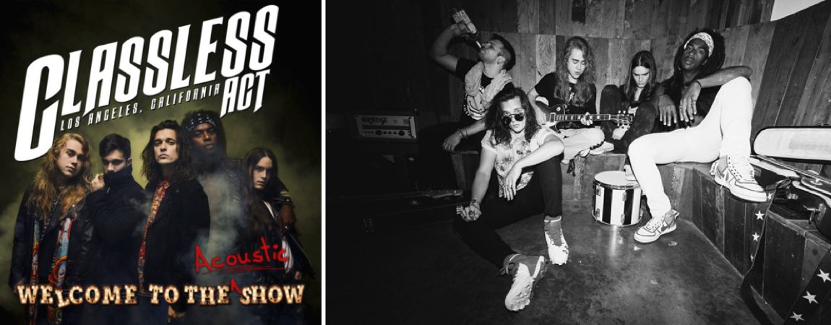
Classless Act band photo by Travis Shinn

LOS ANGELES, CA - Friday, December 16, 2022 - It’s been a big year for rock music’s most exciting debut of 2022, Classless Act, and the band has one final treat in store, today releasing the Welcome To The Acoustic Show EP alongside the full collection of in-studio music videos.

Featuring five tracks total, it gives listeners a different, unplugged take on the amped up, energetic anthems that make up the band’s acclaimed album, Welcome To The Show that was released June 24 via Better Noise Music and already racked up more than 2.8 million streams.

Since October 21, Classless Act has released a new acoustic track every two weeks culminating in today’s final addition to the series, “Storm Before The Calm.”

Hear the acoustic version of “Storm Before The Calm” HERE

See the acoustic video HERE

Read more about Classless Act and the “Storm Before The Calm” Video at Forbes HERE

Previous acoustic singles released included “Classless Act,” “This Is For You,” “Time To Bleed” and “All That We Are.” As of today, all five tracks are now collected in the Welcome To The Acoustic Show EP, available on all DSPs, alongside in-studio music videos available on YouTube.

Recorded live at Sunset Sound, with no overdubs, the new takes hone in on the talent of frontman Derek Day and the musicianship of the talented-beyond-their-young-years ensemble that includes Dane Pieper (guitar), Griffin Tucker (guitar), Franco Gravante (bass), and Chuck McKissock (drums). Gravante personally mixed the acoustic tracks himself.

Hear the entire Welcome To The Acoustic Show EP HERE

See all the in-studio videos HERE

Classless Act is currently on the road for “The Most Wonderful Tour of the Year” with dates supporting Billboard chart toppers Giovannie & The Hired Guns as well as headlining concerts that will see the band wrapping up the year with two shows in their home state of California. Classless Act’s New Year’s Eve show will mark their 100th concert this year since they hit the road with Dorothy on the “Gifts From the Holy Ghost tour back, on March 22. Tickets are on sale now at https://classlessact.com/#tour.

Classless Act singer Derek Day also recently appeared at the Taylor Hawkins Tribute Concert at L.A.’s Kia Forum on Sept. 27 where Day joined Dave Grohl and members of the Foo Fighters as well as Motley Crue for a special two-song set. He was personally recommended for a spot on the all-star lineup by The Darkness’ Justin Hawkins who also appears on the Classless Act track, “This Is For You.”

Upon Welcome To The Show’s release on June 24, Classless Act immediately garnered critical acclaim with press hailing them as “the next big thing in music” (Next Mosh) and “very reminiscent of when rock reigned supreme” (Loudwire). The Rock Pit declared the songs on the album “break like Queen used to so well into flamboyant guitar [with] Supertramp meets Muse aplomb,” and New Noise also said it’s a record “that feels most easily summed up as ‘powerful’” from “a new-ish band who sound like the greatest hits of ‘70s and ‘80s rock eras, with a grace and vibe that’s more modern.”

CLASSLESS ACT TOUR
Dec 16 – Syracuse, NY @ Lost Horizon*
Dec 17 – Harrisburg, PA @ Stage on Herr*
Dec 18 – Richmond, VA @ The Broadberry*
Dec 20 – Indianapolis, IN @ The HiFi
Dec 21 – Lawrence, KS @ Lucia
Dec 22 – Colorado Springs, CO @ The Black Sheep
Dec 29 – Phoenix, AZ @ Valley Bar
Dec 30 – North Hollywood, CA @ Knitting Factory
Dec 31 – San Diego, CA @ Beaumonts

ABOUT CLASSLESS ACT:
It’s not often that a band comes around like Classless Act who have tempted a new generation of fans and given rock’s faithful a reason to keep believing. Influenced by Queen, Led Zeppelin, The Beatles and Bowie, the L.A.-based five-piece bring a fresh, young take on a golden age of music. They’ve been applauded by bands like Jane’s Addiction, given nods from execs with Live Nation and MTV, and are already finding their footing in major international markets barely a year after releasing their first single “Give It To Me” in 2021.

With the release of their anticipated debut Welcome To The Show via Better Noise Music on June 24, the band immediately racked up 2 million streams and got the attention of rock bibles like Loudwire, SPIN, Metal Hammer, and Blabbermouth, the latter who said Classless Act “stands ready to carve out a legacy of its own.”

While the music tells its own story, so do the members of the band themselves, hailing from all over the globe, including Hawaii, Los Angeles, Argentina, and Dallas. The band, featuring Derek Day (vocals), Dane Pieper (guitar), Griffin Tucker (guitar), Franco Gravante (bass), and Chuck McKissock (drums), first formed in 2018 when the five former strangers met through friends via social media. Their chemistry quickly came to light, the members fusing together anthemic rhythms, shreddy guitars, soaring vocals and clever arrangements that, as one writer astutely said, have "...enough energy to power a city."

With personal invites to appear on summer 2022’s highest grossing tour, The Stadium Tour, as well as the Taylor Hawkins tribute and Aftershock festival, Classless Act are giving the industry whiplash with the constant head turning and are poised to become a next-generation defining act.

CONNECT WITH CLASSLESS ACT
Facebook | Twitter | Instagram | YouTube | TikTok | Twitch

ABOUT BETTER NOISE MUSIC
BETTER NOISE MUSIC is the premiere independent music label under BETTER NOISE ENTERTAINMENT, a content creation and marketing company that produces music, books, films, documentaries, TV shows, theatrical productions, and tours. Better Noise Music (formerly Eleven Seven Music), founded in 2006 by music industry veteran and independent pioneer Allen Kovac, focuses on artist development and has grown into a music industry independent powerhouse, with a roster including Five Finger Death Punch, Asking Alexandria, Bad Wolves, Dirty Heads, Nothing More, The HU, AWOLNATION, All Good Things, From Ashes To New, Cory Marks, and Fire From The Gods. Partnering with FUGA, AMPED and Membran, the company operates a global marketing and distribution platform with offices in New York, Los Angeles, London, Berlin, Paris, Toronto and Sydney.

In 2021, Better Noise Music dominated Billboard’s Year End charts in the rock space, landing at #1 on the Mainstream Rock Imprint, Hard Rock Songs Imprint, Hard Rock Songs Label charts and ranked as one of the top Mainstream Rock Label for the year.

CONNECT WITH BETTER NOISE
Website | Facebook | YouTube | Spotify | Instagram | Twitter | TikTok

NORTH AMERICAN MEDIA CONTACTS:
Classless Act U.S. National Media | Heidi Ellen Robinson-Fitzgerald | HERFitzgerald@outlook.com
Classless Act U.S. Tour Media | Selena Fragassi | selena@fr-pr.net

# # #

