SHARE THE NEW SINGLE ‘VAULT OF HEAVEN’
LISTEN HERE / WATCH THE VIDEO HERE

FROM THE NEW ALBUM DOGGEREL WHICH FOLLOWS ON SEPTEMBER 30

“Pixies' new album 'Doggerel' is the most inventive since their reunion nearly two decades ago.” - NME

“Dark pop that still soars and thrills.” - The Guardian

“The masters of pre-grunge.” - Louder Than War

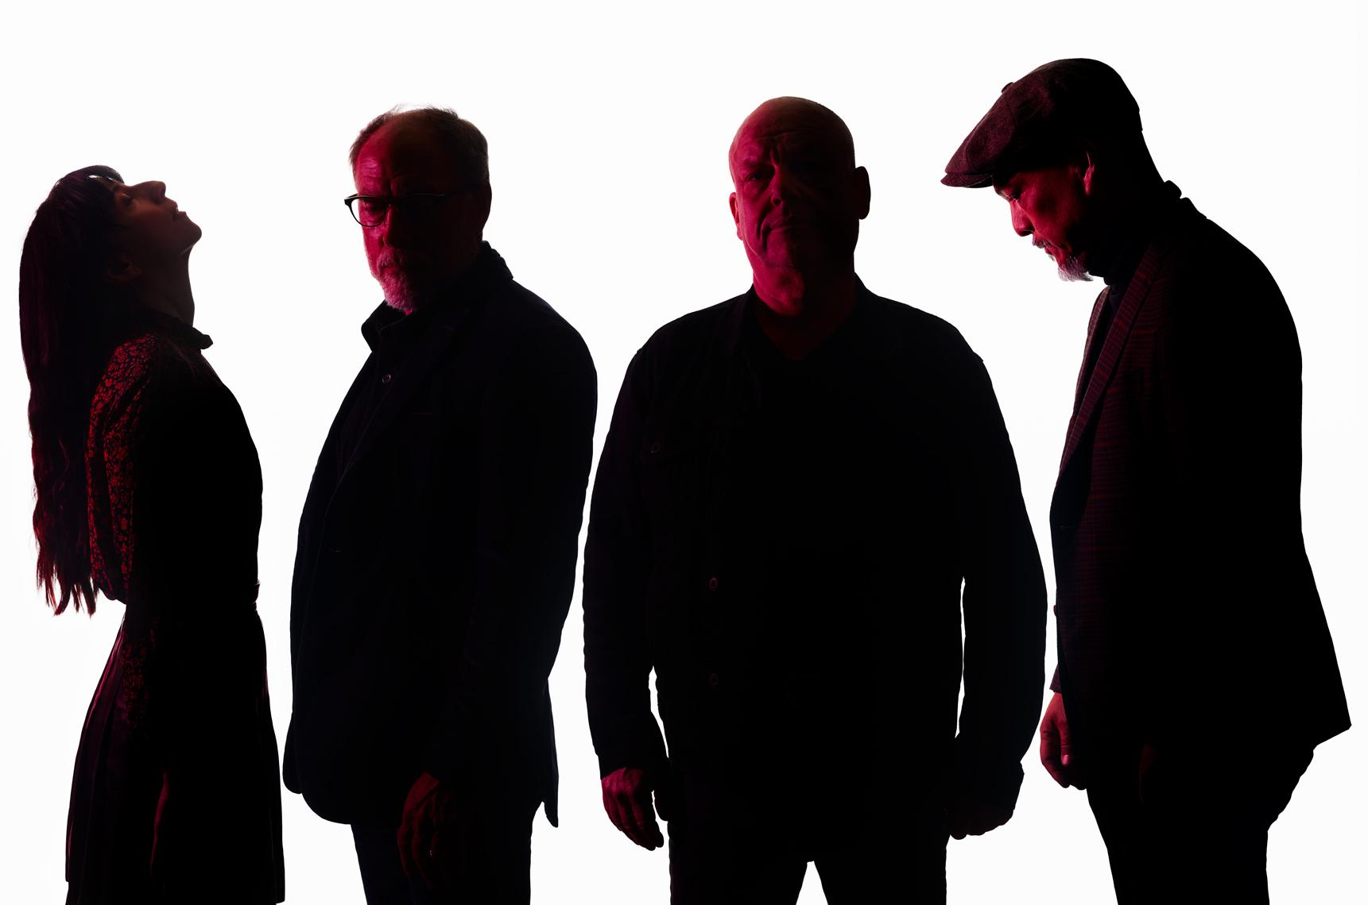
Download photo by Tom Oxley HERE

LOS ANGELES, CA -- Tuesday, August 9, 2022 -- The return of Pixies has been rapturously received, the alt-rock trailblazers reconnecting with long-term fans and introducing themselves to a fresh new audience. In recent weeks, they’ve headlined large outdoor venues across the UK, performed as special guests to Pearl Jam in Hyde Park, and played one of their most intimate shows in years at Manchester’s historic Band On The Wall venue. The shows come ahead of the September 30 release of the band's new album Doggerel, which was previewed by its lead single "There’s A Moon On," which was instantly A-listed at the UK's digital BBC Radio 6 Music.

Pixies’ momentum continues as today they share the follow-up single "Vault of Heaven." The track has just premiered in the UK on Steve Lamacq’s Radio 6 Music show and was given its live debut at the recent Band On The Wall show.

Mixing dusky, Morricone-style desert noir atmospherics with a chiming, melodic guitar motif, "Vault of Heaven" also takes a leftfield turn as flourishes of female backing vocals provides an almost hymnal touch. Black Francis’s lyrics combine elements that are both abstract and every day in a surrealist narrative, in which the protagonist aims for salvation but only ends up falling flat on his face.

"Vault of Heaven" is released alongside an official video that brings its absurdist tale to life. It begins with a semi-clothed Zorro-esque figure who is heading into Los Angeles on the back of a toy horse. He arrives at a 7-Eleven, where things get stranger still with the help of bizarre Elvis Presley and Marilyn Monroe lookalikes. The visual was directed by the filmmaker and musician Charles Derenne.

Said Derenne about the video, "When I first listened to the track, the idea that came to my mind was modern western rock sonorities. It would have been too obvious to shoot a western, so we decided to use the irony of the lyrics and create some sort of psychedelic, outsider story using American icons but showing them in a different way. Zorro leads the dance as the protagonist of the story."

As we’ve heard from both "Vault of Heaven" and "There’s A Moon On," Doggerel is a mature yet visceral record of gruesome folk, ballroom pop, and brutal rock. Its stories are haunted by the ghosts of affairs and indulgences, driven wild by cosmic forces and envisioning digital afterlives where no God has provided one. Pixies - completed by Joey Santiago (guitar), Paz Lanchantin (bass) and David Lovering (drums) - recorded the album with producer Tom Dalgety (Royal Blood, Ghost) in Vermont.

Doggerel is available to pre-order HERE. The band’s official store offers a range of limited-edition music and merch and as well as two exclusive Doggerel formats: an orange vinyl and a red cassette.

Pixies’ huge world tour rolls on through to the close of the year, taking in Europe, North America, South America, Japan, Australia and New Zealand. The final shows of their summer tour comes when they headline the End of the Road festival on September 3. Please see their website for a full list of all international dates.

This October, Pixies will take a short break from their international touring to kick off a special, four-date U.S. run of intimate-venue-concerts. As is the Pixies’ "standard,” the band will draw from their extensive catalogue to perform a different set every night, with each song determined just before its first note is played. Attendees can expect the band to perform not only some of the most beloved Pixies songs, but also, for the first time in America, new tracks from Doggerel. Dates are below, and tickets can be purchased HERE.

OCTOBER
1 SOMA, San Diego, CA
2 House of Blues, Anaheim, CA
3 The Wiltern, Los Angeles, CA
5 Terminal 5, New York, NY

Follow Pixies:
Website | Spotify | Apple Music | YouTube | Facebook | Instagram | Twitter | TikTok

For more information please contact herfitz@mac.com

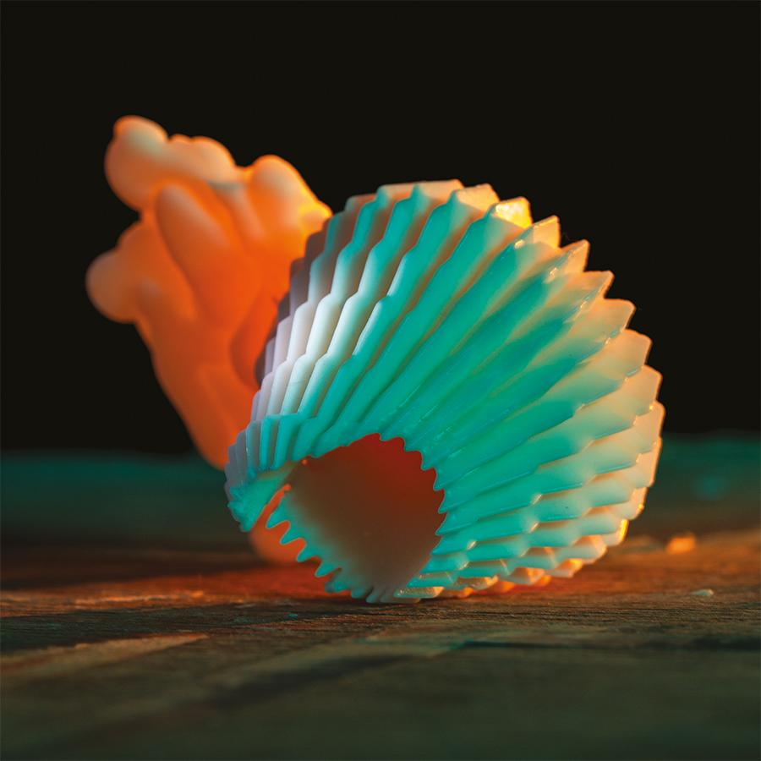
Download high-res artwork HERE

