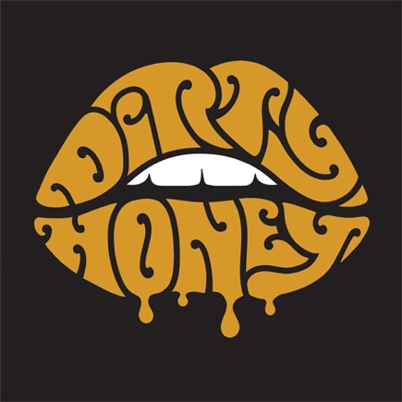

Dirty Honey • Self-Titled Debut EP
Lyrics

When I'm Gone
I’m down and out on my knees
Been working so hard to fill my needs
Now I’ve been bit by a hand that feeds
But I’m burning through cash like gasoline
I’m back to the grind…
All I wanted to say is I’ve been walking this line for too long
All I wanted to say, the time has come, you’re gonna miss me when I’m gone
I’ve got no shelter in the driving rain
Got no lady to ease my pain
I’ve got an empty bottle with an empty glass
Could somebody please just make this pass
I’m back to the grind…
All I wanted to say is I’ve been walking this line for too long
All I wanted to say, the time has come, don’t miss me when I’m gone…
All I wanted to say is I’ve been walking this line for too long
All I wanted to say, the time has come, don’t miss me when I’m gone…
Don’t miss me when I’m gone
Don’t miss me when I’m gone

Rolling 7’s
No need to socialize
No need to fantasy
I’ll shine on, like a star at first night and show you all you need
Now I know all my vices
And I know where you’ve been
Baby take another toss of the dice
I’m rolling sevens again
When you need a little lovin’
Baby all night long
When you need a little lovin’
Come and turn me on
When you need a little loving
All night long

Heartbreaker
Tell me that you need me in the dead of night dead of night
Only to deceive me and my worried mind, worried mind
But if you’d take my shackles off
I’d see you’re just a heartbreaker
A heartbreaker oh, what you do to me
You’re just a heartbreaker
A heartbreaker, what’d you do to me baby please
Everybody’s talking bout how you did me wrong
Every lie you told me is gonna come undone, come undone
But when I throw you to the curb like and old burnt cigarette you’ll see
You’re just a heartbreaker
A Heartbreaker oh, what you do to me
You’re just a heartbreaker
A heartbreaker, what’d you do to me
Take me out of my misery, baby please
You’ve got me burning up inside
Suffocating on all your lies
You’re just a heartbreaker
A heartbreaker oh, what you do to me
You’re just a heartbreaker
A heartbreaker
You’re just a heartbreaker
A heartbreaker oh, what you do to me
You’re just a heartbreaker
Been running round my mind and I’m wondering where you’ve been
Everybody’s talking’ bout how I’ll never see you again
Been running round my mind and I’m wondering where you’ve been
You’re just a heartbreaker
When you need a little lovin’
Oh yeah
Lit by the light of the moon
This love is more than it seems
We’ll stay warm by the heat of our own fire
I’ll be the jack and you’ll be the queen
Now I know all your vices
And you know where I’ve been
So baby take another toss of the dice
We’re rolling sevens again
When you need a little lovin’
Baby all night long
When you need a little lovin’
Come and turn me on
When you need a little loving
Sugar, all night long
When you need a little lovin’
When you need love, need love
So baby take another toss of the dice
We’re rolling sevens again
When you need a little lovin’
All night long
When you need a little lovin’
Baby turn me on
When you need a little loving
Said all night long
When you need a little lovin’
Baby turn me on right now

Down The Road
Lord I see you around town after we said goodbye
God knows I want you, but somehow I know I’ve gotta let you fly
I’ve been down for so long
I’m learning to stand on my own
I wanted to say, you’ll miss me one day
I’ll see you on down the road
I know you see me
If you’d just stay with me then I would hurt no more
But you’ve thrown away our memories,
How many times will you walk out the door
I’ve been down for so long
I’m learning to stand on my own
I wanted to say, you’ll miss me one day
I’ll see you on down the road
Lord knows I was satisfied with you by my side
Just hold me in your loving arms
And don’t shoot down my pride
I’ve been down for so long
I’m learning to stand on my own
I wanted to say, you’ll miss me one day
I’ll see you on down the road
Na Na Na Na, I’ll see you on down the road
Na Na Na Na, I’ll see you on down the road
Na Na Na Na, I’ll see you on down the road
Na Na Na Na, I’ll see you on down the road

Scars
The coldest rain can’t wash away
A past that’s full of my mistakes
But like a wall that’s fallen
You’ve left me crawling
With memories of revelries I can’t forsake
I aint a judge or a priest, but
Hey, I don’t mean no harm
I never thought this life was gonna be so hard
Hey, If I show my scars
Don’t be alarmed
Hey, I don’t mean no harm
I never thought this life was gonna be so hard
Hey, If I show my scars
Don’t be alarmed
Searching the corners of my mind
But this light ain’t bright enough to find
A way out of this cave
Locked in my own cage
No matter how I try, time passes by and still nothings changed
I never said I could help you when I can’t help myself
Hey, I don’t mean no harm
I never thought this life was gonna be so hard
Hey, If I show my scars
Don’t be alarmed
Hey, I don’t mean no harm
I never thought this life was gonna be so hard
Hey, If I show my scars
Don’t be alarmed

