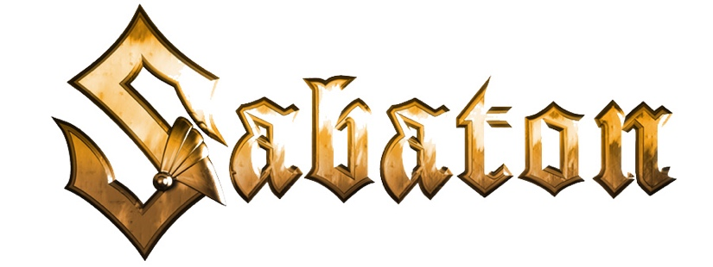
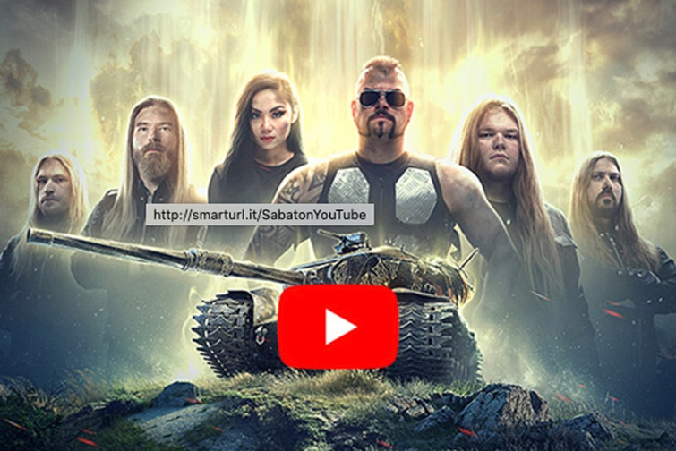

STEEL MEETS STEEL:
SABATON AND WORLD OF TANKS PRESENT
NEW MUSIC VIDEO, "STEEL COMMANDERS,"
AND LAUNCH IN-GAME EVENT
The Swedish battle metallers will headline the 'Spirit of War' event,
Which offers the first-ever Tier IX Premium tank

LOS ANGELES, CA -- Get ready to headbang with the latest collaboration between Swedish metallers SABATON and World of Tanks. The two facets of heavy metal are about to really put on a show. Kicking off in full force with the “Steel Commanders” music video that is an essential addition to every tanker’s battle music playlist, the band will also be staging a massive in-game event that will reward tankers with a little bit of history: the first-ever Tier IX Premium tank.

“It’s been a great experience working with the World of Tanks and Wargaming guys on this huge project,” said Joakim Brodén, lead vocalist of Sabaton. “Together, we made epic music for ’Steel Commanders,’ and it’s the perfect way to kick off our massive collaboration. We’re proud to be part of this brand new, in-game event that features the first-ever Tier IX Premium tank as the ultimate prize, as well as us as crew members.”

Watch the “Steel Commanders” music video here:
https://www.youtube.com/watch?v=peTCePu1jMs

The music video also features GRAMMY Award-nominated and BRIT Female Artist of the Year-nominated Tina Guo. Having established an international career as a virtuoso acoustic/electric cellist, multi-instrumentalist, composer, and entrepreneur, Tina Guo is known for her unique genre-crossing style, is one of the most recorded solo cellists of all time, and can be heard on hundreds of blockbuster film, television, and game soundtracks.

“Steel Commanders” will be available on all digital streaming platforms on September 17. You can pre-save the song here: https://spotify.sabaton.net

All pre-savers will be eligible to win prizes including Steel Commanders merchandise, as well as World of Tanks bonus codes with exclusive Sabaton in-game content.

Apart from the music video, Sabaton is headlining a new in-game event, "Spirit of War." The event will see tankers take on challenges to reap the maximum reward: the game’s first-ever Tier IX Premium tank, the Strv K. Eagle-eyed viewers will have noticed it in the “Steel Commanders” video, and it will be manned by a Sabaton crew that includes Brodén, who recorded a custom voiceover that is full of Easter eggs for fans to discover. Once tankers earn their Strv K, they will be tasked with getting the exclusive “Spirit of War” 3D style.

“We’re really enjoyed working with the Sabaton guys, and we’re happy to have them on board this project,” said Max Chuvalov, Publishing Director, World of Tanks. “Our players love their music, and we complement each other as we are both fascinated with military history. Plus, we hope the new tune will inspire tankers to go that extra mile for the victory.”

Even if players ultimately do not finish the marathon, they will earn plenty of goodies along the way, and each stage they clear will allow them a set 10% discount on purchasing the Strv K, and the same is true for the 3D style. The Strv K also features its own Sabaton soundtrack and will allow you to earn bonds in Random Battles, so it’s a vehicle no tanker will want to miss out on, if not for owning a piece of World of Tanks history. The "Spirit of War" event will run from August 27 through September 6.

For more information about the "Spirit of War" event, visit worldoftanks.com

Sabaton is set to hit the road on September 8 as Special Guest on the Judas Priest “50 Heavy Metal Years” North American tour. The itinerary is as follows:

SEPTEMBER
8 Santander Arena, Reading, PA
9 Blue Ridge Rock Festival, Danville, VA (Sabaton festival date)
11 Warlando Festival, Central FL Fairgrounds, Orlando, FL
13 PNC Music Pavilion, Charlotte, NC
14 Red Hat Amphitheater, Raleigh, NC
16 Van Andel Arena, Grand Rapids, MI
17 Covelli Center, Youngstown, OH
19 Fox Theatre, Detroit, MI
20 Rosemont Theatre, Chicago, IL
22 Miller High Life Theatre, Milwaukee, WI
23 The Armory, Minneapolis, MN
25 Saint Louis Music Park, St. Louis, MO
26 Louder Than Life Festival, Louisville, KY
29 The Mission Ballroom, Denver, CO
30 Maverik Center, West Valley City, UT

OCTOBER
2 Angel of the Winds Arena, Everett,WA
3 Moda Center, Portland, OR
5 Fox Theater, Oakland, CA
6 Microsoft Theater, Los Angeles, CA
8 Zappos Theater at Planet Hollywood, Las Vegas, NV
9 Arizona Federal Theatre, Phoenix, AZ
12 Freeman Coliseum, San Antonio, TX
13 HEB Center, Austin, TX
15 Pavilion at Toyota Music Factory, Dallas, TX
16 The Zoo Amphitheatre, Oklahoma City, OK
19 Cable Dahmer Arena, Independence, MO
21 Nashville Municipal Auditorium, Nashville, TN
22 Ameris Bank Amphitheatre, Alpharetta, GA
24 Charleston Civic Center Coliseum, Charleston, SC
25 The Met, Philadelphia, PA
27 Prudential Center, Newark, NJ
28 MGM Casino, Washington, DC
30 Foxwoods Casino Arena, Mashantucket, CT
31 Tsongas Center at UMass, Lowell, MA

NOVEMBER
2 Scotiabank Centre, Halifax, NS CANADA
4 Place Bell, Montreal, QC CANADA
5 FirstOntario Centre, Hamilton, ON CANADA

* * *

ABOUT WORLD OF TANKS:
World of Tanks is the first team-based, massively multiplayer online action game dedicated to armored warfare. Throw yourself into the epic tank battles of World War II with gamers all over the world. Your arsenal includes over 600 armored vehicles from 11 nations, carefully detailed with historical accuracy.
Official website: worldoftanks.com

ABOUT WARGAMING:
Wargaming is an award-winning online game developer and publisher headquartered n Nicosia, Cyprus. Operating since 1998, Wargaming has grown to become one of the leaders in the gaming industry with 5,500 employees and 18 offices spread all over the world. Over 200 million players enjoy Wargaming’s titles across all major gaming platforms. Our Flagship products include the free-to-play hits World of Tanks and World of Warships, as well as World of Tanks Blitz, the critically-acclaimed mobile tank shooter with cross-platform support.
Official website: wargaming.com

ABOUT SABATON:
In the more than two decades since their launch, Swedish metallers Sabaton have gained a legion of loyal fans across the globe by carving out a reputation as one of the hardest working bands in the business, an assessment shared by the UK's Guardian: "Other than veterans Iron Maiden, Sabaton is the biggest heavy metal band in Europe." Since the band's debut album in 2005, Sabaton has been combining standout stage design and production with epic concept albums, linking real-life historical war events with classic kick-ass metal. Sabaton has released nine studio albums, amassed six GOLD, one PLATINUM, and one four-times-PLATINUM awards, seen eight of its albums score Top 10 international chart status, and six claim the Top 5. The band has earned eight Metal Hammer/Golden Gods Awards nominations, taking home the award for "Breakthrough Artist" in 2011 and "Best Live Band" in three different years, and a Grammis nomination (Swedish equivalent to the U.S. Grammys) as Best Heavy Metal band. Sabaton has also accumulated more than two billion total streams, and 1.5 billion YouTube views. Over its 11 year touring history, Sabaton has headlined major festivals and sold-out arena concerts around the world.
(Continues HERE.)

