FOR IMMEDIATE RELEASE

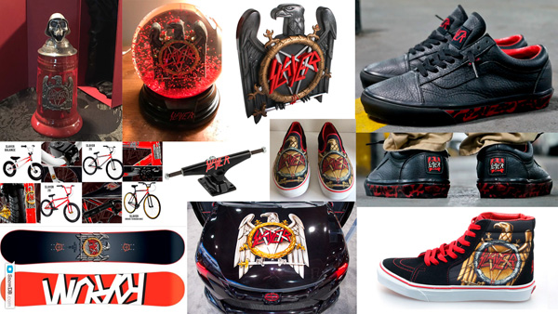

SLAYER RELEASES NEW ”SLAYER LOOKS BACK ON 37 YEARS” INTERVIEW VIDEO, "EPISODE 7, SLAYER SWAG"
Leg Five: North America of Slayer’s Final World Tour Kicks off May 2

LOS ANGELES, CA - Thursday, April 4, 2018 — Over Slayer’s career, the band has made available to its fans some pretty cool swag, from an ugly Christmas sweater to BMX's “Cradle to Grave" four-bike collection, a Slayer Snow Globe where blood-red particles fall, a series of Van’s footwear including one with blood-splatters, the Slayer Pinball Rocks app, the Rockhard Limited Edition biker helmet, and the one-of-a-kind vehicle inspired by Slayer and designed by Scion. In Episode 7, the band members talk about their favorites. Check it out HERE.

On May 2, Slayer will kick off Leg Five: North America for its Final World Tour, to say goodbye and thank the fans for more than three decades of great times. Lamb of God, Amon Amarth and Cannibal Corpse will support on all of these 16 dates. Leg Six will see Slayer saying farewell to its fans for the last time across Europe, from early June to early August. Ticket information for all dates is available at slayer.net

Dates for Leg Five: North America, and Leg Six: Europe, are as follows.

MAY
Leg Five: North America
(Lamb of God, Amon Amarth and Cannibal Corpse will support on all dates)
2 Ak-Chin Amphitheatre, Phoenix, AZ
3 Isleta Amphitheatre, Albuquerque, NM
5 UTEP/Don Haskins Center, El Paso, TX
7 Bert Ogden Arena, Edinburg, TX
8 The Pavilion at Toyota Music Factory, Dallas, TX
10 MidFlorida Credit Union Amphitheatre, Tampa, FL
11 Coral Sky Amphitheatre, West Palm Beach, Florida
13 Big Sandy Superstore Arena, Huntington, WV
14 Merriweather Post Pavilion, Columbia, MD
16 Ruoff Home Mortgage Music Center, Noblesville, IN
17 Providence Medical Center Amphitheatre, Bonner Springs, KS
19 DTE Energy Music Center, Clarkston, MI
20 Covelli Centre, Youngstown, OH
22 Canadian Tire Centre, Ottawa, ON CANADA
24 BB&T Pavilion, Camden, NJ
25 Xfinity Center, Mansfield, MA

JUNE
Leg Six: Europe
4 Arena Gilwice, Gilwice, Poland
6 Sweden Rock, Solvesborg, Sweden
8 Rock Am Ring, Nurburgring, Germany
9 Rock Im Park, Nurnberg, Germany
11 Sports Arena, Budapest, Hungary (headline date)*
13 Leipzig Arena, Leipzig, Germany (headline date)*
14 Nova Rock, Nickelsdorf, Austria
16 Download, Donington Park, UK
19 Arena, Geneva, Switzerland (headline date)*
21 Graspop Metal Meeting, Dessel, Belgium
23 Hellfest, Clisson, France
25 Tipsport Arena, Prague, Czechoslovakia (headline date)*
28 Tons of Rock, Oslo, Norway
29 Tuska Open Air, Helsinki, Finland

JULY
4 Resurrection Festival, Viviero, Spain
5 VOA Heavy Rock Festival, Lisbon, Portugal
7 Rock The Castle, Verona, Italy
10 Metalheadmeeting, Bucharest, Romania (headline date)**
11 Airport Park, Sofia, Bulgaria
13 Rockwave Festival, Athens, Greece
26 Chaos AB, Edmonton, AB
28 Heavy Montreal, Parc Jean-Drapeau, Montreal, QC

AUGUST
3 Hanns-Martin-Schleyer-Halle, Stuttgart, Germany (headline date)*

* Anthrax supports, Alien Weaponry opens
** Carthagods and Methedras support

National Media Contact:
Heidi Ellen Robinson-Fitzgerald
herfitz@mac.com * 818-705-1267
Tour Media Contact:
Selena Fragassi
selena@fr-pr.net * (847) 942-3093

