FOR IMMEDIATE RELEASE

Pixies 'Just Slay It' With New Music Video for “Long Rider”
Paz Lenchantin-Directed Clip Tells the Surreal Tale of The Death of the Surfer Desiree

“In typical Pixies fashion, ’The Long Rider' is not a lamentation on deathly mistakes. Rather it is a celebration of chasing down passion despite the harrowing consequences.” — Pop Matters

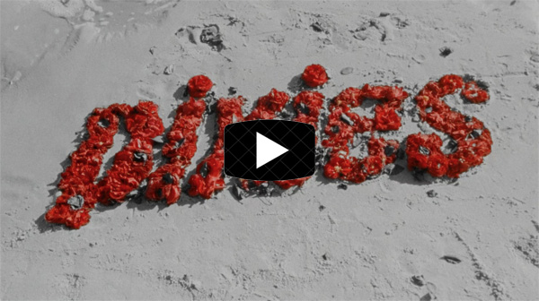

LOS ANGELES, CA - Tuesday, October 29, 2019 — Today, Pixies - Black Francis, Joey Santiago, David Lovering, and Paz Lenchantin - unveil a brand-new music video for the song “Long Rider” from the band’s new album Beneath The Eyrie (BMG/Infectious). Presented in a surreal, dream-like fashion, the video takes its cue from the tragic death of Desiree, an ardent surfer and close friend of Lenchantin’s whose final wave claimed her life a couple of years ago. Said Lenchantin, “It was almost as if Desiree had this dream before she went surfing that morning, and hints at that even if she had known her fate, she would still have taken that wave.” You can check out the “Long Rider” video HERE.

The video’s narrative was conceived by Lenchantin and pulls from the song’s lyrics which she co-wrote with Pixies’ Black Francis. Directed by Gilbert Trejo and filmed in Southern California at Will Rogers State Beach, the clip features pro-surfer Danica Elbertse, a good pal of Lenchantin’s. Lenchantin, a long-time fan of the 1960’s surf films, especially those by the ‘60s and ‘70s celebrated filmmaker George Greenough, shot the video on 16mm film with the water sequences filmed on a Super 8 camera explicitly made for underwater filming. “Long Rider” is Paz's second Pixies music video, having directed the clip for “Classic Masher” from the band’s 2016 album Head Carrier.

Pixies have just wrapped up a completely sold-out, 33-date European tour, Leg One of the band’s 2019-2020 global tour, and will head back out again in December for a limited, seven-date North American run. Kristin Hersh will support on those dates. Pixies will then kick off 2020 with Leg Two of a 14-date tour of Japan, China, New Zealand and Australia. All dates are below, and subsequent shows for 2020 will be announced shortly. Beneath The Eyrie is available now HERE.

DECEMBER
2 The Troubadour, Los Angeles, CA
3 The Troubadour, Los Angeles, CA
5 August Hall, San Francisco, CA
9 Webster Hall, New York, NY
10 College Street Music Hall, New Haven, CT
11 Boston Big Night Live, Boston, MA
12 Phoenix Concert Theatre, Toronto, ONT Canada

2020
FEBRUARY
24 Yokohama Bay Hall, Yokohama, Japan
25 Ex Theater Roppongi, Tokyo, Japan
26 Big Cat, Osaka, Japan
29 Modern Sky Lab SH, Shanghai, China

MARCH
1 Tango Live House, Beijing, China
3 Rotunda 2, KITEC, Kowloon, China
6 Spark Arena, Auckland, New Zealand
8 Golden Plains Festival 2020, Meredith, VIC, Australia
9 Palais Theatre, St. Kilda, VIC, Australia
12 Fortitude Music Hall, Brisbane, QLD, Australia
13 Fortitude Music Hall, Brisbane, QLD, Australia
14 Forecourt, Sydney Opera House, Sydney, NSW, Australia
15 Forecourt, Sydney Opera House, Sydney, NSW, Australia
17 Fremantle Arts Centre, Fremantle, WA, Australia

# # #

