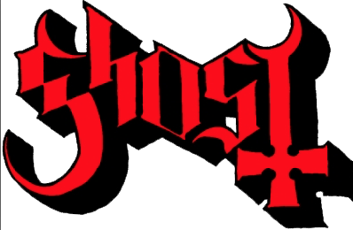

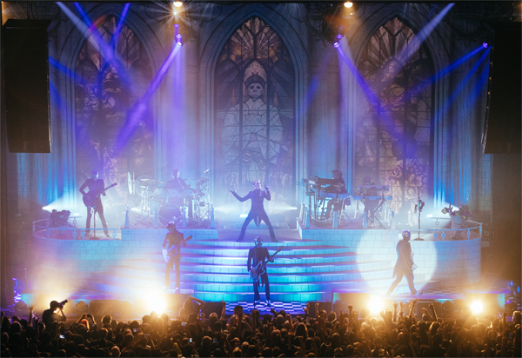
Ghost, the “Ultimate Tour Named Death” • Photo credit: Ryan Chang

FOR IMMEDIATE RELEASE

GHOST ANNOUNCES FALL 2019 NORTH AMERICAN DATES,
THE “ULTIMATE TOUR NAMED DEATH”
Grammy Nominated Rockers Nothing More to Provide Support

LOS ANGELES, CA — (Monday, April 1, 2019) — With “Dance Macabre” becoming the band's third #1 single at Rock Radio, GRAMMY Award-winning artist Ghost announces a six-week North American headline tour that will see the Swedish rock band’s elaborate rock theatre presentation metamorphose into a full-on arena production. Billed as the “Ultimate Tour Named Death” and produced by Live Nation, the tour is due to kick off Friday, September 13 in at the Rabobank Arena in Bakersfield, CA, following Ghost’s Special Guest summer slot on Metallica’s 25-date “WorldWide” European Stadium Tour. A series of ticket pre-sales begins tomorrow, April 2 at 10AM local; tickets for the “Ultimate Tour Named Death” go on sale to the general public beginning this Friday, April 5 at 10AM local. Log on to http://ghost-official.com for all pre-sales, VIP packages and ticketing details. Confirmed dates are below.

San Antonio’s three-time Grammy-nominated alt/rock band Nothing More, who earned three Top 10 singles from their most recent album The Stories We Tell Ourselves, will provide support for the tour. *

Ghost’s widely acclaimed live performances are known for raising an ungodly ruckus, and that will only be amplified as the band brings its stage production to arenas. Cardinal Copia and the seven Nameless Ghouls will perform for more than two hours on a striking stage set resembling a medieval cathedral with a backdrop of illuminated stained-glass windows that pay tribute to the three now-departed Papas. In addition to rich costumes, special effects, and a spectacular light show tailored-made for arenas, the Cardinal and the band will take advantage of a series of multi-level platforms and walkways to prowl around on while performing some of Ghost’s fan-favorite songs from the band’s albums and EPs catalogues. The set list will include favorites “Square Hammer,” "Cirice," "Ashes," "He Is," "Year Zero,” “Rats,” “Mummy Dust,” “Life Eternal,” “Dance Macabre,” and many more.

Twenty-eighteen proved to be a transformative year for Ghost. The band’s album Prequelle debuted at #3 on Billboard’s 200 chart, was named Revolver’s #1 Album of the Year, earned a Grammy nomination in the category of "Best Rock Album,” and accumulated 400,000 album sales and 200-million streams since its June release. Prequelle’s first radio single, “Rats,” held the #1 spot on the Billboard Mainstream Rock Songs chart for a record-setting eight consecutive weeks and received a "Best Rock Song" Grammy nomination, and the most recent radio track, “Dance Macabre,” became the band’s third #1 song at rock radio, a position it held for three weeks. In addition, Loudwire named Ghost its “Artist of the Year."

With more dates coming, the confirmed itinerary for the “Ultimate Tour Named Death” is as follows.

September
13 Rabobank Theatre, Bakersfield, CA
14 Reno Events Center, Reno, NV
16 Theater of the Clouds at Moda Center, Portland, OR
17 Toyota Center, Kennewick, WA
19 WaMu Theatre, Seattle, WA
20 Pacific Auditorium, Vancouver, BC
21 So. Okanagan Events Centre, Penticton, BC
24 The Corral, Calgary, AB
26 Spokane Arena, Spokane, WA
27 Taco Bell Arena, Boise, ID
28 Maverik Center, West Valley City, UT*
30 Budweiser Events Center at The Ranch, Loveland, CO

October
1 Broadmoor World Arena, Colorado Springs, CO
3 Denny Sanford Premier Center, Sioux Falls, SD
4 Scheels Arena, Fargo, ND*
5 The Armory, Minneapolis, MN
7 Resch Center, Green Bay, WI
14 DeltaPlex Arena, Grand Rapids, MI
19 Cross Insurance Arena, Portland, ME
21 DCU Center, Worcester, MA
22 The Oncenter, Syracuse, NY
24 GIANT Center, Hershey, PA
25 Cure Insurance Arena, Trenton, NJ
26 Cool Insuring Arena, Glens Falls, NY

* Nothing More will not appear on this date

ABOUT GHOST
The Swedish-born Tobias Forge, who has been referred to as "the Andrew Lloyd Webber of rock," is Ghost's creative force, singer, songwriter, musician, and architect of the elaborate storylines that are woven through the band's four full-length studio albums, EPs, music videos, webisodes, and live shows, all of which advance the Ghost storyline. Forge grew up listening to a wide array of 70s and 80s rock - Alice Cooper, Journey, Kansas, Boston, Black Sabbath, Jefferson Starship, Iron Maiden, and Foreigner. He's a hardcore music junkie; at home in Sweden, he has a most impressive collection of vinyl, cassettes, CDs, and VHS tapes, and when on tour, he regularly arranges for visits to local record haunts and ships back even more treasures. He plays guitar, bass, drums, keyboards, and kazoo. Ghost's current album, Prequelle, is loosely based on The Black Plague of 14th century Europe, a metaphor Forge hopes will apply to the societal ills of today.

Ghost's music began as being much heavier, harder and "more metal," but over the band's recent history, their songs have evolved to embrace a catchier, straight-ahead rock sound. Five of the band's songs have hit Billboard's Top 5 Rock chart - “Cirice" claimed the #4 spot in 2015, "From The Pinnacle to the Pit" went to #5 in 2016, and "Square Hammer" (2017), "Rats" (2018), and “Dance Macabre” (2018) all held the #1 spot on the Billboard Mainstream Rock Songs chart and on the Mediabase Active Rock chart. Ghost's music retains its rock edge as well as its dark lyrical themes like The Black Plague, the Antichrist, the Inquisition, avarice, and the Apocalypse. Ghost has received three GRAMMY nominations: “Best Metal Performance” in 2016 for “Cirice” which they won, and “Best Rock Album” for Prequelle, and “Best Rock Song” for “Rats” in 2019.

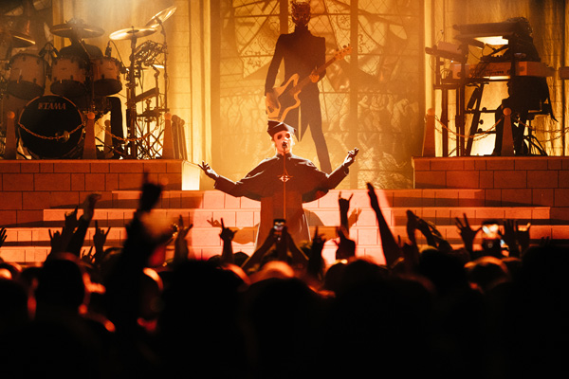

Ghost Media Contacts:
Heidi Ellen Robinson-Fitzgerald/National media • herfitz@mac.com • 818-705-1267
Selena Fragassi/Tour media • selena@fr-pr.net • (847) 942-3093
Ghost Press Assets (bio, photos, etc.): https://www.herfitzpr.net/ghost-home-page-2018

ABOUT NOTHING MORE
Consisting of Jonny Hawkins on vocals, Daniel Oliver on bass, Mark Vollelunga on guitar, and Ben Anderson on drums, Nothing More has worked relentlessly throughout their career to make a name for themselves in the rock world. The band signed to Better Noise Records, a label under Eleven Seven Label Group, and released their self-titled album in 2014 with debut single, “This Is The Time (Ballast)” hitting #1 on the Active Rock Chart in the US with 2 more top 10 singles “Jenny” at #3 and “Here’s To The Heartache” at #4. Following the release, the band toured heavily through out the world with acts including Volbeat, Killswitch Engage, Five Finger Death Punch, Halestorm, and Shinedown. Their most recent album, The Stories We Tell Ourselves (2017) landed them with 3 GRAMMY nominations in 2018 and dominated the rock category with the most nominations for Best Rock Album, while #1 single “Go To War” was nominated for Best Rock Song and Best Rock Performance of that year. The band had an incredible year in 2018, continuing to tour the world with household names such as Breaking Benjamin, and Bullet For My Valentine and Papa Roach. In 2019, the band kicked off their year with the ɥʇnɹʇ headlining tour in the US with Of Mice & Men, Badflower, & Palisades in support. This spring Nothing More will head to the UK with Papa Roach followed by more headline dates in Europe.

ABOUT FRANK PRODUCTIONS:
Frank Productions (FPC Live) is a full-service concert promotion company involved in every facet of live events including production, logistics, ticketing, marketing, sponsorships, food and beverage, operations, and merchandising. Frank Productions produces and promotes live entertainment events in arenas, amphitheaters, performing arts centers, clubs, and other venues across the country. For additional information, visit www.FPC-Live.com.

ABOUT NATIONAL SHOWS 2, LLC:
National Shows 2 (NS2) is a Nashville-based, full-service concert promotion company. NS2 creates, produces and promotes live entertainment events in arenas, amphitheaters, performing arts centers, clubs and other venues across the country. For additional information, visit nationalshows2.com.

# # #

