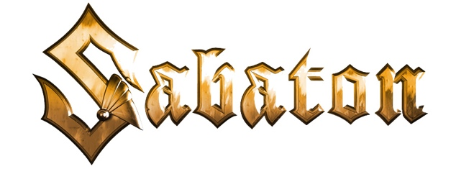

FOR IMMEDIATE RELEASE

SABATON ANNOUNCES PRE-ORDER, RELEASE DATE,
AND TRACK-LISTING FOR UPCOMING NEW ALBUM,
THE WAR TO END ALL WARS

LOS ANGELES, CA - Monday, October 4, 2021 -- — Number One positions in 11 countries with their last record, Swedish Grammis nominations, sold-out arena shows: SABATON indisputably wrote their very own fairytale during the last years, making it to the top of modern metal and beyond. Today, the Swedish heroes flip the book open, adding another chapter: today, with a release date set for March 4, 2022 (Nuclear Blast Records), the pre-order for Sabaton's most ambitious album - The War To End All Wars - begins. Pre-orders can be placed here: https://smarturl.it/SabatonTWTEAW

Written and recorded during the COVID global pandemic, Sabaton has crafted a concept album of 11 brand-new songs that once again dive deep into the atrocities, miracles, and events tied to the early 20th century’s World War I. The tenth album of the Falun-based five-piece will be available in an impressive variety of exclusive formats, including CD, vinyl, and cassette, with most available in limited editions. See below for all formats.

The tracklist for The War To End All Wars is as follows:
1. Sarajevo
2. Stormtroopers
3. Dreadnought
4. The Unkillable Soldier
5. Soldier Of Heaven
6. Hellfighters
7. Race to the Sea
8. Lady Of The Dark
9. The Valley Of Death
10. Christmas Truce
11. Versailles

"The War To End All Wars" will be available in the following formats:
- Jewelcase CD
- Limited Gold CD [Supporter Edition - various versions with translated booklets]
- History Edition
- NB Mailorder Exclusive Edition [ltd. to 1500 copies]
- Earbook [limited to 6000 copies]
- Black Vinyl
- Azure Blue Vinyl [bandshop exclusive, ltd. to 300 copies]
- Inca Gold Vinyl [bandshop exclusive, ltd. to 500 copies]
- Copper Vinyl [ltd. to 500 copies]
- Fluorescent Orange Vinyl [ltd. to 500 copies]
- Leaf Green Vinyl [Sweden exclusive]
- Fluorescent Yellow Vinyl [Ginza exclusive]
- Dusk Vinyl [Levik exclusive]
- Soft Grey Vinyl [Nordics exclusive]
- Lavender Vinyl [FNAC exclusive]
- Rosewood Vinyl [Mystic exclusive]
- Fluorescent Green Vinyl [UK exclusive]
- Pacific Blue Vinyl
- Polar White Vinyl [limited to 300 copies]
- Dewdrop Vinyl [limited to 500 copies, EMP exclusive]
- Blue cassette [limited to 100 copies, bandshop exclusive]
- Green cassette [limited to 100 copies]
- Grey cassette [limited to 300 copies]
- Red cassette [limited to 500 copies]
- Black cassette [limited to 250 copies]
- Smokey cassette [limited to 200 copies]
- White cassette [limited 100 copies]

Following a 29-date headline tour of Sweden, Sabaton will launch the March 4, 2022 release of the new album with The Tour To End All Tours, a massive five-week European trek supported by The HU and Lordi. Complete dates and ticket information are available HERE

ABOUT SABATON:
In the more than two decades since their launch, Swedish metallers Sabaton have achieved quadruple-Platinum sales and headlined major festivals and sold-out arena concerts across the globe, gaining a legion of loyal fans by carving out a reputation as one of the hardest working bands in the business. Sabaton has combined standout stage design and production with epic concept albums, linking real-life historical war events with classic kick-ass metal. To date, Sabaton has released nine studio albums, amassed six GOLD, one PLATINUM, and one four-times-PLATINUM awards, seen eight of its albums score Top 10 international chart status, and six claim the Top 5. The band has earned eight Metal Hammer/Golden Gods Awards nominations, taking home the award for "Breakthrough Artist" in 2011 and "Best Live Band" in three different years, and a Grammis nomination (Swedish equivalent to the U.S. GRAMMY) as Best Heavy Metal band. Sabaton has also accumulated more than two billion streams across all streaming platforms.
(Continues HERE)

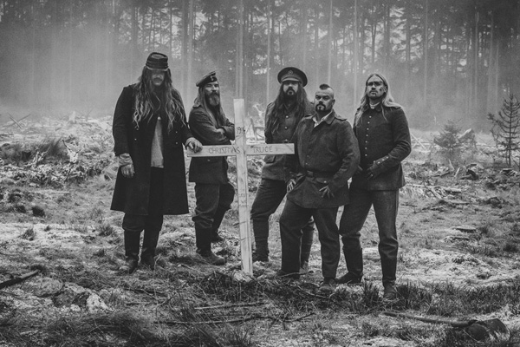
SABATON L-R: Tommy Johansson, Pär Sundström, Chris Rörland, Joakim Brodén, Hannes Van Dahl
PHOTO CREDIT: Christian Ripkens

