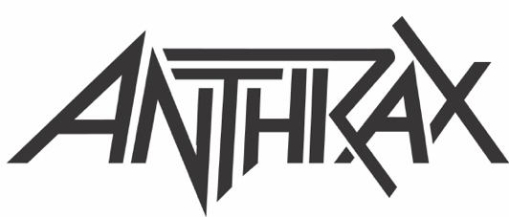

FOR IMMEDIATE RELEASE

ANTHRAX EXTENDS ITS 40TH ANNIVERSARY CELEBRATION
WITH 28-DATE EUROPEAN HEADLINE TOUR SET FOR FALL, 2022
Speed Metal Punks Municipal Waste Will Be Main Support
Check out the Tour Video Trailer HERE

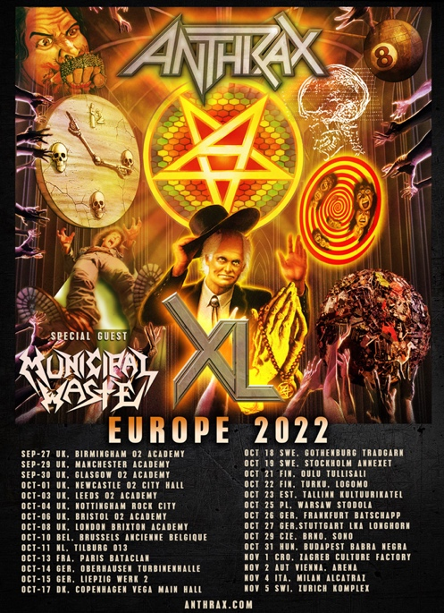

LOS ANGELES, CA - (Tuesday, August 17, 2021) — Still celebrating its 40-year tenure as one of music's premier thrash metal bands, Anthrax announces its first European tour since the summer of 2019. Kicking off on September 27, 2022 in Birmingham, England, the band will play 28 dates in 16 countries, wrapping up in Zurich, Switzerland on November 5. Crossover thrash band Municipal Waste will support on all dates. Tickets go on sale this Friday, August 20 at 10AM BST, 11AM CET; go to www.anthrax.com for all purchasing information.

"It sure has been a long time since we rock’n’rolled in the UK and Europe,” said Anthrax’s Charlie Benante, "but we’re coming back soon to bring the noise to all of you guys. Being that we can’t get over there until 2022, we’re going to make sure that every show will be an eventful one. We won’t just be playing four decades of songs to celebrate our ongoing 40th anniversary - hey, we’ll be giving YOU some history! - but we just might have some brand new ones for you as well. Can’t wait to see all your happy, smiling faces!!!"

On this tour, fans can expect Anthrax - Joey Belladonna/vocals, Scott Ian/rhythm guitar, Frank Bello/bass, Charlie Benante/drums, and Jon Donais/guitar - to draw from all four decades - fan favorite and deep cuts - for their nightly setlist.

"There's just something special about Europe," said Belladonna. "Our fans there have always had a full-fledged excitement about our shows, and I enjoy performing more than anyone can imagine, so we're really looking forward to this tour."

Dates for Anthrax’s 2022 European tour are as follows:

SEPTEMBER
27 02 Academy, Birmingham, UK
29 Academy, Manchester, UK
30 02 Academy, Glasgow, UK

OCTOBER
1 02 City Hall, Newcastle, UK
3 02 Academy, Leeds, UK
4 Rock City, Nottingham, UK
6 02 Academy, Bristol, UK
8 Brixton Academy, London, UK
10 Ancienne Belgique, Brussels, Belgium
11 013, Tilburg, Netherlands
13 Bataclan, Paris, France
14 Turbinenhalle, Oberhausen, Germany
15 Werk 2, Leipzig, Germany
17 Vega Main Hall, Copenhagen, Denmark
18 Tradgarn, Gothenburg, Sweden
19 Annexet, Stockholm, Sweden
21 Tullisali, Oulu, Finland
22 Logomo, Turku, Finland
23 Kultuurikatel, Talinn, Estonia
25 Stodola, Warsaw, Poland
26 Batschapp, Frankfurt, Germany
27 LKA Longhorn, Stuttgart, Germany
29 Sono, Brno, Czech Republic
31 Babra Negra, Budapest, Hungary

NOVEMBER
1 Culture Factory, Zagreb, Croatia
2 Arena, Vienna, Austria
4 Alcatraz, Milan, Italy
5 Komplex, Zurich, Switzerland

• • •

ABOUT ANTHRAX: Twenty-twenty-one marks Anthrax's 40th anniversary, during which time the band has released 11 studio albums, been awarded multiple Gold and Platinum certifications, received six GRAMMY nominations, and a host of other accolades from the media, the music industry, and fans. In 1991, the band helped break down race and genre barriers when they collaborated with Public Enemy on the track "Bring The Noise," and was the first metal band to have its music heard on Mars when NASA played "Got The Time" to wake up the Mars Rover in 2012. Along with Metallica, Slayer, and Megadeth, Anthrax is a card-carrying member of The Big Four, the four bands that defined the speed/thrash/metal genre. Anthrax has also introduced a series of now sold-out signature whiskeys and bourbons and partnered with the Stockholm-based NEZUMI Studios for a high-end, limited-edition Baleine dive watch. Twenty-twenty-one has seen the release of Z2 Comics' "Among the Living" graphic novel with a track-by-track storyline inspired by Anthrax's iconic 1987 album, Among The Living. The book pulls together a "who's who" of names from the worlds of comics and music who created "bubble dialogue" and original artwork to express what the songs meant to them. Taking advantage of COVID-19's prohibition of concert touring, the band has been hard at work writing the next Anthrax album.
Starting May 3, 2021, Anthrax counted down the days to their official July 18 anniversary, first with a three-times-a-week, 40-episode, guest-filled web series that included testimonials from friends such as Chuck D, Kerry King, John Carpenter, Slash, Tom Morello, Rob Zombie, Robert Trujillo, Dave Grohl, Keanu Reeves, and many more. The celebration culminated on July 16 with a global livestream event that offered a set list that spanned the band’s entire career.

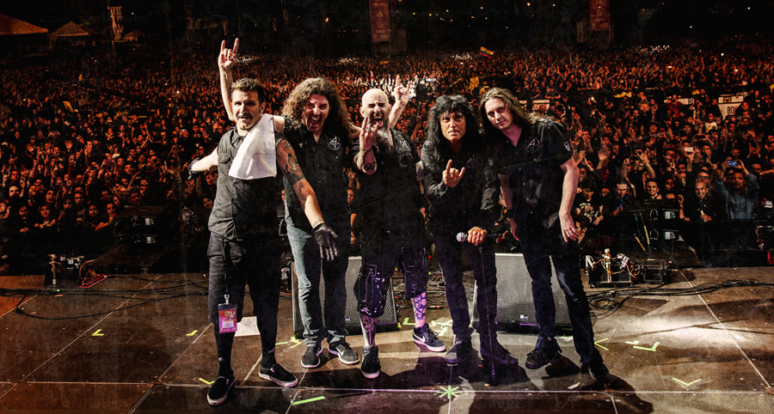

Anthrax, L-R: Charlie Benante, Frank Bello, Scott Ian, Joey Belladonna, Jonathan Donais
Photo credit: Ignacio Galvez

