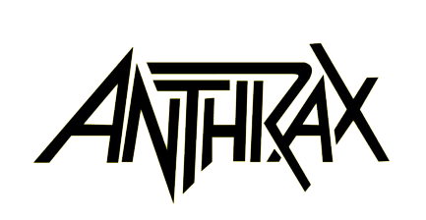

TO TOP OFF ITS 40TH ANNIVERSARY CELEBRATION,
ANTHRAX ANNOUNCES THE ULTIMATE FUSION
OF THRASH AND MASH:
"ANTHRAX XL"
THE BAND'S 40th ANNIVERSARY BOURBON WHISKEY

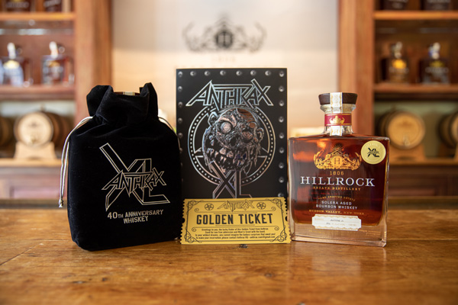

LOS ANGELES, CA - (Thursday, August 26, 2021) - Anthrax - Scott Ian, Frank Bello, Charlie Benante, Joey Belladonna and Jon Donias - have been celebrating the band's 40th anniversary since the festivities kicked off in late April. But even with the actual Big-40 having taken place on July 18, the band is not quite done saluting that milestone.

Today, the band announces the release of its 40th anniversary, high-end spirit, "Anthrax XL" (Roman numerals for 40), a smooth Solera-aged, single- barrel bourbon finished for 40 days in a 20-year old Oloroso Sherry cask, providing the spirits with balanced flavors and layers of complexity. Only one barrel of "Anthrax XL" has been produced, yielding 400 hand-numbered bottles at a cask strength of 115 proof. Each bottle features the band members' signatures, and is encased in a black drawstring velvet gift bag emblazoned with the Anthrax XL logo, with a suggested retail price of $155. Additionally, 40 limited edition numbered bottles will be available. Priced at $350, each limited edition bottle is also housed in a black drawstring velvet gift bag, imprinted with the Anthrax XL logo, then packed in a customized box encased in a SilverFoil card stock wrap-around. Each limited edition item comes with a Golden Ticket, printed and debossed on gold foil-coated-card stock. The Golden Ticket awards the purchaser and a guest admission to an Anthrax headline concert in the purchaser's area and includes a special in-person Meet & Greet with the band to take place during Anthrax's 2022 U.S. tour. For all details pertaining to "Anthrax XL," go to www.anthrax.com ; to purchase a bottle of "Anthrax XL," go to
www.120west58wine.com. Customers can expect a turn-around time of about 10-days.

In July, Ian and Bello traveled up to the Hillrock Estate Distillery for a series of tastings to find that perfect elixir that would be "Anthrax XL" worthy. To check out that video clip, go to https://youtu.be/7IBV4BjvLOQ

"I had a great time up at Hillrock," said Bello of the experience. "Everything there is homegrown, and all done by hand. Jeffrey, Cathy, Alex, and everyone who works there are all really nice people who care so much about what they do and how they do it. I'm very, very happy with our 'Anthrax XL' whiskey. It's smooth, has a great aftertaste, and creates a great vibe. Right after my first taste, I wanted more."

"I sampled eight different whiskeys from Hillrock's rickhouse when I was there to pick one for our 40th-anniversary bottle," said Scott Ian. "It's a difficult task in that they're all so great, thieved from the barrel and into my glass. Every time I've had to choose a whiskey, I wait for the juice to tell me that, 'it's the one.' This barrel spoke up loud and clear. On the nose, there is an explosion of caramel, toffee, and butterscotch with hints of dried cherries and fresh herbs. The palette has a rich texture of bright red fruits, baking spices, and toasted almonds. I'm drooling just reading that back. Get yourself a bottle, you deserve it!"

"Anthrax XL" is the band's most recent collaboration with the multi-award-winning Hillrock Estate Distillery, located in the luxuriant Hudson Valley Highlands in New York State. Built from the ground up by husband and wife Jeffrey Baker and Cathy Franklin and the legendary late Master Distiller Dave Pickerell, Anthrax continues to return due to the high level of care and attention that the Hillrock trio puts into what they do.

According to Franklin, Baker, and Alex Eckstein, owners of Hillrock Estate Distillery, "This 'Anthrax XL' Anniversary cask is the band's fourth Hillrock Solera Aged Bourbon selection. Over that time, we have become very close with Scott and have enjoyed getting to know all of the other band members, either up here with us in person or virtually. We hope to have Scott and Frank, as well as Charlie, Joey, and Jon all up here together soon to taste, create and finish more beautiful craft whiskey together for many more years."

* * *

ABOUT ANTHRAX: Twenty-twenty-one marks Anthrax's 40th anniversary, during which time the band has released 11 studio albums, been awarded multiple Gold and Platinum certifications, six Grammy nominations, and a host of other accolades from the media, the music industry, and fans. In 1991, the band helped break down race and genre barriers when they collaborated with Public Enemy on the track "Bring The Noise," and was the first metal band to have its music heard on Mars when NASA played "Got The Time" to wake up the Mars Rover in 2012. Along with Metallica, Slayer, and Megadeth, Anthrax is a card-carrying member of The Big Four, the four bands that defined the speed/thrash/metal genre. Anthrax has also introduced a series of now sold-out signature whiskeys and bourbons as well as the band's 2021 Anniversary "Anthrax XL" bourbon whiskey, and partnered with the Stockholm-based NEZUMI Studios for a high-end, limited-edition Baleine dive watch. Twenty-twenty-one also has seen the release of Z2 Comics' "Among the Living" graphic novel with a track-by-track storyline inspired by Anthrax's iconic 1987 album, Among The Living. The book pulls together a "who's who" of names from the worlds of comics and music who created "bubble dialogue" and original artwork to express what the songs meant to them. Taking advantage of COVID-19's prohibition of concert touring, the band has been hard at work writing the next Anthrax album.

