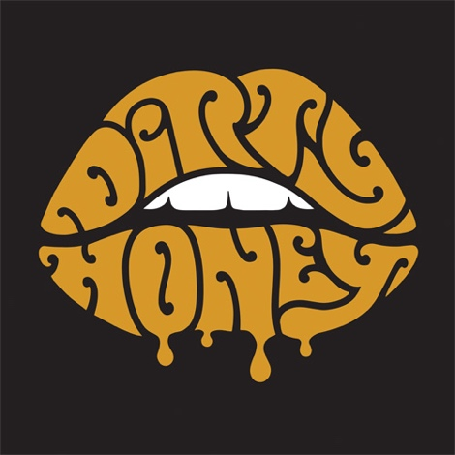

DIRTY HONEY ANNOUNCES
THE "ROLLING 7S" 2020 U.S. TOUR DATES
"New Track "Rolling 7s" Already Top 30 at Rock Radio

LOS ANGELES, CA - Tuesday, November 19, 2019 - Having commanded the #1 spot at Rock Radio with its debut single "When I'm Gone," and its sophomore track "Rolling 7s" already a Top 30 track at Active Rock Radio, the blazing-hot rock band Dirty Honey announces the first leg of its 2020 "Rolling 7s" U.S. tour. The 25-date, coast-to-coast trek kicks off January 17 in Austin, TX at The Parish and wraps up six weeks later in Los Angeles at the El Rey Theatre on February 28. Hotly-tipped UK rock outfit The Amazons will open on all dates. VIP packages go on sale tomorrow, Wednesday, November 20 at 10AM (local); tickets go on sale to the public this Friday, November 22 at 10AM (local); go to https://www.dirtyhoney.com for all VIP, pre-sale and additional ticketing information.
"Dirty Honey celebrated the breakout success of its song 'When I'm Gone' with a performance rich in both riffs and rock-star vibes." -- Rolling Stone/Exit 111

To call 2019 a "breakout year" for Dirty Honey - Marc LaBelle/vocals, John Notto/guitars, Justin Smolian/bass and drummer Corey Coverstone - would be an understatement. Over the course of the past year, Dirty Honey has opened for The Who, Guns N' Roses, and Slash featuring Myles Kennedy and The Conspirators, been named Canadian Rock Radio's #1 International Breakout Artist of 2019, made history as the only unsigned artist in Billboard's near four-decade history to hit #1 on the magazine's Mainstream Rock Chart, been chosen as iHeart Radio's "On The Verge" rock artist, and racked up more than 10-million total streams.

"It didn't take the crowd very long to realize they were seeing stars in the making."
-- Down South Magazine

The "Rolling 7s" tour is in support of Dirty Honey's self-titled debut EP that was recorded last Fall by producer Nick DiDia (Pearl Jam, Rage Against The Machine) at his studio in Byron Bay, Australia. The band is currently on its first-ever U.S. headline tour, playing to SRO houses every night. This tour wraps up this Friday, November 22 with a sold-out show at The Troubadour in Los Angeles.

"A rock band can fake it in the studio. A rock band can fake it on the Net. But a real rock band can't fake it where it counts the most - on stage. That's "sink or swim' territory, baby. And Dirty Honey proves to certainly be the real deal onstage - oozing the authentic spirit of rock and roll with the greatest of ease." -- Ink 19

Complete dates for Dirty Honey's 2020 "Rolling 7s" U.S. tour are as follows:

JANUARY 2020
17 The Parish, Austin, TX
18 The Blue Light, Dallas, TX
19 The Studio at Warehouse Live, Houston, TX
21 The Parish at House of Blues, New Orleans, LA
22 Club LA, Destin, FL
24 Dixie Roadhouse, Ft. Myers, FL
25 Jack Rabbits, Jacksonville, FL
27 Sidetracks, Huntsville, AL
28 The Basement East, Nashville, TN
29 Capone's Johnson City, TN
31 Metro Gallery, Baltimore, MD

FEBRUARY
1 Stage On Herr at HMAC, Harrisburg, PA
5 Knitting Factory, Brooklyn, NY
7 The Stache, Grand Rapids, MI
8 The Machine Shop, Flint, MI
10 The Shelter, Detroit, MI
11 Bottom Lounge, Chicago, IL
12 Turner Hall Ballroom, Milwaukee, WI
14 Old Rock House, St. Louis, MO
15 Riot Room, Kansas City, MO
17 Bluebird Theatre, Denver, CO
21 Nuemos, Seattle, WA
22 Polaris Hall, Portland, OR
25 Slim's, San Francisco, CA
28 El Rey, Los Angeles, CA

# # #

Dirty Honey Media Contacts
National Media:
Heidi Ellen Robinson-Fitzgerald
herfitz@mac.com
818-705-1267

Tour Media:
Selena Fragassi
Selena@fr-pr.net
847-942-3093

