Pixies – Doggerel Biography 2022 (Abridged)

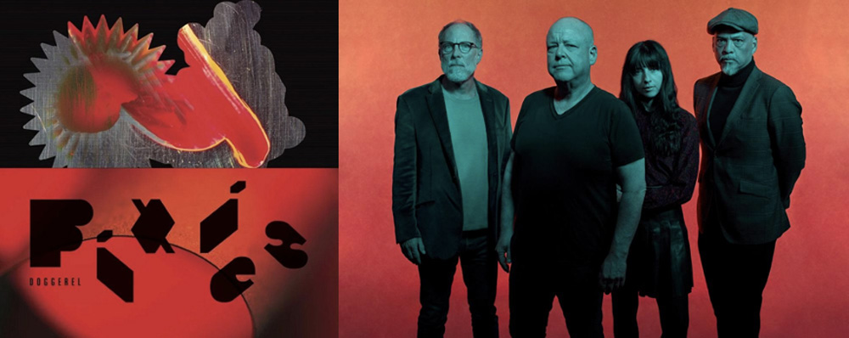

As a blood moon looms over mankind in the wake of the pandemic, Pixies come out to play, gripped by a creative rage. In a virtually peerless 36-year history taking in a first era (1986-1993) that gouged out a raw, dynamic and influential new path for alternative rock over a clutch of seminal albums merging mythological savagery, sci-fi intrigue and collegiate pop charm, and a second since their 2004 reunion that has seen them alchemize more sophisticated dark arts, the iconic alt-rock pioneers rarely been so fired up and wracked with that ancient hunger. “We're trying to do things that are very big and bold and orchestrated,” says frontman Black Francis, “not necessarily without any sophistication or complexity, but it's nuanced.”

Their renewed musical fervour saw a stand-alone single ‘Human Crime’ leap from the shadows in March and has created an eighth album, Doggerel. Produced by regular studio foil Tom Dalgety, it’s a mature yet visceral record of gruesome folk, ballroom pop and brutal rock, haunted by the ghosts of affairs and indulgences, driven wild by cosmic forces and envisioning digital afterlives where no God has provided one. Here are captivating songs of fatalistic hedonism (‘Dregs Of The Wine’) and subsequent collapse (‘Vault Of Heaven’). Of ancient outcasts (‘Pagan Man’) and online meta-futures (‘Get Simulated’). Of romantic spectres (‘Haunted House’), full-moon lusts (‘There’s A Moon On’) and the distant rumbles of war and personal destruction (‘Thunder & Lightning’). Like 2019’s Beneath The Eyrie, Doggerel is a record brilliantly evolved from, but not beholden to, their acclaimed past. And like all things Pixies, it comes steeped in a darkness that illuminates.

