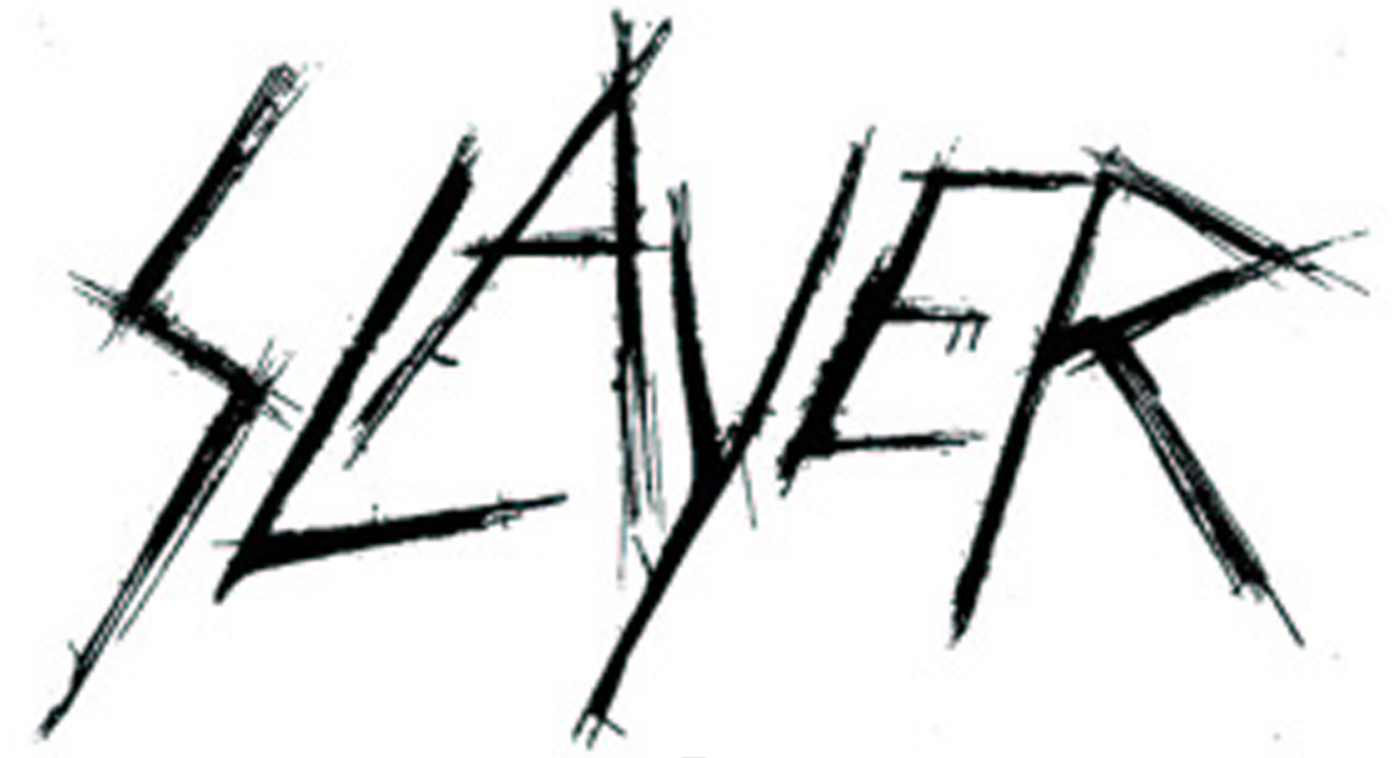

Repentless Credits

Album title: Repentless
Release date: September 11, 2015
Label: Nuclear Blast

Produced, Engineered and Mixes by Terry Date
Recorded and Mixed at Henson Studios, Hollywood, CA
Additional Engineering by Peter Mack
Mastered by Howie Weinberg at Howie Weinberg Mastering, Los Angeles, CA

Cover Art: Marcelo Vasco

Tom Araya – bass, vocals
Kerry King – guitars
Paul Bostaph – drums
Gary Holt - guitars

Final track listing:
- Delusions of Saviour
- Repentless
- Take Control
- Vices
- Cast The First Stone
- When The Stillness Comes
- Chasing Death
- Implode
- Piano Wire
- Atrocity Vendor
- You Against You
- Pride in Prejudice

Additional track listing for “Slayer Live at Wacken 2014” CD (included in the Limited 12-inch Box Set:
- Intro (Lyrics: Sprache)
- Hell Awaits*
- The Antichrist*
- Mandatory Suicide**
- Hate Worldwide***
- War Ensemble**
- Postmortem**
- Captor of Sin*
- Disciple***
- Seasons in The Abyss**
- Born Of Fire**
- Dead Skin Mask**
- Raining Blood**
- Black Magic*
- South of Heaven***
- Angel of Death**

* Bloody Skull Music/Bug Music • Music and Lyrics: Jeff Hanneman, Kerry King

** Death’s Head Music • Music and Lyrics: Tom Araya, Jeff Hanneman, Kerry King

*** Molosser Music/Pennemunde Music/Universal Music-Mgb Songs • Music and Lyrics: Tom Araya, Jeff Hanneman, Kerry King

