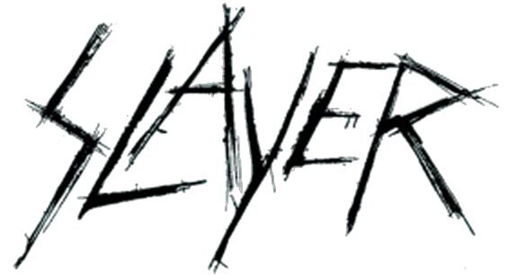

FOR IMMEDIATE RELEASE

THE END IS NEAR:
SLAYER TO MAKE ITS EXIT
WITH ONE FINAL WORLD TOUR
Lamb of God, Anthrax, Behemoth, Testament to Accompany on Leg One
Lamb of God, Anthrax, Testament, Napalm Death to Accompany on Leg Two
(See video announcement HERE)

LOS ANGELES, CA - Friday, March 9, 2018 - After making some of the most brutal, breathtakingly aggressive, all-hell's-a-breaking-loose music ever created, being one of the four bands that defined an entire musical genre and being the band that other heavy acts are measured against and aspire to...after nearly 37 years, releasing 12 studio albums, multiple live recordings, compilations, live video and two box sets, playing nearly 3000 concerts in all corners of the world, receiving countless awards including five Grammy nominations and two Grammy awards, Gold records and other accolades...having its own exhibit in the Smithsonian Institute, gracing hundreds of magazine covers, experiencing the devastating loss of a founding brother, and even appearing on "The Tonight Show," the age of Slayer, one of the greatest thrash/metal/punk bands of this or any age, is coming to an end.

Slayer announces that it will do one last concert tour around the globe to thank their fans for all of their support over the years, for making the last three-and-a-half decades so packed with good times and unforgettable experiences, and will then move on.

Lamb of God, Anthrax, Behemoth and Testament will support Slayer on Leg One/North America, of its final world tour. For Leg Two/ North America, Lamb of God, Anthrax, Testament and Napalm Death will support. Tickets are on sale now; very limited Slayer onstage + meet & greet+ exclusive merchandise packages are also available. Log on to www.slayer.net for this and all ticket purchasing info.

LEG ONE (w/ support from Lamb of God, Anthrax,
Behemoth, Testament)
MAY
10 Valley View Casino Center, San Diego, CA SOLD OUT
11 Five Point Amphitheatre, Irvine, CA SOLD OUT
13 Papa Murphy's Park at Cal Expo, Sacramento, CA SOLD OUT
16 Pacific Coliseum, Vancouver, BC SOLD OUT
17 South Okanagan Events Centre, Penticton, BC
19 Big Four, Calgary, AL SOLD OUT
20 Shaw Conference Centre, Edmonton, AB SOLD OUT
22 Bell MTS Place, Winnipeg, MB
24 The Armory, Minneapolis, MN SOLD OUT
25 Hollywood Casino Amphitheatre, Tinley Park, IL
27 Michigan Lottery Amphitheatre at Freedom Hill, Detroit, MI SOLD OUT
29 Budweiser Stage, Toronto, ON SOLD OUT
30 Place Bell, Montreal, PQ SOLD OUT

JUNE
1 Mohegan Sun Arena, Uncasville, CT SOLD OUT
2 PNC Bank Arts Center, Holmdel, NJ
4 Santander Arena, Reading, PA SOLD OUT
6 Riverbend Music Center, Cincinnati, OH
7 Blossom Music Center, Cleveland, OH
9 KeyBank Pavilion, Pittsburgh, PA
10 Jiffy Lube Live, Bristow, VA
12 Veteran's United Home Loans Amphitheater, Virginia Beach, VA
14 PNC Music Pavilion, Charlotte, NC
15 Orlando Amphitheater, Orlando, FL
17 Smart Financial Centre at Sugar Land, Houston, TX SOLD OUT
19 The Bomb Factory, Dallas, TX SOLD OUT
20 Austin360 Amphitheater, Austin, TX

LEG TWO (w/ support from Lamb of God, Anthrax, Testament, Napalm Death)
JULY
26 Bank of New Hampshire Pavilion, Gilford, NH
27 Impact Music Festival, Darling's Waterfront Pavilion, Bangor, ME
29 Northwell Health at Jones Beach, Wantagh, NY
31 The Pavilion at Montage Mountain, Scranton, PA

AUGUST
1 Times Union Center, Albany, NY
3 Darien Lake Performing Arts Center, Darien Lake, NY
4 Lakeview Amphitheater, Syracuse, NY
6 Budweiser Gardens, London, ON
7 Van Andel Arena, Grand Rapids, MI
9 Hollywood Casino Amphitheatre, St. Louis, MO
10 Cellairis Amphitheatre at Lakewood, Atlanta, GA
12 Municipal Auditorium, Nashville, TN
13 Walmart AMP, Rogers, AR
15 Freeman Coliseum, San Antonio, TX
16 The Zoo Amphitheatre, Oklahoma City, OK
18 Fiddler's Green Amphitheatre, Denver, CO
19 USANA Amphitheatre, Salt Lake City, UT
21 Ford Idaho Center Amphitheater, Boise, ID
23 Sunlight Supply Amphitheater, Portland, OR
26 SAP Center, San Jose, CA

SLAYER Press Assets Site (bio, photos, more info);
https://www.herfitzpr.net/slayer-home-2018

SLAYER Media Contacts:
National Media • Heidi Ellen Robinson Fitzgerald • herfitz@mac.com • 818-705-1267
Tour Media • Julie Arkenstone • julieark@me.com • 747-900-6212

