FOR IMMEDIATE RELEASE

GRETA VAN FLEET ANNOUNCES FALL LEG OF ITS
2019 MARCH OF THE PEACEFUL ARMY TOUR

LOS ANGELES, CA - (Monday, May 13, 2019) - Grammy-winning rock 'n' roll band GRETA VAN FLEET today announces a three week Fall North American leg of its March of the Peaceful Army Tour, set to kick off in Kansas City on Saturday, September 21. The tour will include first-time visits to Kansas City and Irvine, and the band performing a blend of fan-favorites and some brand new tunes. Shannon and the Clams, a GVF personal pick, will support on all dates. Pre-sales for Peaceful Army Fan Club members begin Wednesday, 5/15, and the public on-sale starts Friday, 5/17 at 10 AM local time. Log on to http://www.gretavanfleet.com for all ticketing details.

Greta Van Fleet - Josh Kiszka/vocals, Jake Kiszka/guitars, Sam Kiszka/bass & keyboards, and drummer Danny Wagner - kicked off 2019 with sold-out shows on the band's first-time tours of Japan, Australia, South America, and Mexico. The group is currently on a four-week tour of North America and will then head to Europe on June 27 to play a series of major outdoor festivals and some stand-alone headline dates. All confirmed dates are below.

*****
MAY
13 Fox Theatre, Atlanta, GA
15 Charlotte Metro Credit Union Amphitheatre, Charlotte, NC
16 Red Hat Amphitheatre, Raleigh, NC
18 The Stone Pony Summer Stage, Asbury Park, NJ
19 Kerfuffle, Merriweather Post Pavilion, Columbia, MD (DC101 Radio show)
21 MECU Pavilion, Baltimore, MD
22 Rochester Dome Arena, Rochester, NY
24 Boston Calling Festival, Boston, MA
25 Forest Hills Stadium, Queens, NY
28 Echo Beach, Toronto, ON CANADA
29 Echo Beach, Toronto, ON CANADA
31 Bunbury Music Festival, Cincinnati, OH

JUNE
1 Bunbury Music Festival, Cincinnati, OH
2 Jacobs Pavilion at Nautica, Cleveland, OH
4 Breese Stevens Field, Madison, WI

(June 27 - September 10 - Europe, Australia and New Zealand dates)

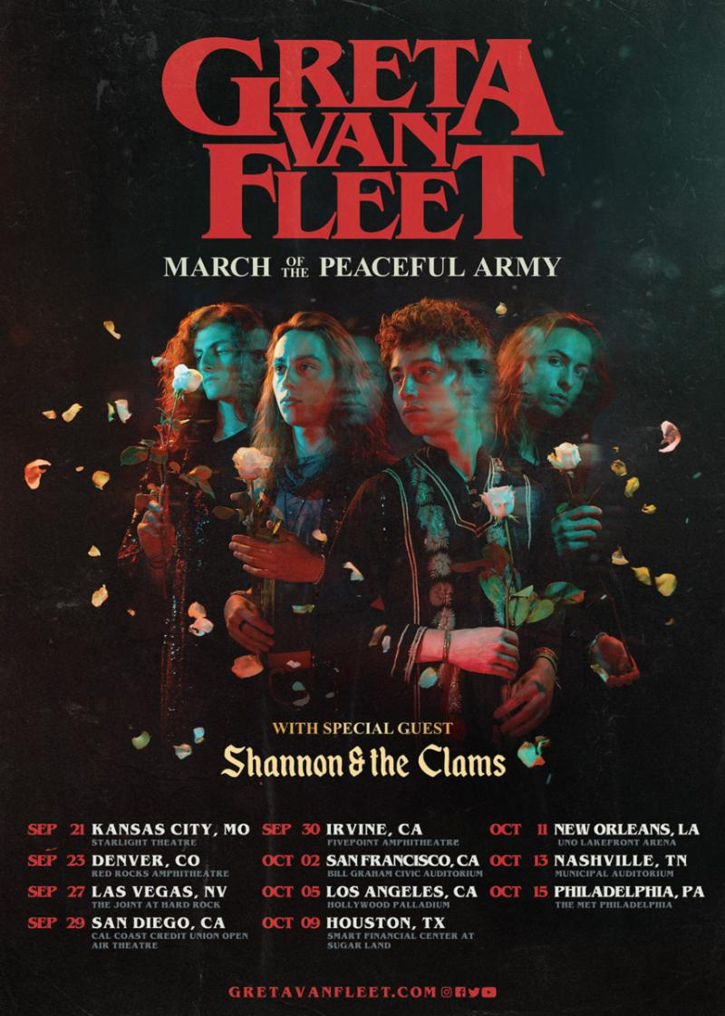
NORTH AMERICAN FALL RUN
SEPTEMBER
21 The Starlight Theatre, Kansas City, MO
23 Red Rocks Amphitheatre, Morrison, CO
27 The Joint at Hard Rock Hotel Las Vegas, Las Vegas, NV
29 Cal Coast Credit Union Open Air Theatre, San Diego, CA
30 FivePoint Amphitheatre, Irvine, CA

OCTOBER
2 Bill Graham Civic Auditorium, San Francisco, CA
5 Hollywood Palladium, Los Angeles, CA
9 Smart Financial Centre at Sugar Land, Sugar Land, TX
11 UNO Lakefront Arena, New Orleans, LA
13 Nashville Municipal Auditorium, Nashville, TN
15 The Met Philadelphia, Philadelphia, PA

*****

ABOUT GRETA VAN FLEET:
Greta Van Fleet is four young musicians - twin brothers Josh (vocals) and Jake Kiszka (guitar), both 22, younger brother Sam (bass/keys, 20), and longtime family friend Danny Wagner (drums, 20). All are from the tiny Michigan hamlet of Frankenmuth known for its family-style chicken dinners and the world's largest Christmas store. All four were raised on their parents' extensive vinyl collections which helped give birth to the music they make today: a high-energy hybrid of rock'n'roll, blues and soul.

Since the March 2017 release of "Highway Tune," the band's first single that claimed the #1 spot at Rock Radio for five consecutive weeks, the four members of Greta Van Fleet have achieved three more #1 rock singles ("Safari Song," "When The Curtain Falls," and "You're the One"). The group has also been on a wild ride of sold-out concerts around the world, racked up tens of millions of YouTube video plays and audio streams, received glowing accolades from iconic artists like Elton John, Dave Grohl, Joe Satriani, and Billy Corgan, and recorded two #1 EPs. The band's debut album Anthem of the Peaceful Army (10-19-18), entered Billboard's Top Album Sales and Top Rock Albums charts at #1, and at #3 on the Billboard 200 chart. On December 7, 2018, the band awoke to find they had received four Grammy nominations - Best New Artist, Best Rock Song ("Black Smoke Rising"), Best Rock Performance ("Highway Tune"), and Best Rock Album (From The Fires EP), which the band took home. Greta Van Fleet has made two late-night television appearances: "The Tonight Show Starring Jimmy Fallon" (7/26/18), and "Saturday Night Live" (1/19/19). Most importantly, Greta Van Fleet has been building an extraordinary connection with its fans.

Greta Van Fleet's shared message with their music is to spread "peace, love, and unity," and their collective goal is to have people walk out of their live shows feeling invigorated, energized and exhilarated, and to take that feeling out into the world.

