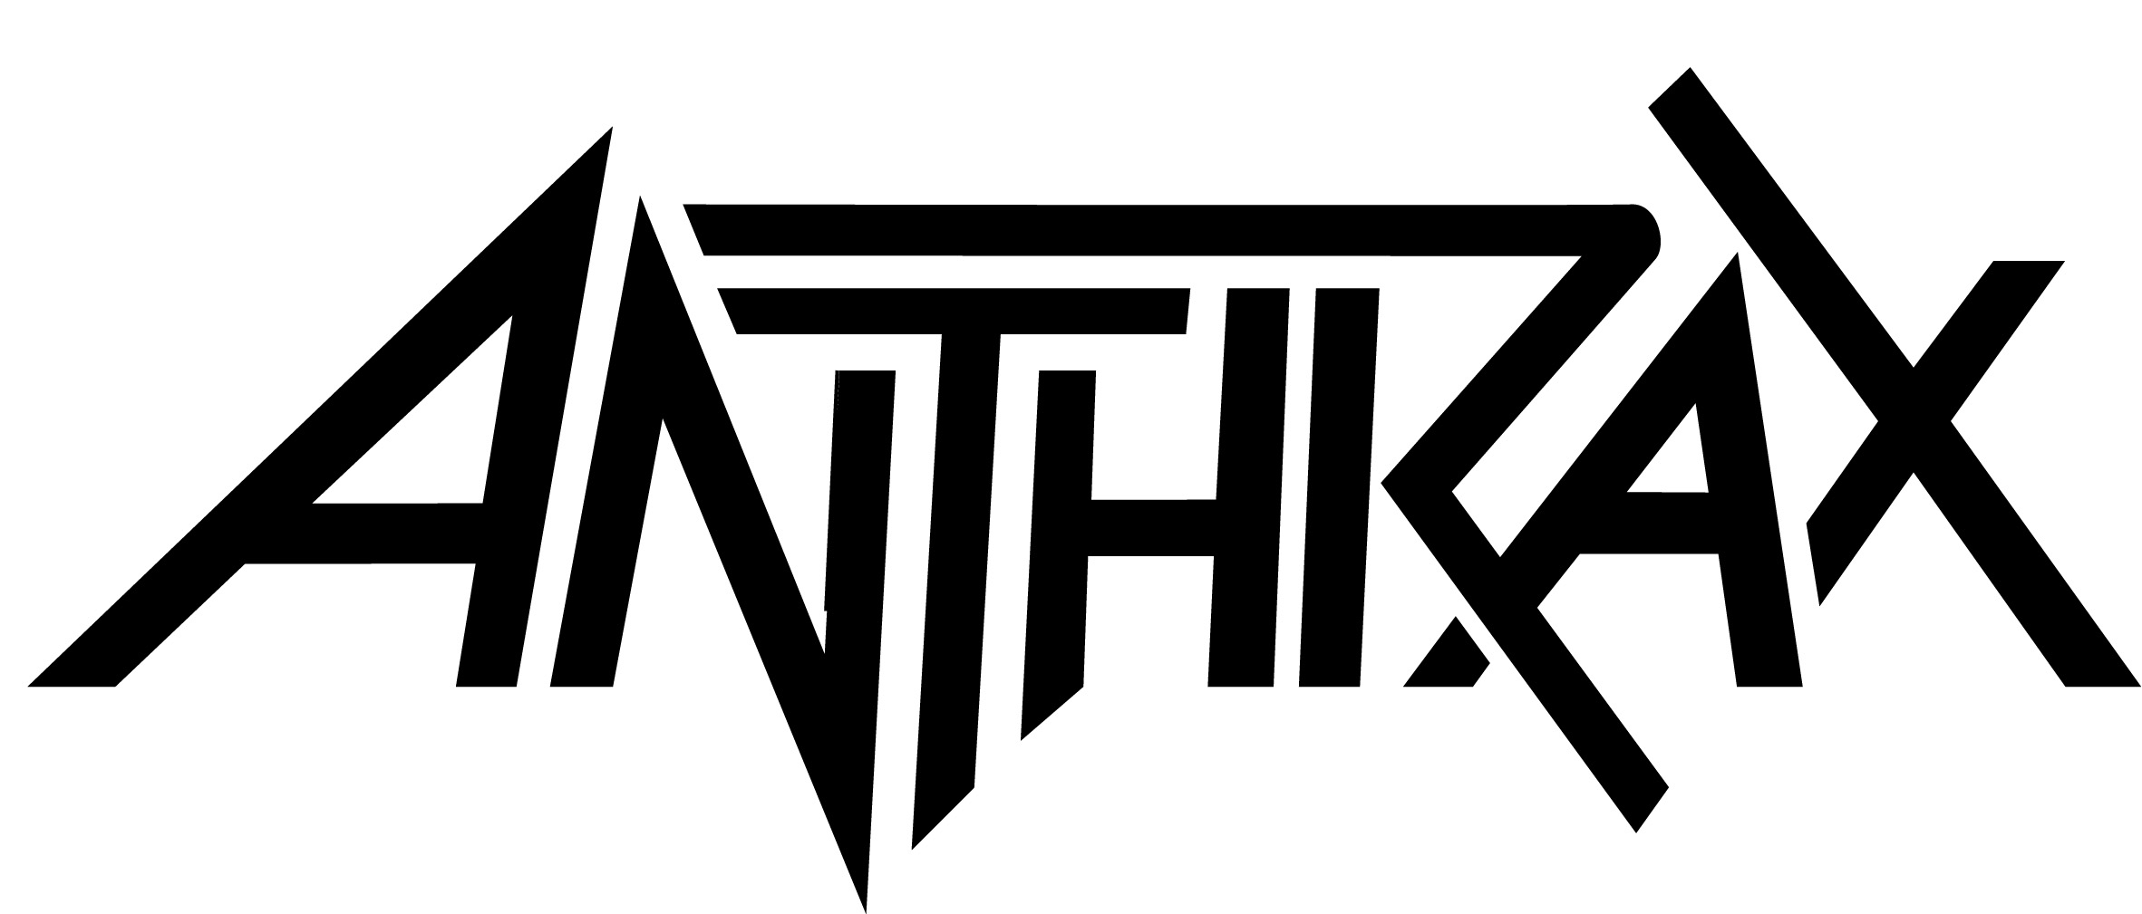
Biography • For All Kings • 2016
Joey Belladonna - vocals
Frank Bello - bass
Charlie Benante – drums
Jonathan Donais – lead guitar
Scott Ian – rhythm guitar

It’s rare that a career gets a second shot, let alone a whole second act, but then Anthrax isn’t your average band. Formed in New York in 1981, the group that would go on to sell over ten million records and become the living embodiment of America’s hi-top wearing, riff-spitting, ear-thrashing answer to the New Wave Of British Heavy Metal has undergone not one, but two complete eras - but that isn’t their real achievement. More than the group who let a fledgling Metallica crash on their studio floor in 1983, who became a lightning rod for geekdom by immortalizing Judge Dredd with “I Am The Law” in 1987, who enthusiastically raised a middle finger to the critics and unimaginative fans alike by collaborating with rappers Public Enemy in 1991, and who - in 2011 with the release of Worship Music - proved that classic albums aren’t a bygone concept, the story of Anthrax is one of gritty determination in the face of outrageous odds.

The liveliest fourth of the Big Four, they’re arguably the only member of that legendary fraternity who’ve kept their eyes so firmly focused forward and who’ve so consistently delivered the goods, both on stage and in the studio. Ironically, it was on stage alongside those immortal co-conspirators where the story of Anthrax’s 11th studio record began. Seeing their names in lights next to Slayer, Megadeth, and Metallica had a catalyzing effect on the band weary from years of toil and changing times. According to bassist Frank Bello, it wasn’t just a potent reminder of what they did back in the 80s, but also of how far they’ve come.

"Charlie, Scott and I have talked about how we have to credit Metallica with what we’re doing right now,” he says. “When the Big Four got back together back in 2009, it kinda reminded us that we belonged, that we really were part of that group of bands. We didn’t forget it but maybe people did - it suddenly made sense. It was like, 'wow, we’ve been busting our asses for all those years,' and then we released Worship Music - that was the catalyst. We knew we had something awesome, but it was about everybody giving it a chance - we sold a lot of records. It’s testament to how great metal fans are, because they came back.

“We’ve been doing this for 35 years now,” Frank continues. “We are who we are, we can’t be something we’re not, we can’t bullshit people…that’s just a New York mentality.”

As with any band, Anthrax has its creative turbulences, but those add up to their unique chemistry. While all five members contribute ideas and make suggestions to pretty much every song, drummer Charlie Benante makes early writing inroads with foundation riffs and other ideas, rhythm guitarist Scott Ian has a very particular way of incorporating his intense lyrical ideas into the band's music, Bello has proven to be a very talented melody writer, something that has helped set the band’s music apart from others in the same genre, Belladonna crafts his vocals to best utilize that soaring voice of his, and guitarist Jon Donais brings crushing leads. In the end, the five bring it all together to create what simply is Anthrax music.

Scott will be the first to admit that the For All Kings (Megaforce/North America • Nuclear Blast/International) backstory hasn’t exactly been conventional or without its setbacks. In the summer of 2012, Charlie realized that due to his ongoing carpel tunnel syndrome, he would be unable to join the band on all tour dates going forward. But Charlie wasn’t about to just sit around at home, so began writing riffs for the new album.

“When the Mayhem tour was over,” said Scott,” Frank, Charlie and I got together in the Jam Room in my house in L.A. and started arranging, and out of those first sessions, we had like four skeletal arrangements. Those first sessions were unbelievable.”

Crucially, Charlie would employ a secret weapon that would become central to the process of creating an album that would stand tall in a back-catalogue bejeweled with some of the most important and influential releases of all time: a mutant guitar called The Shark.

“It’s a weird story,” he says. “Paul Crook, who used to be our guitar player (1995-2001), hooked me up with a good friend of his from Las Vegas, Mark Katzen, who spent all his time making custom guitars. I wanted this Eddie Van Halen replica of his, which is taken from an Ibanez Destroyer but it kinda looks like an Explorer now. Mark made an exact replica for me and from the time I got it, there was just something strange about it - it’s like I just wanted to keep playing it. About a year later I heard that Mark had passed away, and I had this weird feeling about the guitar, like he packed it with riffs and went, ‘here, take this and do something great with it.’"

The result, in short, is a record that’s as diverse as it is satisfying: a feast for the ears, and something of a victory lap for a band that bears the unique distinction of inventing what they do while still being the best at what they do. From the straight-ahead, no-nonsense fury of “You Gotta Believe” and “Evil Twin” to the sprawling, heavy-riffing masterpiece of “Blood Eagle Wings” (original working title, “Epic,”) to its stately title track, “For All Kings” was - as Joey reveals - as much fun to record as it was to listen to. Chalk it up to the masterful efforts of Grammy-nominated Worship Music co-producer Jay Ruston, whose credits span the likes of Stone Sour, Killwswitch Engage, and Steel Panther, among others.

“It’s awesome working with Jay,” says Joey. “It’s like we can just nail a track and move on. I love that confidence, and we’re doing some crazy things. ‘Listen to Zero Tolerance,’ man - that song is so fast!"

There have been other changes, too. In 2013, it was announced that Rob Caggiano, longtime lead-player who’d become known for his startling solos as well as his backstage antics, left the band to resume his role as a producer, but not before he’d introduced the band to highly respected shredder Jonathan Donais from New England bruisers Shadows Fall.

It would be an emotional experience for Jon, who confesses to the unique problem of simultaneously being a fanboy of a band in which he’s now a full-time member.

“I grew up with them,” says Jon. "I still remember being in junior high, on a beach trip in Maine and my parents got me State of Euphoria. I just loved it as soon as I heard it. Anthrax was a huge influence on me and my other band so it’s still kinda weird for me. I mean, Scott is just a top-notch rhythm player - there are a lot of classic riffs going on! I was working most closely with Charlie. He’d go, ‘alright, gimme some Dimebag, no - go for Randy this time. Ok, now gimme some Eddie.’ It was intimidating, I mean these guys are legends."

It’s about more than just the music though, and true to Anthrax form, For All Kings isn’t just infused with pop-culture references, but deeper subtexts that bespeak the thoughtful artistry that underpins everything that they do. As Charlie explains, while Anthrax’s 11th studio record doesn’t have a running theme, there’s a significance to it all that comes straight from the heart.

“A king to me doesn’t mean King Henry the Eighth,” he says. “My Dad passed away when I was five years old, I never really had that Dad relationship so I looked elsewhere for role model and inspirations. KISS was a big thing for me, they were like kings to me. And that’s who this record is dedicated to - those people, maybe they’re sports figures, family members - the people that are big in your life.”

Look closely at the album artwork, and you’ll notice the fingerprints of one such hero in the band’s life - the inimitable work of godlike comic artist and longtime Anthrax supporter Alex Ross, whose immortal depictions of classic DC and Marvel characters are in a league of their own.

There’s an interesting parallel there, because there’s little that Anthrax does that doesn’t have a story or thought-process behind it. Take “Blood Eagle Wings,” for instance, and consider the wide-eyed imagination that inspired it. Says Scott:

“I was sitting in my hotel room in London the day before hosting the Golden Gods, specifically with the intent of needing to write - I was so behind, and when I’m at home with my wife Pearl and my son Revel I just don’t have the discipline. I can’t go, ‘Daddy’s gotta go write!’ If I here him playing, it’s like, ‘alright, I gotta go play, there’s some Lego Star Wars shit I gotta be a part of.’ So I was sitting there in London banging my head against a wall, and Pearl goes, ‘go get out for a walk,’ so I did, and I started thinking about London and the blood that every great city has been built on - the murder, the bones and the blood of so many millions of people. Any great city is built on the blood of the innocent: Rome, New York, Los Angeles, London, or go watch Chinatown. The last season of ‘Hannibal’ also happened to be on TV at the time, where I learned about the Viking practice of slicing a person’s back open and pulling the lungs out, so…”

“Evil Twin” isn’t just influenced by the shocking state of international affairs, but by the emotions accompanied by the realization that you suddenly have everything to lose.

“Lyrically there’s no overall concept,” Scott adds. "I have a child now, and this is the first record I’ve ever written lyrics for since I’ve had a son. That’s how I view the world now. You bring a child into the picture, and it makes everything so much scarier. Out of fear comes anger and it makes you hate the world that much more. You’ve got this human being you would take a bullet for - I would do anything to protect my son - so most of the album comes from that place. I don’t write happy lyrics, but to have a child in this world and then tell me that I shouldn’t be angry? That was a huge well of fear in my belly to draw from.

The result is an album that’s as ferocious as it is sublime, as current as it is classic. From the straight-ahead thrashing brilliance of opener “You Gotta Believe” and “Breathing Lightning” to the seven-minute majesty “Blood Eagle Wings,” For All Kings is the quintessential Anthrax record, and proof positive that you can’t keep a good band down.

# # #

0216

