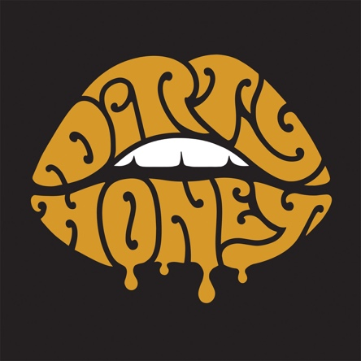

FOR IMMEDIATE RELEASE

RED-HOT BREAKING ROCK BAND DIRTY HONEY UNLEASHES
RAUCOUS AMAZON ORIGINAL COVER
OF AEROSMITH’S “LAST CHILD"

AVAILABLE TO STREAM ONLY ON AMAZON MUSIC

Recorded Live at the Historic RCA Studio B in Nashville, and Produced by Six-Time GRAMMY Award-Winning Producer Dave Cobb

Watch the Behind-the-Scenes Footage of the Band’s Recording Session HERE

LOS ANGELES, CA - Friday, January 17, 2020 - Dirty Honey, one of the hottest new bands in rock today, offer up a brand new Amazon Original," a soul-and-swagger-filled cover of Aerosmith’s “Last Child” written by Steven Tyler and Brad Whitford and originally released on the iconic band’s 1976 album, Rocks. Click HERE to check out Dirty Honey’s cover version, available now only on Amazon Music.

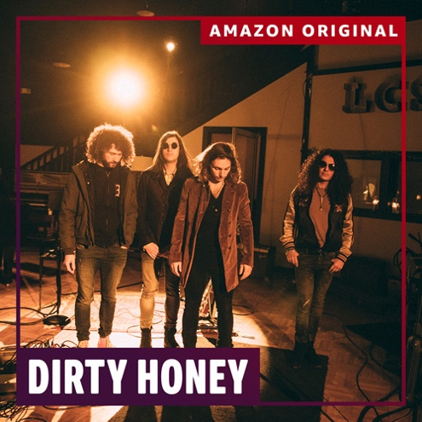

Dirty Honey - Marc LaBelle/vocals, John Notto/guitars, Justin Smolian/bass and drummer Corey Coverstone - recorded the track on December 21 at the historic RCA Studio B in Nashville, TN, the same studio where The King of Rock & Roll himself, Elvis Presley, recorded more than 250 songs. Six-time Grammy-winning producer Dave Cobb (Chris Stapleton, Brandi Carlile, John Prine, and the Lady Gaga/“A Star Is Born” six-million selling “Always Remember Us This Way”) produced the track. Fans can go HERE to check out the in-studio, behind-the-scenes video footage of the recording, as well as Labelle discussing the track, Dirty Honey’s connection to Aerosmith, and working with Cobb.

Said Labelle, “Aerosmith has been a huge influence on our band, and ‘Last Child’ is a staple in our live set, so to be tipping our hat to the band is really special. Plus, we're all big fans of the way Dave makes records. He does it live, he tracks live, he does minimal overdubs, and we love that. Our goal has always been to make music that has soul, that has a live feel, and has a performance element to it instead of perfectly in-tune vocals and perfectly played guitar solos. That’s our philosophy for everything we do, we’re trying to capture performance, not perfection."

Launched in September 2019, Amazon Music HD provides customers with the highest quality, with more than 50 million songs in High Definition, millions of songs in Ultra HD, and a growing catalog of 3D Audio. Dirty Honey’s “Last Child” is available in Ultra HD, (better than CD quality), with a bit depth of 24 bits and a sample rate of 96 kHz.
Amazon Music listeners can find “Last Child” on the Rock Scene playlist. Customers can also simply ask, "Alexa play the Amazon Original by Dirty Honey" in the Amazon Music app for iOS and Android and on Alexa-enabled devices. In addition to “Last Child,” Amazon Music listeners can access hundreds of Amazon Originals featuring both emerging and established artists across numerous genres, available to stream and purchase only on Amazon Music.
To say that 2019 was a breakout year for Dirty Honey would be an understatement. Recorded in Byron Bay, Australia with producer Nick DiDia (Pearl Jam, Rage Against The Machine), the band released its self-titled debut EP in March 2019. Over the course of the year, Dirty Honey opened for The Who, Guns N’ Roses, and Slash ft. Myles Kennedy & The Conspirators, performed at more than a dozen major summer festivals including Welcome to Rockville, Louder Than Life, Heavy MTL, Rocklahoma, Sonic Temple and Epicenter, and played to SRO crowds at every show on its first-ever headline tour in December. Dirty Honey also made music history when it became the only unsigned artist ever to hit #1 on Billboard’s Mainstream Rock Chart with its debut track “When I’m Gone.” Additionally, the band was named Canadian Rock Radio’s #1 International Breakout Artist of 2019, Loudwire cited “When I’m Gone” as one of the “66 Best Songs of the Decade,” the UK’s Louder/Classic Rock magazine hailed Dirty Honey as one of the “20 great bands to shake up the 2020s, and the band was just named a nominee as Best New Rock/Alternative Artist for the 2020 iHeartRadio Music Awards. “Rolling 7s,” Dirty Honey's sophomore single, is already a Top 20 track at Rock Radio, and the band has racked up more than 14.4-million total streams.

Dirty Honey hits the road today on the first leg of its 2020 “Rolling 7s” North American tour. The 25-date, coast-to-coast trek kicks off in Austin, TX at The Parish, and wraps up six weeks later on February 28 at the El Rey Theatre in Los Angeles. Hotly-tipped UK rock outfit The Amazons will open on all dates. The itinerary is below; for all ticketing and VIP information, go to https://www.dirtyhoney.com

JANUARY 2020
17 The Parish, Austin, TX
18 The Blue Light, Dallas, TX
19 The Studio at Warehouse Live, Houston, TX
21 The Parish at House of Blues, New Orleans, LA
22 Club LA, Destin, FL
24 Dixie Roadhouse, Fort Myers, FL
25 Jack Rabbits, Jacksonville, FL
27 Sidetracks, Huntsville, AL
28 The Basement East, Nashville, TN
29 Capone's Johnson City, TN
31 Metro Gallery, Baltimore, MD

FEBRUARY
1 Stage On Herr at HMAC, Harrisburg, PA
5 Knitting Factory, Brooklyn, NY
7 The Stache, Grand Rapids, MI
8 The Machine Shop, Flint, MI
10 Saint Andrews Hall, Detroit, MI
11 Bottom Lounge, Chicago, IL
12 Turner Hall Ballroom, Milwaukee, WI
14 Old Rock House, St. Louis, MO
15 The Riot Room, Kansas City, MO
17 Bluebird Theatre, Denver, CO
21 Nuemos, Seattle, WA
22 Polaris Hall, Portland, OR
25 Slim's, San Francisco, CA
27 The Parish at House of Blues, Anaheim, CA
28 El Rey, Los Angeles, CA

APRIL
17 WXTB 98RockFest, Amalie Arena, Tampa, FL
18 WJRR Earth Day Birthday, Central Florida Fairgrounds, Orlando, FL
24 WDHA Rocks the Rock, Prudential Center, Newark, NJ
25 WAAF 50th Anniversary, DCU Center, Worcester, MA

MAY
1 Lunatic Luau, Veterans United Home Loans Amphitheater at Virginia Beach, Virginia Beach, VA

# # #

Dirty Honey Media Contact:
Heidi Ellen Robinson-Fitzgerald
herfitz@mac.com
818-705-1267

