DIRTY HONEY PRESENTS
THE “CALIFORNIA DREAMIN’” TOUR
Dorothy and Mac Saturn will Special Guest

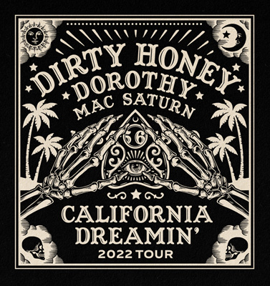

“Dirty Honey is full of raw, bluesy songs that’ll keep your hope for rock on fire.” — Loudwire

(LOS ANGELES, CA) — Tuesday, June 7, 2022 — Having recently wrapped up the massively successful Young Guns tour that Bass Magazine called “a co-headline tour of two of the greatest modern-day rock bands,” today DIRTY HONEY announces, “The California Dreamin’ Tour.” The 28-date, North American headline trek will also see the band play a handful of major festivals and radio shows and include their first tour of Canada. “The California Dreamin' Tour” will launch on Thursday, August 25, at Waterfest in Oshkosh, WI, and wrap at the Aftershock Festival in Sacramento, CA, on October 9. Fellow Los Angeles rock band Dorothy will join the tour in Portland, OR on September 7 as direct support, and Detroit rockers Mac Saturn will open the shows on all dates. Go HERE for all ticket purchasing information.

* Artist Presale: Wednesday, June 8 at 10 AM (local) through Thursday, June 9 at 10 PM (local)
• Artist Presale Password: DREAMIN
• Local Presales: Thursday, June 9 at 10 AM (local) - 10 PM (local)
• Local Presale Password: Local Discretion
• Public OnSale begins Friday, June 10 at 10 AM (local)

“This tour is a statement tour, and the statement is that ‘Rock is alive and well,' and three bands are heading out to prove that - Dirty Honey, Dorothy, and newcomers Mac Saturn,” said guitarist John Notto. “Get your ticket and get your ass out here.”

“While this will be our first tour of Canada,” vocalist Marc LaBelle added, “we've played a handful of shows there and were floored by the reception. Canada definitely has a very strong appetite for rock’n’roll, and we’re coming to feed the fire.”
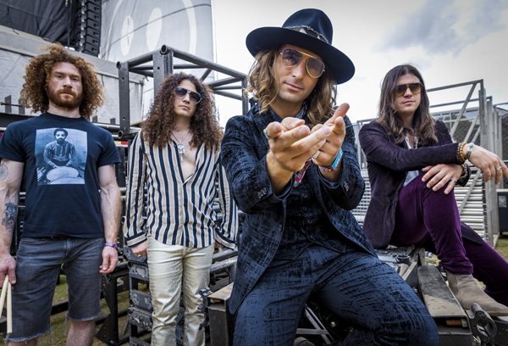
Dirty Honey L-R: Corey Coverstone, Justin Smolian, Marc LaBelle, John Notto
Photo credit: Scott Legato

Although this is their first proper Canadian tour, Dirty Honey is no stranger to the Great White North. Dirty Honey’s debut single, “When I’m Gone,” hit #7 Active Rock in Canada, and their second single, “Rollin’ 7s,” peaked at #5 on the same chart. And this past March, Dirty Honey co-headlined a
show with Mammoth WVH in Toronto and has previously played in Canada with Slash and Miles Kennedy/Alter Bridge and at Heavy MTL in 2019.

Just before the “California Dreamin' Tour” kick-off, Dirty Honey will make its UK/European debut with a 29-city run. The itinerary will include a handful of headline club dates, and slots on major summer festivals, including the UK’s Download Festival, Switzerland’s Rock The Ring, Hellfest in France, and Belgium’s Graspop, playing stadiums with Guns N’ Roses and KISS, and theaters with Rival Sons.

The dates for Dirty Honey’s “California Dreamin’ Tour” are as follows:

August
25 Waterfest, Leach Amphitheater, Oshkosh, WI*
26 Fine Line, Minneapolis, MN*
27 Fargo Brewing Co., Fargo, ND*
29 The Park Theatre, Winnipeg, MB*
31 Louis’, Saskatoon, SK*

September
2 Starlite Room Edmonton, AB*
3 Commonwealth, Calgary, AB*
5 Rickshaw, Vancouver, BC*
7 Revolution Hall, Portland, OR^
8 The Neptune, Seattle, WA^
9 Knitting Factory, Spokane, WA^
11 The Pub Station, Billings, MT^
13 Bourbon Theatre, Lincoln, NE^
14 Val Air Ballroom, Des Moines, IA^
16 House of Blues, Cleveland, OH^
17 Del Lago Casino, Waterloo, NY@
19 Club Soda, Montreal, QC*
21 HMAC, Harrisburg, PA^
24 Pine Knob, WRIF Radio Show, Detroit, MI+
25 Louder Than Life, Louisville, KY+
27 The Intersection, Grand Rapids, MI^
28 The Forge, Joliet, IL^
30 Apollo Theatre AC, Belvidere, IL^

October
1 Red Flag, St. Louis, MO^
2 TempleLive, Fort Smith, AR^
5 Rialto Theatre, Tucson, AZ^
7 The Catalyst, Santa Cruz, CA^
9 Aftershock Festival, Sacramento, CA+

* Mac Saturn will support
@ Dorothy will support
^ Mac Saturn and Dorothy will support
+ Festival date

# # #

