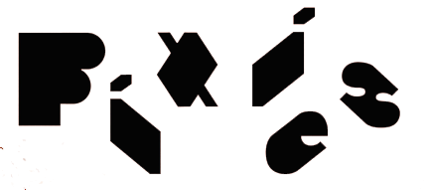

PIXIES ANNOUNCE ITS
2023 NORTH AMERICAN TOUR

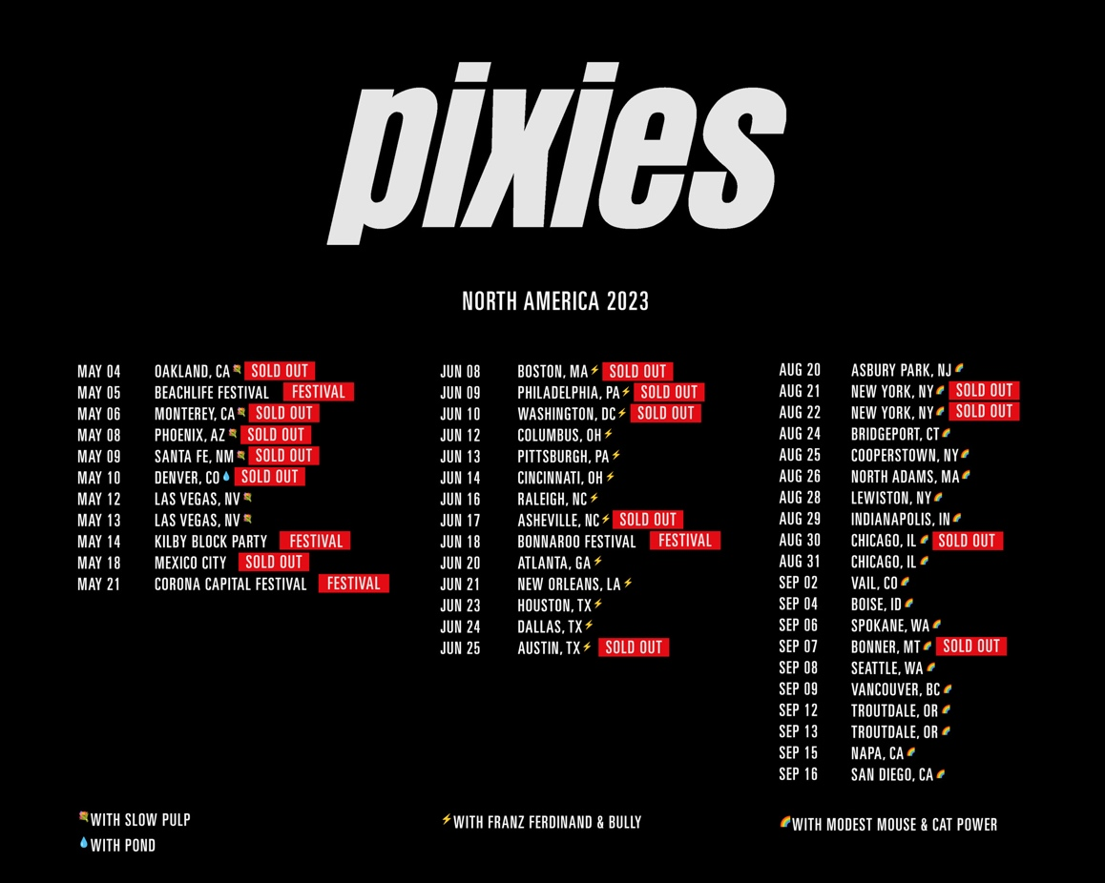

LOS ANGELES, CA - Tuesday, March 28, 2023 — For the first time since 2018, indie rock kingpins Pixies, will be heading out on a massive, multi-leg, 40-plus date North American tour, the finale for the band’s 2022-2023 World Tour. Pixies’ World Tour launched in March 2022, concludes in September 2023, and has seen the band play sold out shows across North America, the UK, Europe, South America, Japan, Australia and New Zealand.

Pixies’ 2023 North American run kicks off on May 4 in Oakland, CA and concludes in Southern California mid-September. Over the course of the three legs, Pixies will share the stages with Slow Pulp, Pond, Franz Ferdinand, Bully, Modest Mouse, and Cat Power. Tickets are on sale now, and can be purchased here: https://bnds.us/ziwfqx
Pixies’ 2022-2023 World Tour is in support of the band’s latest album Doggerel (BMG) about which the NME reported “is the most inventive since their reunion nearly two decades ago.” American Songwriter’s Alli Patton wrote, "The Pixies’ new album, Doggerel is ominous, haunting, and gruesome, heavy with treacherous sounds that indulge in an equal softness. The drums punch and the bass slinks along in a mucky mire of a beat, but those harsh sounds are met with a cosmic velvet, a cushy patchwork of breath and light. The album is Medieval in the Space Age. It’s a somber march to the executioner’s block and a celestial trek among the Pleiades. Doggerel’s lyrics are whimsical but insightful in the Pixies’ irreverent songwriting fashion. Charming and yet still sagely.”

Pixies’ concerts are well-known for being “one-of-a-kind,” as the band has no pre-determined set lists, the “next song” is the one that “feels right," so you’ll never see the same show twice. And the song choices go deep, as the band - Black Francis/guitar, vocals, Joey Santiago/guitar, David Lovering/drums, background vocals, and Paz Lenchantin/bass, background vocals) come on to every stage prepared to play any of the 90-100 songs they've rehearsed.

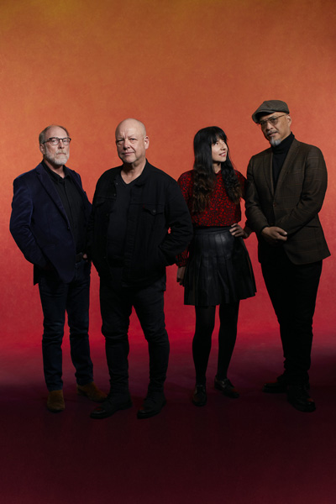
Pixies L-R: David Lovering, Black Francis, Paz Lenchantin, Joey Santiago
Photo credit: Tom Oxley

Confirmed dates for all three North American tour legs are as follows:
LEG ONE:
MAY 2023
4 Fox Theater, Oakland, CA*
5 BeachLife Festival, Redondo Beach, CA (Festival)
6 Golden State Theatre, Monterey, CA*
8 The Van Buren, Phoenix, AZ*
9 Lensic Performing Arts Center, Santa Fe, NM*
10 The Mission Ballroom, Denver, CO@
12 Encore Theatre at Wynn, Las Vegas, NV*
13 Encore Theatre at Wynn, Las Vegas, NV*
14 Kilby Block Party, Utah State Park, Salt Lake City, UT (Festival)
18 Teatro Metopólitan, Cuauhtémoc, Mexico
21 Corona Capital Festival 2023, Mexico, Mexico

* Slow Pulp supporting
@ Pond supports

LEG TWO (all dates with Franz Ferdinand and Bully):
JUNE 2023
8 MGM Music Hall at Fenway, Boston, MA
9 The Met, Philadelphia, PA
10 The Anthem, Washington, D.C.
12 Kemba Live!, Columbus, OH
13 Stage AE, Pittsburgh, PA
14 Andrew J. Brady Music Center, Cincinnati, OH
16 Red Hat Amphitheater, Raleigh, NC
17 Rabbit Rabbit, Asheville, NC
18 Bonnaroo, Manchester, TN (Festival)
20 Coca-Coca Roxy, Atlanta, GA
21 The Fillmore, New Orleans, LA
23 Bayou Music Center, Houston, TX
24 Southside Ballroom, Dallas, TX
25 Moody Amphitheatre, Austin, TX

LEG THREE: (all dates, co-headline with Modest Mouse, special guest Cat Power):
AUGUST 2023
20 Stone Pony Summerstage, Asbury Park, NJ
21 The Rooftop at Pier 17 - New York, NY
22 The Rooftop at Pier 17 - New York, NY
24 Hartford HealthCare Amphitheatre, Bridgeport, CT
25 Brewery Ommegang, Cooperstown, NY
26 MASS MoCA, North Adams, MA
28 Artpark Amphitheater, Lewiston, NY
29 TCU Amphitheatre at White River State Park, Indianapolis, IN
30 Salt Shed - Outdoors, Chicago, Il
31 Salt Shed - Outdoors, Chicago, Il

SEPTEMBER 2023
2 Gerald R. Ford Amphitheatre, Vail, CO
4 Outlaw Field at the Idaho Botanical Garden, Boise, ID
6 Pavilion at Riverfront, Spokane, WA
7 Kettlehouse Amphitheatre, Bonner, MT
8 Climate Pledge Arena, Seattle, WA
9 Doug Mitchell Thunderbird Sports Centre, Vancouver, BC
12 McMenamins Edgefield, Troutdale, OR
13 McMenamins Edgefield, Troutdale, OR
15 Oxbow RiverStage, Napa, CA
16 Gallagher Square, San Diego, CA

For more info (bio, photos, etc.) on Pixies, please go HERE.

Pixies Media Contacts:
National: Heidi Ellen Robinson-Fitzgerald • heidirobinsonfitz@icloud.com • 818-705-1267
Local/Tour: Selena Fragassi • selena@fr-pr.net • (847) 942-3093

