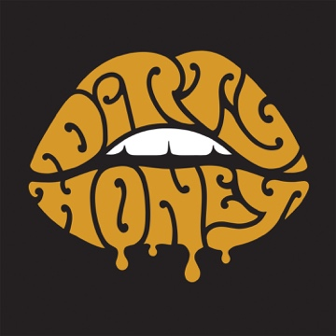

FOR IMMEDIATE RELEASE

DIRTY HONEY HEADS TO THE HILLS
TO SHOOT A GOLDEN HOUR "SUITCASE SESSION"

LOS ANGELES, CA - (Monday, June 29, 2020) - On a late-afternoon earlier this month, with Dodger Stadium and the downtown Los Angeles skyline in the background, Dirty Honey took to the hills - with suitcase in hand - and shot an acoustic performance clip of their song "Down The Road" as the newest installment in their "Suitcase Sessions" video series. Due to the COVID-19 shutdown, Dirty Honey launched the series when the band had to cancel its plans to travel to Australia to record new music with producer Nick DiDia, as well as perform their first-ever concerts there and in Japan.

"Down The Road" is a seductive and melancholy anthem and this acoustic performance underscores the band's strong connection to the blues. The video's gentle transition from late afternoon to dusk is courtesy of cinematographer Nick Almanza and Director of Photography Jonathan Suarez. You can check out the clip HERE.

From the band's Los Angeles base, Dirty Honey has been writing and demoing new music with Australia-based producer Nick DiDia via Zoom, and are looking to meet up with DiDia to record either in Los Angeles or Australia - depending on travel restrictions - this summer.

• • •

ABOUT DIRTY HONEY:
To say that 2019 was a breakout year for Dirty Honey would be an understatement. Recorded in Byron Bay, Australia with producer Nick DiDia (Pearl Jam, Rage Against The Machine), the band released its self-titled debut EP in March 2019. Over the course of the last year-plus, Dirty Honey opened for The Who, Guns N' Roses, and Slash ft. Myles Kennedy & The Conspirators, performed at more than a dozen major summer festivals including Welcome to Rockville, Louder Than Life, Heavy MTL, Rocklahoma, Sonic Temple and Epicenter, and played to SRO crowds at every show on its first-ever headline tour in December and January & February this year. Dirty Honey also made music history when it became the only unsigned artist ever to hit #1 on Billboard's Mainstream Rock Chart with its debut track "When I'm Gone." Additionally, the band was named Canadian Rock Radio's #1 International Breakout Artist of 2019,

Loudwire cited "When I'm Gone" as one of the "66 Best Songs of the Decade," the UK's Louder/Classic Rock magazine hailed Dirty Honey as one of the "20 great bands to shake up the 2020s," and the band was nominated as Best New Rock/Alternative Artist for the 2020 iHeartRadio Music Awards. "Rolling 7s," Dirty Honey's second single, went all the way to #4 at Rock Radio, and the band has racked up nearly 30-million total streams.

