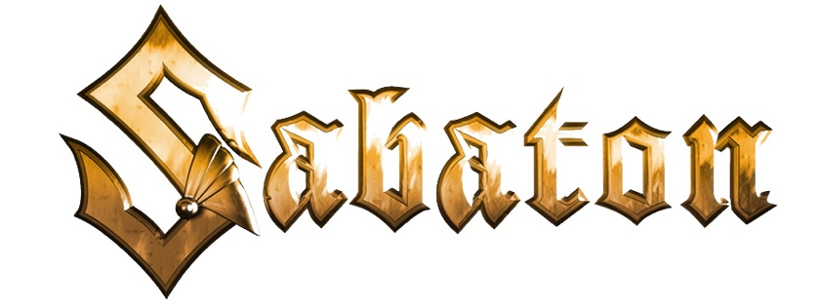

The War to End All Wars
(Band/Project Biography)

Joakim Brodén • Vocals
Pär Sundström • Bass
Chris Rörland • Guitar
Tommy Johansson • Guitar
Hannes Van Dahl • Drums

"If history were taught in the form of stories, it would never be forgotten." -- Rudyard Kipling

The members of Sabaton have much in common with each other, but likely the most vital is their shared desire to be storytellers. Sabaton is known for its high-intensity heavy metal, juxtaposed with narratives that recount harrowing yet epic tales of real-life military battles and the brave men and women who lived them. Released on March 4, 2022 (Nuclear Blast), Sabaton’s tenth album, The War To End All Wars, revisits The Great War, a conflict of unprecedented ferocity.

Written and recorded between Spring 2020 and Spring 2021, the band has crafted a concept album of 11 brand-new songs that once again dive deep into the atrocities, miracles, and events tied to the early 20th century World War I. According to vocalist Joakim Brodén, there were still stories linked to the first world war left untold on the band's 2019 release, The Great War. "In some cases," he explains, "we just didn't have the right music, and there were specific stories we had wanted to tell, like 'The Christmas Truce' and 'Hellfighters.' Also, once we went on tour in support of 'The Great War,' we met and heard from so many fans who told us about other great WW1 stories we'd never heard before, stories that were just so good, we kept asking ourselves, 'how did we miss this?'"

With fiery riffs, pounding drums, and Brodén's signature gruff baritone, each of the 11 songs on The War to End All Wars shines a bright light on these true-life stories, the personal courage and bravery, triumphs and tragedies: “Sarajevo” - the assassination of Archduke Franz Ferdinand of Austria that prompted the start of WW1; “Lady of the Dark” - Milunka Savić, the Serbian woman who took her brother’s place in the army and, disguised as a man, became one of most decorated soldiers of the war; “The Unkillable Soldier” - the story of the “indestructible” Sir Adrian Carton De Wiart, who survived gunshots to his left eye, skull, hip, leg, stomach, ankle and ear, and numerous plane crashes, yet kept fighting; “Hellfighters” - dedicated to the famous 369th regiment made up primarily of African American and Puerto Rican soldiers; and the poignant "Christmas Truce," when, on Christmas Eve, 1914, British and German found a moment of peace and reconciliation on a bloody battlefield.

Leading up to the release of The War to End All Wars, a wealth of singles from the album were made available, each one accompanied by a compelling and emotional music video that served to illustrate the fact-based story behind the song. Additionally, The War To End All Wars is now available in a wide variety of exclusive formats, including CD, vinyl, and cassette, with most as limited editions. Details can be accessed HERE. Plans are for The War To End All Wars to have a multi-year touring cycle.

In the more than two decades since the band's launch, Sabaton has headlined major festivals and sold-out arena concerts worldwide and gained a legion of loyal fans across the globe by carving out a reputation as one of the hardest working bands in the business. Since Sabaton’s debut album in 2005, the band has released ten studio albums, of which most have been certified GOLD, PLATINUM, and even QUADRUPLE PLATINUM, seen eight of its albums score Top 10 international chart status, and six claim the Top 5. The band has earned eight Metal Hammer/Golden Gods Awards nominations, taking home the award for "Breakthrough Artist" in 2011 and "Best Live Band" in three different years, and a Grammis nomination (Swedish equivalent to the U.S. GRAMMY) as Best Heavy Metal band. Sabaton has also accumulated more than two billion streams across all streaming platforms.
In 2008, Sabaton hosted the first now annual, three-day concert festival, the "Sabaton Open Air," at the Lugnet ski stadium in Sweden. The following year, the band launched its annual - and always sold out - Sabaton Cruise that sails out of Stockholm for epic sea adventures, rocking the ship with fellow metalheads and lots of SABATON. Twenty-nineteen saw the debut of the band's own YouTube channel, "Sabaton History Channel." The channel combines the power of YouTube, music, and storytelling to dive into the true-life stories behind every Sabaton song, bringing history to life in an informative and entertaining way. Sabaton's Pär Sundström and Joakim Brodén are joined by the renowned historian Indy Neidell, of "The Great War" and "WW Two in Real Time" fame. New episodes tied to several songs on The War To End All Wars have already been produced and added to the channel's playlist.
Sabaton refuses to be simply slotted into a genre. Fans need only know them as Sabaton, the heavy metal band that sings of real-life wars and the people who played a part in them; of grueling campaigns and dazzling acts of bravery, magnificent victories, and touching personal struggles, true stories more fantastic than any fiction.

3/2022

