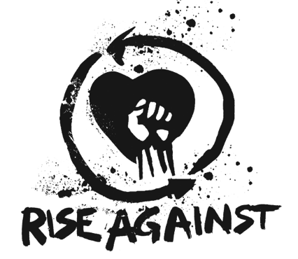

FOR IMMEDIATE RELEASE

RISE AGAINST RELEASES BRAND NEW SONG AND ANIMATED VIDEO,
“BROKEN DREAMS, INC."
Song is Lead-Off Track for DC’s Upcoming
“Dark Nights: Death Metal” The Original Soundtrack,
To Be Released by Loma Vista Recordings
Check out the Animated Motion Comic Video HERE

LOS ANGELES, CA - (Wednesday, September 16, 2020) — Multi-Gold and Platinum-selling punk rock stalwarts RISE AGAINST will see “Broken Dreams, Inc.,” their first new song in three years, and the first as part of a new agreement with Loma Vista Recordings, released today. Produced by Bill Stevenson, Jason Livermore, Andrew Berlin, and Chris Beeble, “Broken Dreams, Inc.” is angry, fast and furious punk rock, with ruthless drums, pounding bass, blazing guitar and impassioned vocals. Also released today is the animated/motion comic video for the song that features art from DC's “Dark Nights: Death Metal” drawn by the series' artist Greg Capullo, and can be viewed HERE.

“Broken Dreams, Inc.” speaks to today's changing landscape of American society, the opportunities that are available to some but not to others, the people who are able to benefit versus those who get left behind, who suffer and end up as casualties. How do we level the playing field so everyone can have a real chance at attaining the American Dream? Said Rise Against’s vocalist/lyricist Tim McIIlrath, “One word, ‘disruption.’ You have to put power into the hands of the people, not business, you have to value people and community over profit. You can't have a shareholder-run country or a shareholder-run world, a world that values profit above all else, because profit above all else can result in dangerous repercussions for humankind.”

Rise Against - rhythm guitarist/vocalist McIlrath, bassist Joe Principe, guitarist Zach Blair and drummer Brandon Barnes - is known for its explosive live shows, and its outspoken, socially-conscious lyrics that speak to the mood of our times: the environment, economic injustice, forced displacement, political corruption, voter registration, animal rights, and interpersonal relationships, all delivered with big, chunky riffs and melodic post-grunge hooks. Rise Against has amassed five top 10 albums on Billboard’s Top 200 chart, and six top ten singles on its Hot 100 chart. The band’s gold-certified single “Savior” alone, has accumulated nearly half-a-billion streams.

# # #

For more information on Rise Against, go to http://www.riseagainst.com

