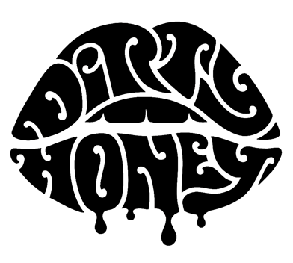

About Dirty Honey (2022)

In October 2019, Dirty Honey proved with its sexy, bluesy debut single, “When I’m Gone,” that you don’t need a record deal to go all the way to #1 on Billboard's Mainstream and Hard Rock Charts - the only unsigned artist ever to achieve this. The track was the first song from the band’s self-titled debut EP, produced by Nick DiDia (Pearl Jam, Rage Against The Machine), recorded in Byron Bay, Australia, and released in March 2019.

Dirty Honey’s second single/video, the loaded-with-swagger “Rollin 7s," went to #3 at Rock Radio (still heading up the charts when COVID changed everything), and its music video has racked up north of 7.6 million YouTube plays. Between the Fall of 2018 and early 2020, Dirty Honey opened for The Who, Guns N' Roses, and Slash ft. Myles Kennedy & The Conspirators, was tagged as a “do not miss” band at the more than a dozen major N.A. summer festivals they played, performed for SRO crowds at every show on its first-ever U.S. headline tour, and Rolling Stone featured them as “An Artist You Need To Know.” Dirty Honey’s self-titled debut album hit the streets on April 23, 2021 and made its bow on the Hard Rock Albums Chart at #2. Following the album’s debut, the band headed out on a nine-week tour as Main Support for The Black Crowes' “Shake Your MoneyMaker” U.S tour, receiving glowing reviews and standing ovations at the majority of the tour's shows - not bad for a still-breaking opening act.

Dirty Honey began 2022 with a special performance of the Prince classic, "Let's Go Crazy," shot on one of Minnesota's 10,000 frozen lakes, that kicked off TNT's New Year's Day broadcast of the National Hockey Winter Classic. On February 20, the band headed out on the Young Guns tour, a 34-city, co-headline tour with Mammoth WVH. Jointly, both bands intended to prove that rock'n'roll is very much alive and well, and saw New Jersey's Aquarian naming the trek "rock N' Roll's Tour of the Year." Dirty Honey will launch its first UK European tour this summer, playing a handful of headline club shows, jaor UK/?Euro summer festivals, ane support slots with Guns N' Roses, KISS, and Rival Sons. As Guitar World wrote,"...the future of rock music is in safe hands."

# # #

