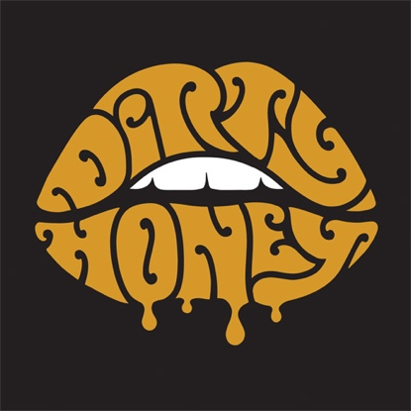

ABOUT DIRTY HONEY
To say that 2019 was a breakout year for Dirty Honey would be an understatement. Recorded in Byron Bay, Australia with producer Nick DiDia (Pearl Jam, Rage Against The Machine), the band released its self-titled debut EP in March 2019. Over the course of the last year-and-a-half, Dirty Honey opened for The Who, Guns N' Roses, and Slash ft. Myles Kennedy & The Conspirators, performed at more than a dozen major summer festivals including Welcome to Rockville, Louder Than Life, Heavy MTL, Rocklahoma, Sonic Temple and Epicenter, and played to SRO crowds at every show on its first-ever headline tour in December and January and February this year. Dirty Honey also made music history when it became the only unsigned artist ever to hit #1 on Billboard's Mainstream Rock Chart with its debut track "When I'm Gone." Additionally, the band was named Canadian Rock Radio's #1 International Breakout Artist of 2019, the UK's Louder/Classic Rock magazine hailed Dirty Honey as one of the "20 great bands to shake up the 2020s," and the band was nominated as Best New Rock/Alternative Artist for the 2020 iHeartRadio Music Awards. "Rolling 7s," Dirty Honey's second single, went all the way to #4 at Rock Radio, and the music video has racked up more than 4.5-million YouTube plays. The band is currently recording its follow-up release which is expected out early next year.

# # #

10/7/20

