TODAY, DIRTY HONEY RELEASES ITS NEW ALBUM,
CAN’T FIND THE BRAKES
FEATURING THE BAND’S TOP TEN SINGLE,
“WON’T TAKE ME ALIVE"

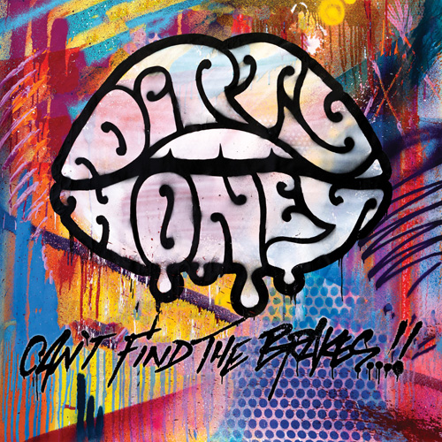

(LOS ANGELES, CA - Friday, November 3, 2023) — With a hot new single, “Won’t Take Me Alive,” now Top 10 at Rock Radio, and the band well into their extensive, nine-week, 39-date North American headline tour, today, Dirty Honey sees the release of its full-length sophomore album, Can’t Find The Brakes. Produced by Nick DiDia and recorded at his studio in Byron Bay, Australia this past Spring, the album also features the recently-released second single, “Coming Home (Ballad of the Shire),” a 180-degree turnabout from the high-energy rock’n'roll the band is known for. “Coming Home (Ballad of the Shire)” is a profoundly personal, shatter-your-heart-into-a-million-pieces ballad and a song that illustrates what Dirty Honey is capable of. You can access the Can't Find The Brakes album HERE.

But wait, there’s more: Famed world-renowned graffiti artist Kelly “RISK” Gravel, who designed and spray-painted the Can't Find The Brakes album’s original cover art, has pulled a bit of a “Willy Wonka.” As of today, distributed to a handful of record stores across America are ten copies of the Can’t Find The Brakes album. Unlike the standard issue, each one of these has been specially embellished with its own one-of-a-kind album cover artwork, each one individually spray-painted by “RISK.” Those who find and purchase these one-of-a-kind albums will win tickets to one of the band's shows and more. Check out the video clip HERE to see RISK as he creates these exclusive items - and happy hunting!

• • • • •
﻿
The making of Can't Find The Brakes, as told by Marc LaBelle...
"Making the Can’t Find The Brakes album was a completely different experience than making the Dirty Honey album,” said Marc LaBelle. "Covid created a situation where we weren't really living or experiencing. But, for our new album, we were able to spend time with each other again. We spent more than a month with Nick, our producer, at his studio in Australia. Just getting back into the studio with him - no ZOOM this time - all of us physically being together in the same space allowed us to do some experimenting, all of which contributed to the wide spectrum of emotion on the new album."

About Can’t Find The Brakes...

“Blending classic rock riffs with Marc LaBelle’s searing vocals, Dirty Honey have established themselves as one of the most exciting bands of the past few years.
– Bass Player Magazine/UK

“Full of catchy licks and thrilling solos, this record takes you on a journey…
Honey for hard rockers” -- Rolling Stone/France

“Dirty Honey’s new record, ‘Can’t Find The Brakes,’ could well just be the album of the year.
Rock and Roll hasn’t felt this alive in years!” 9.5/10
-- The Rockpit/Australia

"Ultimately, 'Can’t Find The Brakes' stands as their best record to date
and should further demonstrate Dirty Honey as among the most promising and most
thrilling rock bands of our time."
– The Spill Magazine/Canada

"One of the strongest aspects of "Can't Find the Brakes" is the album's variety. At a time when bands sometimes play it safe and stick to one particular sound, DIRTY HONEY switch up their sound from track to track, offering everything from thick, hard rock anthems to soft, hymn-like numbers. DIRTY HONEY are just getting started, and if they can pack in this much variety this early in their career, it'll be exciting to see where they are in 10 years."
-- Blabbermouth/USA -- 8.5/10

"This band represents the present and future of rock."
-- Long Live Rock'n'Roll/Italy

“Following up on such an impressive debut was always going to be a challenge, but Dirty Honey have exceeded expectations. Their ascendancy continues.”
-- PowerPlay Magazine/UK - 10/10 Powerpoints

"In a nutshell, 'Can't Find The Brakes' is a modern-day rock'n'roll gem.'”
-- Sonic Perspectives/USA

ABOUT DIRTY HONEY:
https://www.herfitzpr.net/dirty-honey-about-2023

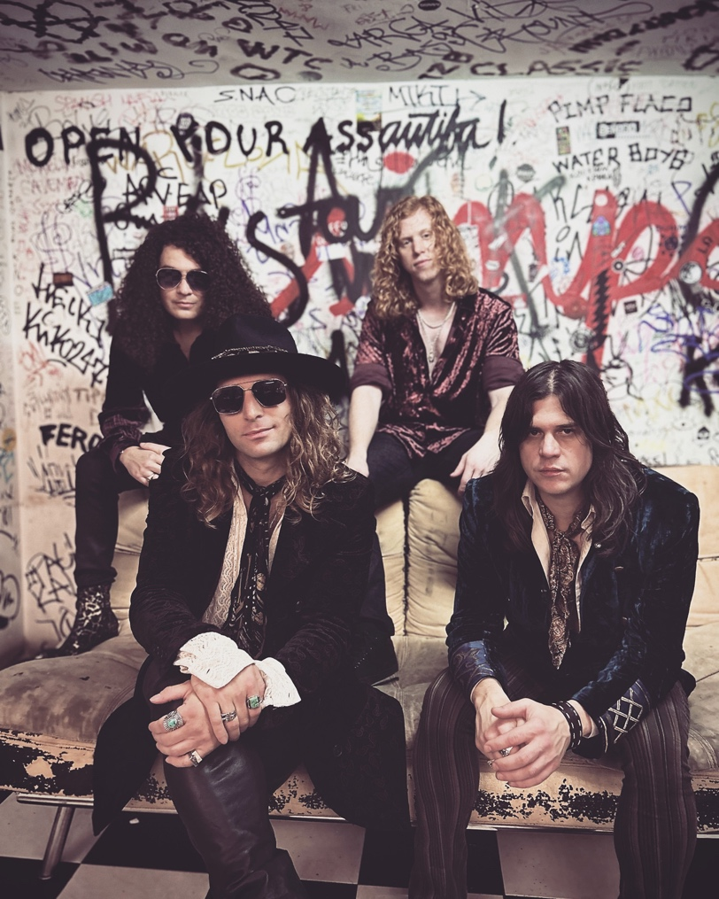
Dirty Honey
Rear • Justin Smolian/bass, Jaydon Bean/drums
Front: Marc LaBelle/vocals, John Notto/guitars
Photo credit: Courtesy of Dirty Honey

For Press: If you haven’t had a chance to check out Can’t Find The Brakes,
go HERE (stream)
or HERE (download)

Dirty Honey One-Sheet – access to ALL background/prep material:
https://www.herfitzpr.net/copy-of-dirty-honey-cftb-links-1-shee-1

Dirty Honey North American National Media Contact:
Heidi Ellen Robinson-Fitzgerald • HERFitz@mac.com • 818-705-1267

