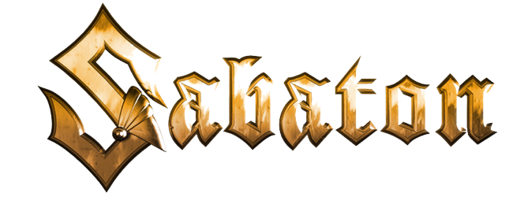

The War to End All Wars
"Dreadnought"

Music: Joakim Brodén
Lyrics: Pär Sundström & Joakim Brodén

A shadow moves across the water in pursuit
It splits the waves, commands the sea and defies the wind
Instilling fear among its prey, feels nought for itself
Ahead the sea lies calm awaiting the storm

Displace the water in its path
Reveal the cannons, align the guns, unleash their wrath

Unopposed under crimson skies
Immortalized, over time their legend will rise
And their foes can’t believe their eyes, believe their size, as they fall
And the Dreadnoughts dread nothing at all

A hull of steel and all big guns to serve the fleet
Unrivalled firepower riding the waves to war
A devastating blow will send their foes down below
Fearless armada now bombarding their shore

Light up the night when cannons roar
In fear of nothing, they lead the navy into war

The North Sea has drawn them near
The Fleet of the High Seas approach
A contest of titans commence
These days will dictate their fate
The Grand Fleet prepares their guns
Unleashed as the Dreadnoughts clash at last

